Speaking Notes for 3-Hour Session:
Business training on natural capital

(Slides 1-27)
  - Introductions
  - Setting the scene and a brief re-cap on natural capital

Welcoming & opening
Slide 1

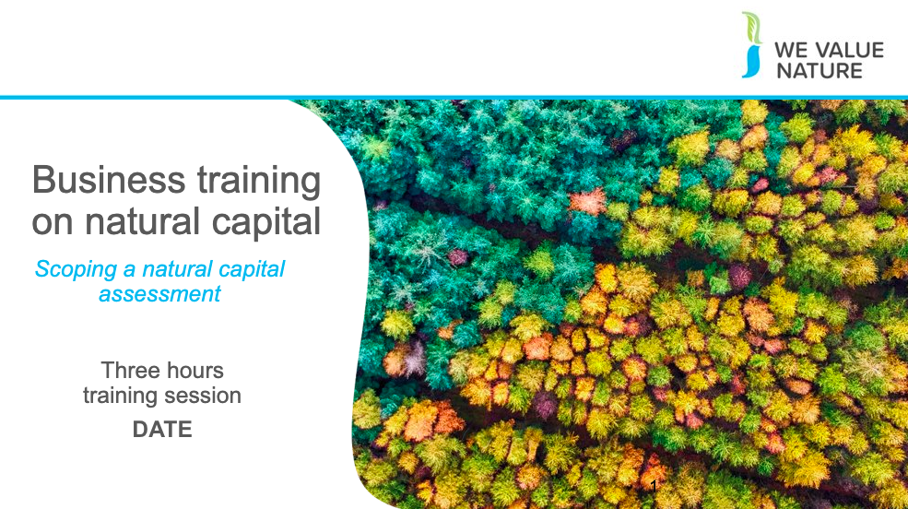

Presenter to welcome the group to the business training on natural capital

Slide 2

Before starting the training, presenter should introduce that this training is being given as part of the We Value Nature Campaign and explain what it is, its purpose, objectives and partners involved:

The We Value Nature Campaign is a €2 million EU-funded campaign supporting businesses and the natural capital community across Europe with the aim of making valuing nature the new normal for business. As we will have a chance to explore during today’s training, by valuing nature, businesses can make smarter decisions that benefit themselves, society and the planet as a whole.

The campaign is coordinated by the Institute of Chartered Accountants in England and Wales (ICAEW), World Business Council for Sustainable Development (WBCSD), The International Union for Conservation of Nature (IUCN) and Oppla. And it is supporting the Natural Capital Coalition, which has recently merged with the Social & Human Capital Coalition to become now the ‘Capitals Coalition’.

The campaign will aim to increase the uptake of the natural capital approach (including: natural capital assessment, natural capital accounting, nature-based solutions and green infrastructure) by identifying barriers and opportunities, providing practical support to business through activities (such as webinars, helpdesk calls, etc.) and training such as this one, as well as by inspiring businesses to adopt the NCP.

Presenter to take this opportunity to thank the different stakeholders that support the training (if relevant).

Slide 3
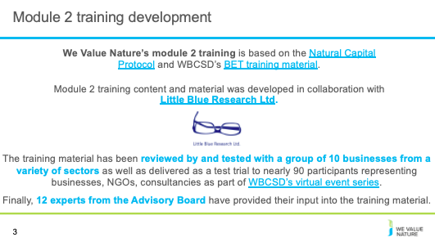
Include an acknowledgement slide for the training: presenter to read through the slide
Slide 4
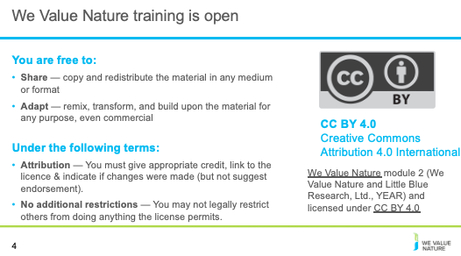
Presenter to read through the slide stating that the training is free to use under a creative commons license

Slide 5
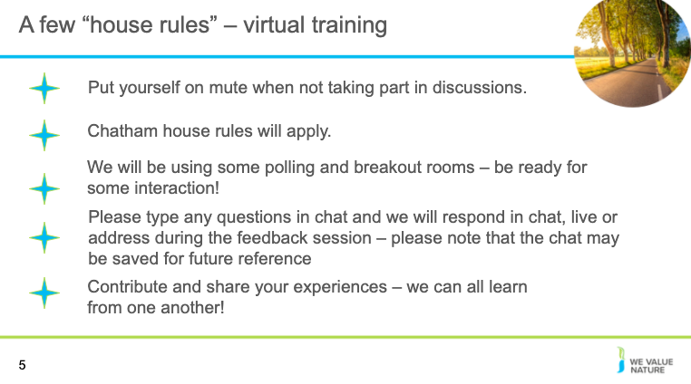
Optional depending on session type:
Presenter to explain the house rules on the screen, also using the notes below for a virtual session:

Point 1: Explain that for now are all muted but will unmute when open floor for Qs & discussion – will be flexible with time
Point 2: Encourage to participate – the more discussions, the more beneficial the VO
Point 3: Make sure to explain that will be able to write down their Qs directly in the google document

If using: presenter mention that there is a live document is available for update during the training (this will depend on whether the presenter wishes to use a live document during the session)

Slide 6

Optional depending on session type: Presenter to explain the house rules on the screen, also using the notes below for an in-person training:

Encourage to participate – the more discussions, the more beneficial the VO
Option of using a parking lot for questions that cannot be answered during the training

If using, presenter to mention that there is a workbook available for the session

Slide 7
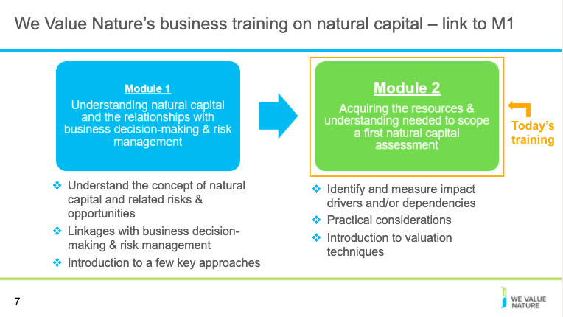

Presenter to elaborate on the content of Module 2 further, using the notes below:

- In M1, we were familiarized with the basic concepts of natural capital and how these can be applied to a business context. This helped us to understand why one would conduct a natural capital assessment.
- In M2, we will introduce measuring and assessing impacts and dependencies between ecosystems and services.
- This module is a primer to help delegates understand how impact/dependency assessment can aid business decision making
- More specifically, in M2, we will learn how to scope a first natural capital assessment:
- We will acquire the tools to determine the appropriate scope to meet our objective
- In doing this we will learn how to identify which impact drivers and dependencies are material
- We will also be introduced to practical considerations to take when pursuing a natural capital assessment, including the timeframe of the assessment, the budget and the human resources and data available

- In order to commence with M2, it is important to have a grasp of a of couple of key definitions from the M2 pre-reading, including natural capital and minimum ecosystem services

Slide 8
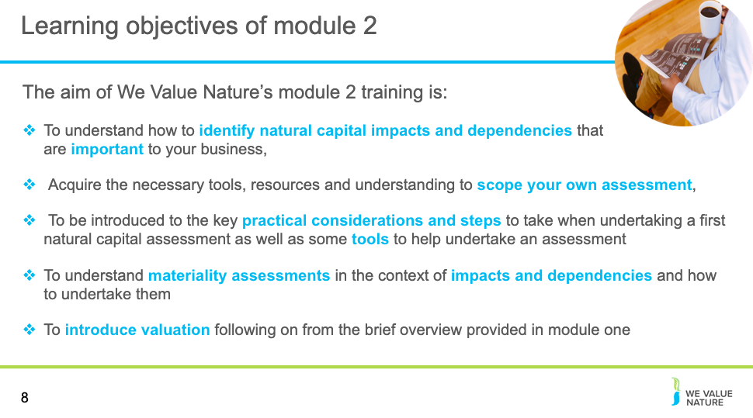

Presenter to explain the draft learning objectives of Module 2 from the slides.
- In M2, we will also:
- Develop an understanding of materiality assessments in the context of impacts and dependencies as well as how to undertake them
- Introduce valuation: how to define consequences, determine the relative significance of associated consequences and select the appropriate valuation technique for assessment
Through this, M2 hopes to build a standardized framework to identify, measure and value direct and indirect impacts and or dependencies on natural capital
Slide 9
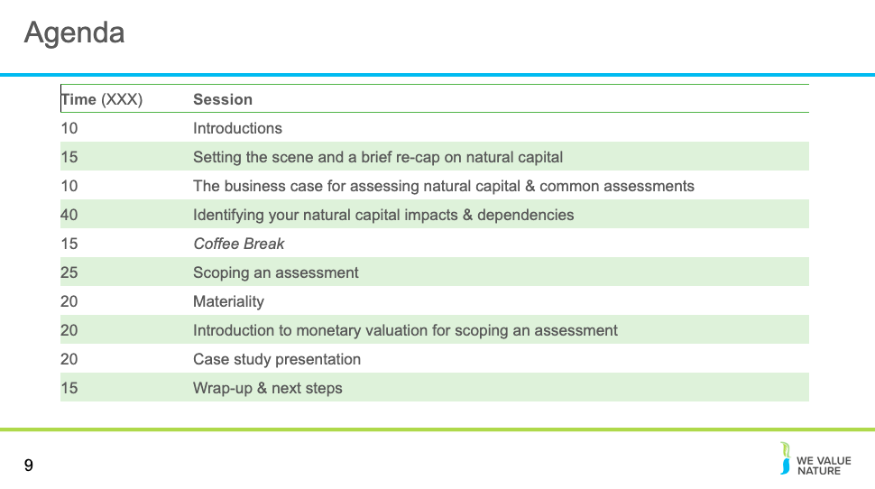

Presenter to run through the training program for the session.

NOTE: if the company examples are not used add more time to the valuation session (10 minutes)

Slide 10

Slide 11
NOTE: slide is optional – please adapt to your context
Introductions for those who are presenting the session (virtual or in person)

Slide 12
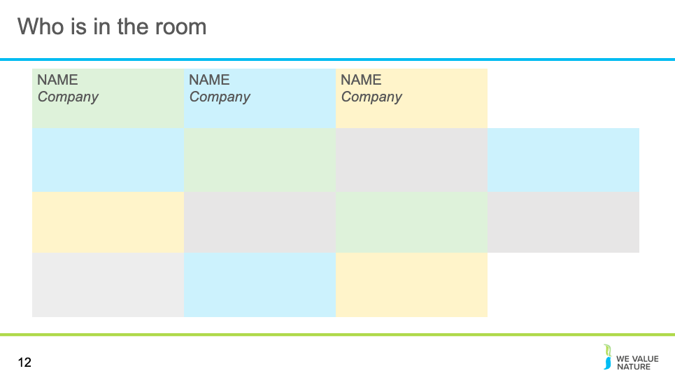
￼
NOTE: slide is optional – please adapt to your context
Either use this slide or slides 13 or 14 to introduce delegates – this is dependent on the number of participants in the training and whether it is virtual
For the virtual session, presenter should add all participants to the slide names and place of work
Slide 13
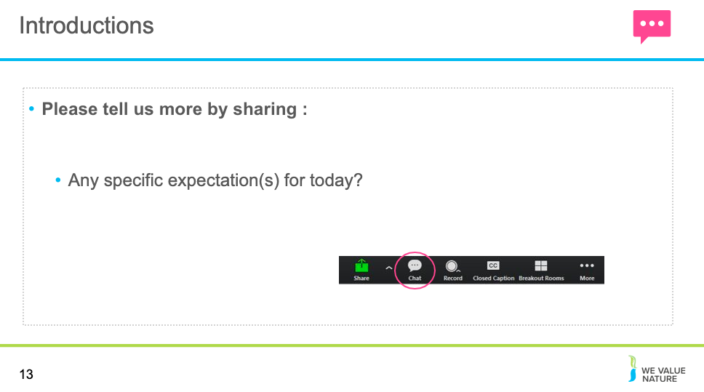￼
NOTE: slide is optional – please adapt to your context
Either use this slide or slide 12 or 14 to introduce delegates – this is dependent on the number of participants in the training and whether it is virtual
Presenter should ask the delegates if they have any specific expectations from the session or things that they would like to discuss. On the virtual session, the presenter can direct them towards the chat feature on Zoom to share these thoughts.

Slide 14
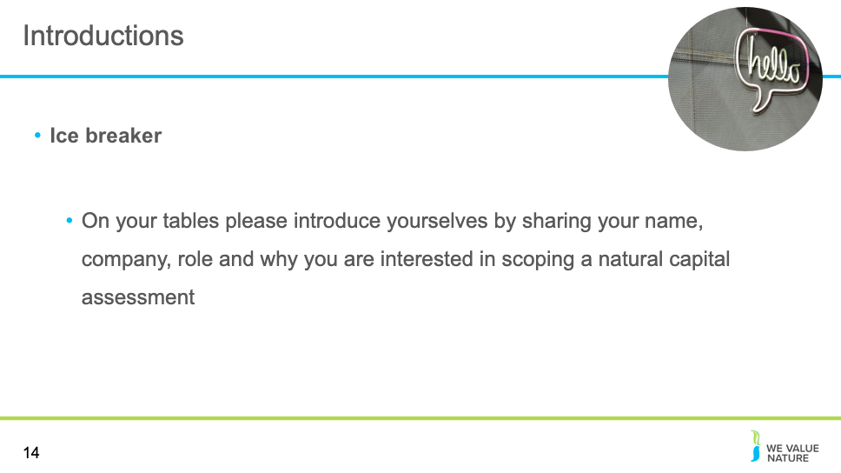￼
NOTE: slide is optional – please adapt to your context Either use this slide or slide 12 or 13 to introduce delegates – this is dependent on the number of participants in the training depends if this is virtual. Presenter should ask every person in the room take part in a quick ice breaker at their tables – name, company and role.

Setting the scene and a brief re-cap on natural capital
Slide 15
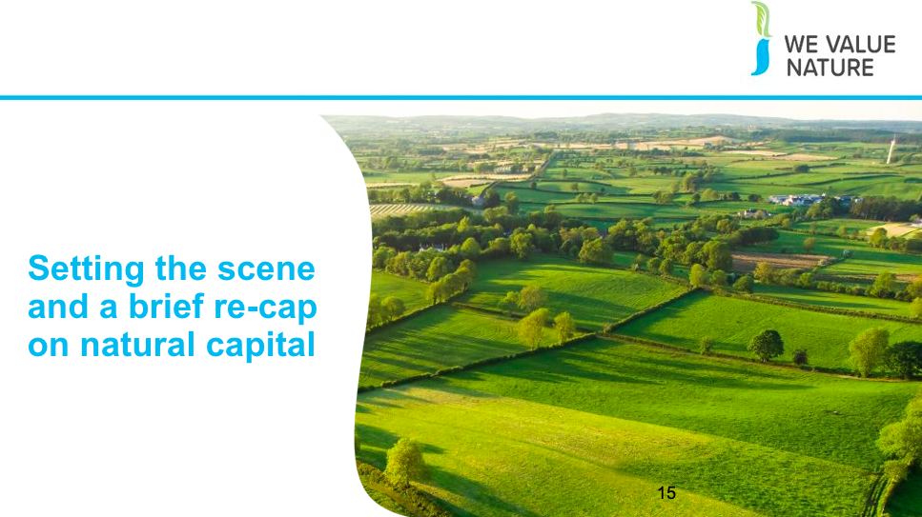
Presenter to introduce the section on ‘setting the scene and a brief re-cap on natural capital’
Slide 16
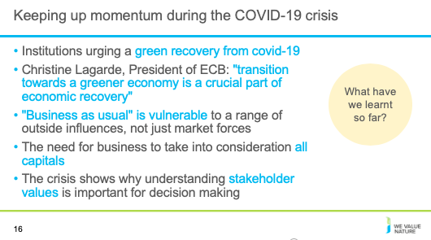
Presenter to give a re-cap on natural capital in relation to the current context on covid-19, using the notes below – this slide should be adapted to the specific country in which training is being given and as the global context changes.
- Number of organisations have considered the impact and how to ensure sustainability remains on the agenda
- The crisis may help senior managers to realize that "business as usual" is vulnerable to a range of outside influences, not just market forces.
- The crisis has highlighted more than ever, the need for business to take into consideration all capitals
- The crisis has also further emphasized the need for business to shift from shareholder value to stakeholder focused business models – Stakeholder Capitalism
- The crisis shows why understanding stakeholder values into account for decision making is important i.e. understanding the wider implications of decisions

Presenter to give an example of institutions action on the environment currently the slide is focused on responses to COVID 19 and those urging a green recovery from the crisis, this will need to be updated by presenters as the context changes. An example of this is Christine Lagarde's introductory statement at the Hearing at the Committee on Economic and Monetary Affairs of the European Parliament:
- Christine Lagarde is pushing to include climate change considerations in a review the central bank is due to hold into the way it conducts monetary policy:
- "The transition towards a greener economy is a crucial part of economic recovery. We have the opportunity to step up the EU’s efforts to achieve its sustainability objectives by including climate change and sustainability considerations in the financial response to the COVID-19 pandemic:
  - Sustainable finance will be key to the transition to a carbon neutral economy. Today, we published our reply to the Commission’s public consultation and reaffirmed our readiness, in line with our mandate, to support the efforts of governments, public institutions and the private sector
  - Moreover, our forthcoming report on the international role of the euro finds that the euro was the main currency of denomination for the issuance of green bonds in 2019"
- This move comes alongside moves by the European Parliament to declare a climate emergency and moves from the European Commission, to promise an imminent "green new deal" in their strategy
Potential VO outputs from these moves:
- Forces people to think differently and be more creative (boost innovation, not just resilience).
- Switching to digital meetings has opened up possibilities for (more) colleagues joining in without cost-increases otherwise related to travelling.
- More motivated than ever before to energise the inclusion of the nature agenda in restarting.
- Take the crisis as an opportunity to communicate on the links health/biodiversity
- The crisis may get senior managers realize that "business as usual" is vulnerable to a range of outside influences, not just market forces.
- The crisis has opened up access to technology and free training materials (new opportunities).
Sources: https://www.ecb.europa.eu/press/key/date/2020/html/ecb.sp200608~4225ba8a1b.en.html

Slide 17
[INSERT SLIDE ON VIDEO/ FURTHER EXAMPLES/CASE STUDIES]

Slide 18

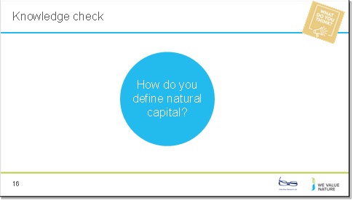
NOTE: knowledge check exercise is optional
Presenter to read the question out on the slide.
Once the poll is complete, presenter should use the notes below to explain that there are different definitions. Go through what has been shared by participants.
Virtual session- https://zoom.us/
Add question & answers to a live poll in zoom as per instructions
To enable Polling: Sign into the Zoom web portal. In the navigation menu, click Account Management then Account Settings (if you are an account administrator) or Settings (if you are an account member). Navigate to the Polling option on the Meeting tab and verify that the setting is enabled. If the setting is disabled, click the toggle to enable it. If a verification dialog displays, choose Turn On to verify the change. Note: If the option is greyed out, it has been locked at either the Group or Account level, and you will need to contact your Zoom administrator.
Creating a poll: Go to the Meetings page and click on your scheduled meeting. If you do not have a scheduled meeting, schedule a meeting now. From the meeting management page, scroll to the bottom to find the Poll option. Click Add to begin creating the poll. Enter a title and your first question. (Optional) Check the box to make the poll anonymous, which will keep the participant's polling information anonymous in the meeting and in the reports. Select whether you want the question to be single choice (participants can only choose one answer) or multiple-choice question (participants can choose multiple answers). Type in the answers to your question and click Save at the bottom. If you would like to add a new question, click Add a Question to create a new question for that particular poll.
You can launch a poll by clicking on the live polling icon in the meeting controls and selecting the poll you want to launch. The participants in the meeting will now be prompted to answer the polling questions. The host will be able to see the results live. Once you would like to stop the poll, click End Poll. If you would like to share the results to the participants in the meeting, click Share Results. The results can be downloaded once the meeting has ended.
In person session – https://www.mentimeter.com/
Mentimeter is an interactive presentation software. The host can create a presentation once signing up to Mentimenter. Questions and activities can be added to each slide of the presentation. Participants can answer the questions and interact with the presentation by typing a 6-digit code found at the top of the presentation into Menti.com. The host can either create a new share on Zoom to display the Mentimeter slides or download the Mentimeter plug-in for PowerPoint.
To run this question, select the Multiple-Choice question type when creating your presentation, and fill in the question and answers as directed.
Slide 19
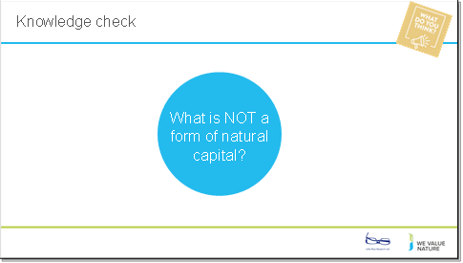
NOTE: knowledge check exercise is optional. Presenter to read the question out on the slide. Once poll is complete, presenter should use the notes below to explain that there are different answers:
- Plants
- Air
- Water
- Soil
- People
Virtual session- https://zoom.us/
Add question & answers to a live poll in zoom as per instructions. To run this question, select the Multiple-Choice question type when creating your presentation, and fill in the question and answers as directed.
Slide 20
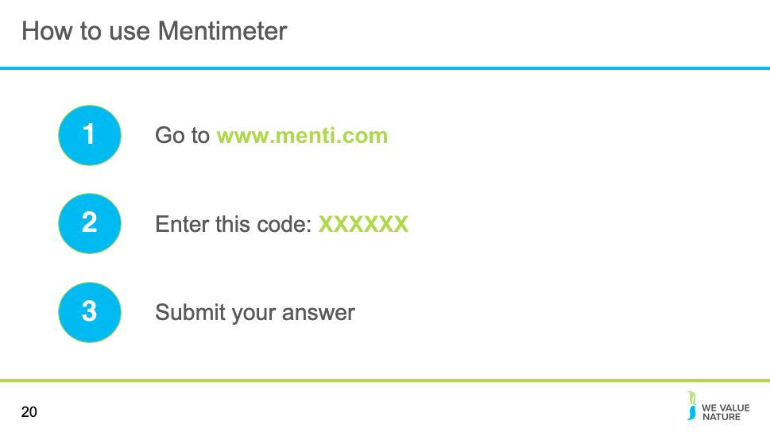
To use Menti meter please go to www.menti on your computer; check slide 18 for instructions

Slide 21
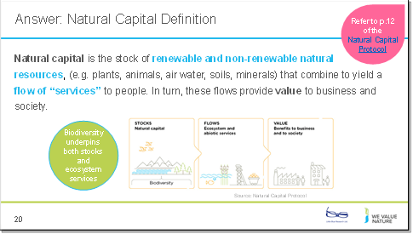
Presenter to use the notes below to introduce the slide on natural capital:
We have started thinking about natural resources an agricultural producer relies and impacts on but what do we mean when we talk about natural capital?
Well in fact, everything you have discussed through the previous example is natural capital is some form or another. Whether it is the assets/resources it represents (such as water and soil you have identified as needed for the farm) or the services it brings (e.g. pollination, etc.).
From climate adaptation to ecosystem services, the environmental jargon is everywhere. What is important, is not to remember all the terminology used, but rather that these are all connected to the value of nature and that people have different entry points and priorities and will use one or another terminology based on that. But fundamentally, we are all speaking about the same things, just in different ways.
This is the definition according to the Natural Capital Protocol.
Presenter to read out the definition of natural capital on the slide, referring to pg. 12 of the Natural Capital Protocol. Presenter to then explain natural capital stocks using the notes below:
The stocks refer to the natural resources available to us while the flows refer to the different benefits people receive from ecosystems such as:
timber, fiber, pollination, water regulation, climate regulation, recreation, etc.
Abiotic services are benefits to people that do not depend on ecological processes but arise from fundamental geological processes e.g. – supply of minerals, metals and oil and gas, as well as geothermal heat, wind, tides, etc.
Presenter to address biodiversity; what CAN and CANNOT be covered in the training session, referring to pg. 14/15 of the Natural Capital Protocol
- In this training, we will demonstrate ways in which biodiversity underpins stocks and ecosystem services
- In the Protocol, biodiversity (part of stocks) is considered critical to the health and the stability of natural capital in so much that it provides resilience to shocks like floods and droughts…
- As well as supporting fundamental processes such as carbon and water cycles and soil formation
- Since biodiversity underpins stocks and ecosystem services, business impacts and dependencies on biodiversity are often hard to measure, remaining hidden in many cases. To truly measure and value business impacts on biodiversity, you need to understand the causal relationships between your business activities, the changes in biodiversity and the associated changes in ecosystem services.
- Whilst we will explain how natural capital impacts and dependencies can be identified during this training, it will not be possible to unpack all of the complexities of measuring and valuing specific changes in biodiversity.
- There are different for valuing biodiversity for example using total economic value techniques in which is the value that people place on the continued existence of species or ecosystems, regardless of whether they ever encounter the species or ecosystem is sought. Others try to attach intrinsic value to biodiversity which is linked to concepts like “duty of care” and “stewardship of nature”, these are beyond the current scope of the training.
NOTE: a further definition on the natural capital approach is included below. Presenter has the option to use this depending on the audience and context of the training.
Source: https://www.iisd.org/pdf/2008/natural_capital_approach.pdf
- The Natural Capital Approach (NCA) is a means for identifying and quantifying natural resources and associated ecosystem goods and services that can help integrate ecosystem-oriented management with economic decision-making and development (this includes abiotic services as well as ecosystem services). By integrating economic and environmental imperatives, NCA operationalizes the ecosystem approach and facilitates policymaking for sustainable development

Slide 22
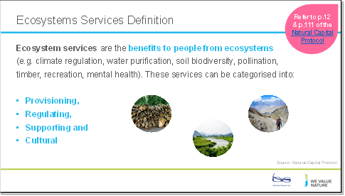

Presenter to explain ecosystem services using the notes below and referring to pg. 12 and 111 of the Natural Capital Protocol:
- Ecosystems services are the benefits to people from ecosystems, where an ecosystem is defined as the interaction between complex plants, animals and microorganisms and their non-living environment
- Examples of ecosystem services include timber, fiber, pollination, water regulation, climate regulation, recreation, fostering wellbeing and others
- Ecosystem services can be classified into provisioning, regulating, cultural and supporting services
- Provisioning: material outputs from nature (e.g. fiber, timber, etc.)
- Regulating: indirect benefits from nature generated through regulation of ecosystem processes (e.g. mitigation of climate change through carbon sequestration)
- Cultural: non-material benefits from nature (e.g. recreational, spiritual, aesthetic). It is much harder to measure these kinds of services in quantifiable terms so often have to use qualitative approaches
- Supporting: fundamental ecosystem processes that support the delivery of other ecosystem services (e.g. nutrient cycling)
There are many classification schemes for ecosystem services including the CICES and the FEGS-CS which measure ecosystem outputs that are directly consumed or used by beneficiaries:
The Common International Classification of Ecosystem Services aims to classify the contributions that ecosystems make to human well-being that arise from living processes – the classification has been broadened in this tool to cover abiotic outputs (https://cices.eu/)
The Final Ecosystem Goods and Services Classification System provides a foundation for measuring, quantifying, mapping, modelling and valuing ecosystem services. The FEGS-CS can serve as the basis for valuation (https://www.epa.gov/eco-research/final-ecosystem-goods-and-services-classification-system-fegs-cs)

Slide 23
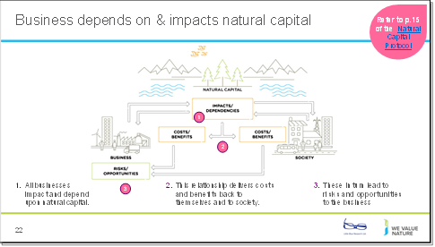

Presenter to talk about the relationship between businesses and natural capital, using the notes below and the diagram above:
1. All businesses impact and depend upon natural capital.
2. This relationship delivers costs and benefits back to themselves and to society.
3. These in turn lead to risks and risks and opportunities to the business
What the examples show (from the previous slide) is that natural, social and economic issues are fundamentally interconnected and cannot be separated from one another. It also illustrates how natural capital underpins all the other capitals and without it we would not have social and human or financial capital.

Slide 24
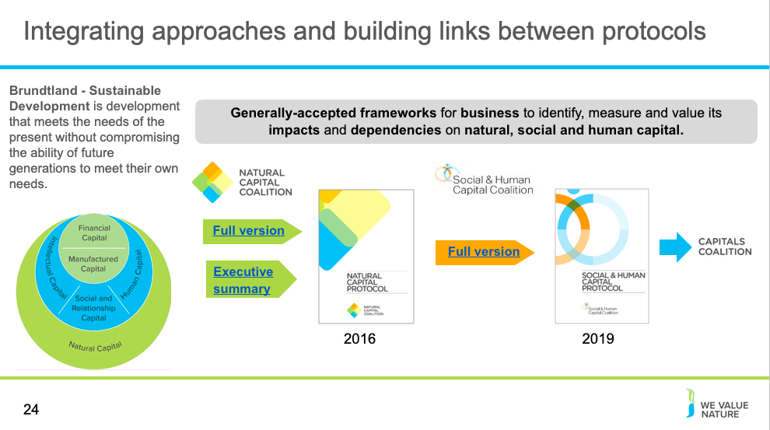
Presenter to first introduce the Brundtland Sustainable Development definition, using the notes on the slide and the notes below:
It contains within it two key concepts: the concept of 'needs', in particular the essential needs of the world's poor, to which overriding priority should be given; and the idea of limitations imposed by the state of technology and social organization on the environment's ability to meet present and future needs – WCED, 1987. Adapted from BET module 1 (WBCSD, 2012)
Presenter to then provide an explanation of the development of different protocols:
- NC – The Natural Capital Protocol is a decision-making framework that enables organizations to identify, measure and value their direct and indirect impacts and dependencies on natural capital. It was developed in 2016 by the Natural Capital Coalition (now the Capitals Coalition). Three sector guides (Apparel; Food and Beverage; Forest Products) and a Finance sector supplement have since been released to accompany the Protocol.
- SC – The Social and Human Capital Protocol is a decision-making framework that enables organizations to identify, measure and value their direct and indirect impacts and dependencies on social and human capital. The Protocol is the result of four years of collaborative development – involving input from over 50 businesses and a public consultation. The Protocol was released in 2019 by the Social & Human Capital Coalition (now the Capitals Coalition).
- The Capitals Coalition unites the Natural Capital Coalition and the Social & Human Capital Coalition to accelerate momentum, leverage success, connect powerful and engaged communities, and identify the areas, projects and partnerships where we can collectively deliver benefits for nature, people and the economy. The Coalition is a collaboration of over 370 of the world’s leading organizations from business, accountancy, science and academia, membership organizations, standard setting, finance, policy and civil society, who have united in a pre-competitive space because they believe that the Coalition is a vehicle that can drive the global conversation and deliver desperately needed systemic change by bringing nature and people into the heart of decision making.
Link to The Capitals Coalition website: https://capitalscoalition.org/

Slide 25
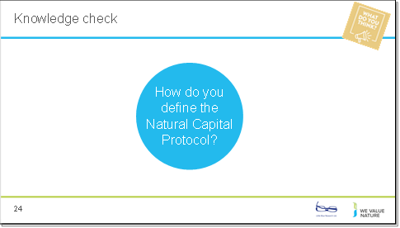
Presenter to read the question out on the slide. This can either be completed by participants using free text or using the list below as options for answers.
Answer options for a multiple-choice poll (presenter can update these as needed)
- Framework to help generate trusted, credible and actionable information that business managers need to inform decisions
- Includes how we interact with natural capital in decision asking
- Offers standardization and clarity to identify, measure and value impacts and dependencies on natural capital
- Builds on a number of approaches that already exist including the Corporate Ecosystem Services Review and the Guide to Corporate Ecosystem Valuation
- Does not list specific tools or methodologies because the choice of tools is dependent largely on business context, resources and needs
- A standardized framework to identify, measure and value direct and indirect impacts and/or dependencies on natural capital.

The answer in the Protocol is: “A standardized framework to identify, measure and value direct and indirect impacts and/or dependencies on natural capital”
Virtual session- https://zoom.us/
Add question & answers to a live poll in zoom as per instructions
To enable Polling: Sign in to the Zoom web portal. In the navigation menu, click Account Management then Account Settings (if you are an account administrator) or Settings (if you are an account member). Navigate to the Polling option on the Meeting tab and verify that the setting is enabled. If the setting is disabled, click the toggle to enable it. If a verification dialog displays, choose Turn On to verify the change. Note: If the option is greyed out, it has been locked at either the Group or Account level, and you will need to contact your Zoom administrator.
Creating a poll: Go to the Meetings page and click on your scheduled meeting. If you do not have a scheduled meeting, schedule a meeting now. From the meeting management page, scroll to the bottom to find the Poll option. Click Add to begin creating the poll. Enter a title and your first question. (Optional) Check the box to make the poll anonymous, which will keep the participant's polling information anonymous in the meeting and in the reports. Select whether you want the question to be single choice (participants can only choose one answer) or multiple choice question(participants can choose multiple answers). Type in the answers to your question and click Save at the bottom. If you would like to add a new question, click Add a Question to create a new question for that particular poll.
You can launch a poll by clicking on the live polling icon in the meeting controls and selecting the poll you want to launch. The participants in the meeting will now be prompted to answer the polling questions. The host will be able to see the results live. Once you would like to stop the poll, click End Poll. If you would like to share the results to the participants in the meeting, click Share Results. The results can be downloaded once the meeting has ended.
In person session – https://www.mentimeter.com/
Mentimeter is an interactive presentation software. The host can create a presentation once signing up to Mentimenter. Questions and activities can be added to each slide of the presentation. Participants can answer the questions and interact with the presentation by typing a 6-digit code found at the top of the presentation into Menti.com. The host can either create a new share on Zoom to display the Mentimeter slides or download the Mentimeter plug-in for PowerPoint.

To run this question, select the Multiple-Choice question type when creating your presentation, and fill in the question and answers as directed.

Slide 26
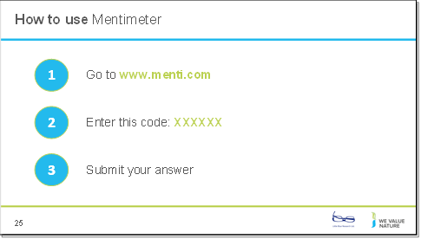
To use Menti meter please go to www.menti on your computer; check slide 25 for instructions
Slide 27
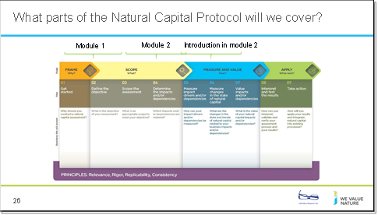
Presenter to explain the parts of the Natural Capital Protocol that will be covered in this training, using the notes below:
- Scope the assessment - What is an appropriate scope to meet your objective?
- Determine the impacts and/or dependencies - Which impacts and/or dependencies are material?
- Measure impact drivers and/or dependencies - How can your impact drivers and/or dependencies be measured?
Module 2 also introduces:
- Measuring changes in the state of natural capital – i.e. what are the changes in the state and trends of natural capital related to your business impacts and/or dependencies?
- Valuing impacts and/or dependencies – i.e. what is the value of your natural capital impacts and/or dependencies? By introducing valuation techniques to aid scoping an assessment

Disclaimer: The information contained in this report is based on a review of Natural Capital training material in May 2020. The information contained herein is of a general nature and is not intended to address the circumstances of any particular individual or entity. Although we endeavour to provide accurate and timely information, there can be no guarantee that such information is accurate as of the date it is received or that it will continue to be accurate in the future. No one should act on such information without appropriate professional advice after a thorough examination of the particular situation.
The We Value Nature Network hereby expressly disclaim all warranties of originality, accuracy, completeness, merchantability or fitness for a particular purpose with respect to any of this information and in no event shall the parties have any liability for any damages of any kind.
The citing of trade names, reports, websites does not constitute endorsement. The We Value Nature Network and Little Blue Research Ltd. do not accept any liability for damage arising from the use of these speakers notes and make no representation regarding the advisability or suitability of this to specific business or training needs.

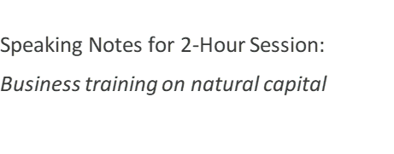

(Slides 28-56)
  - The business case for assessing natural capital & common assessments
  - Identifying your natural capital impacts & dependencies

The business case for assessing natural capital & common assessments

Slide 28
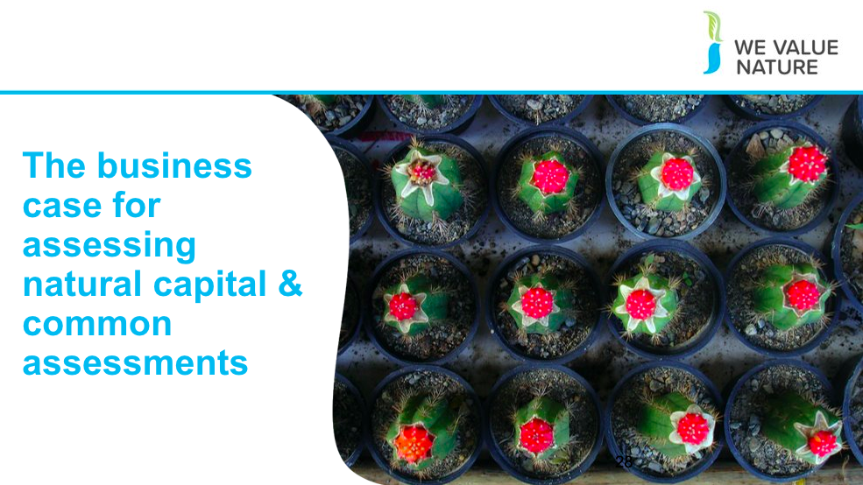
Presenter to introduce the section on ‘common assessments and first steps’

Slide 29
Presenter to talk through risks and opportunities for businesses and why it’s important to assess impacts and dependencies in the context of risks and opportunities. Presenter to highlight that we will be going into more detail in the following slides as to what some examples of impacts and dependencies are, but before, it is important to highlight typical risks and opportunities that businesses face:

Source: WVN Module 1 training (2019)
Operational risk – Vale damn collapse
Reputation risk – increased public & consumer awareness of environmental and social damages + consumers are increasingly demanding assurance that the products they buy are produced in way that protect our environment and respect human rights – link with SOCIETAL risks – health impacts on local communities, social license to operate
Legal risk – giant Texas oil company, Anadarko Petroleum, has agreed to pay $5.1 billion for a vast environmental clean-up - aimed at restoring thousands of sites polluted by toxins and compensating thousands of people with personal injury claims. https://www.nytimes.com/2014/04/04/business/energy-environment/anadarko-petroleum-to-pay-5-1-billion-to-settle-pollution-case.html
Financial risk – Underlying all of these risks & opportunities are financial ones! As we have seen, these risks imply important financial costs. Canadian gold mining company, Infinito Gold, lost over 50% of its share value as a result of the withdrawal of a mining concession in Costa Rica due to concerns about the potential impacts on agriculture, endangered species and forests. This led to a reference in the audit accounts to material uncertainties regarding the company’s ability to continue as a going concern
Source: KPMG, Flora and Fauna International, Acca, Is natural capital a material issue (2012) Biodiversity loss risk: Biodiversity loss comes at the nexus of many other business risks. E.g. through decreasing food security (which itself has economic ramifications) or increasing the likelihood of coastal flooding. Biodiversity loss can be felt through physical risks (increased cost of resources, disruption of operations due to natural disasters unmitigated by appropriate ecosystems), associated regulatory and legal risk, market risk from changing consumer preference as consumers become more aware & discerning RE biodiversity, and supply chain risks. Examples: “Deforestation in the Agno River basin in the Philippines has led to such extensive river and reservoir siltation that the 100-megawatt Binga hydroelectric facility can only operate intermittently”, Studies have shown that the total economic impact of Hurricane Katrina (approximately US$150 billion), was significantly higher than would have been the case if coastal wetlands in the region had been preserved, In 2008, the Norwegian Pension Fund withdrew its £500 million stake in the mining giant Rio Tinto and excluded the company from its funds. The decision to withdraw was based on the activities of Rio Tinto’s mining operations in Indonesia.

https://www.pwc.co.uk/assets/pdf/wef-biodiversity-and-business-risk.pdf

But the good news is that, where there is risk, there is opportunity to:
- Secure natural resources
- Save costs
- Manage future risks
- Engage stakeholders

Operational opportunity – EDF rainwater harvesting to manage water scarcity risks leading to reduction in water consumption, economical & energy savings https://www.wbcsd.org/Programs/Food-Land-Water/Water/Circular-water-management/Resources/Case-studies/Rainwater-harvesting-for-water-reduction
Reputation opportunity – IKEA to use only renewable and recycled materials by 2030 https://www.reuters.com/article/us-ikea-sustainability/ikea-to-use-only-renewable-and-recycled-materials-by-2030-idUSKCN1J31CD
Legal opportunity – Union Carbide Corporation, subsidiary of The Dow Chemical Company: Seadrift, TX Wetlands for Wastewater Treatment Project description: 110-acre engineered wetland in lieu of an industrial wastewater treatment plant In 1995, the Seadrift water treatment facility was seeking a solution to consistently meet regulatory requirements for water discharge. An innovative GI solution consisting of a constructed wetland was installed and has been successfully operating upon startup and for the last 15 years. https://www.naturalinfrastructureforbusiness.org/wp-content/uploads/2015/11/DowUCC_NI4BizCaseStudy_ConstructedWetlands.pdf
Financial opportunity – But when these risks are taken into account, we saw how it can also lead to reduced financial costs or improve access to finance. Companies like those you can see here have managed to secure substantial billion-dollar loan facilities where the interest rate of repayments is linked to ESG performance. That is to say if the company has string environmental and social performance they pay back less on the loan.

Image sources, clockwise from top left
Risks:
EPA via the BBC (https://www.bbc.com/news/business-47432134)
Li-An Lim on Unsplash
Bill Oxford on Unsplash
Markus Spiske on Unsplash
Opportunities:
EDP; Ikea; Union Carbide Corporation
Source: WVN training module 1

Slide 30

Optional exercise depending on time: presenter to read the question out on the slide, using the notes below to clarify:

Soil regulation
- Soil regulation is considered as an ecosystem characteristic or process for regulating soil quality and health rather than soil creation in this example
- More details regarding the ecosystem service functions relating to soil are given in different ecosystem service classification systems including:
- The Common International Classification of Ecosystem Services (CICES): https://cices.eu/
- The National Ecosystem Services Classifications System (NESCS): https://www.epa.gov/sites/production/files/2015-12/documents/110915_nescs_final_report_-_compliant_1.pdf

Pollination
- Wild animal pollination (for farmers, gardeners, foresters)
- Pollination could be interpreted as rented pollinators or wind
Water extraction
- Freshwater (for utilities, farmers)
- Water extraction can be easily mixed up with the labour and capital (pipes, pumps) needed for extraction rather that the freshwater getting to the user

Once reflection is complete and feedback has been received (either virtually or in person; see below), presenter should use the notes below to explain that there are different answers:

- Generally, it is difficult to tell whether natural capital will pose more of a risk or an opportunity without knowing the specific context
- Different forms of natural capital can pose more of a risk or more of an opportunity depending on the timescale, the sector of the company, who is impacted, the size of the population, the significance of different values, how big the change is from the baseline, the type of ecosystem service or stock in question etc.

Virtual
Presenter should ask each delegate to share their thoughts in the chat

In person
Each table will be asked to reflect on these points as a group and feedback

Slide 31
Presenter to provide the business case for assessing natural capital, using the notes below and the information on the slide:

There are evidently a lot of pertinent risks around nature and the environment facing businesses today. Where does natural capital come into this - how can it help you manage these risks?

- To assess natural capital is to assess your company’s impacts and dependencies on nature.
- It provides information that will help you to understand your relationship with nature. By focusing on impacts and dependencies, natural capital provides structure to this understanding.
- Once you have a better understanding of your relationship with nature, you can use this to challenge your business model, mitigate risks and create opportunities. Natural capital can also be a valuable tool for broadening the conversation to include all parts of your business, including the finance team.

Slide 32

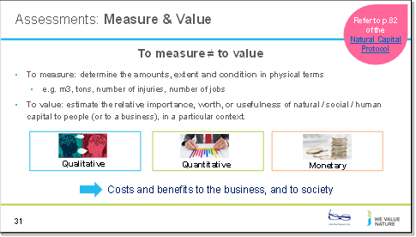
Presenter to explain the difference between measuring and valuing, using the notes below:
There are different ways of valuing – could be qualitative, quantitative and monetary
Important to note that monetary values without any context (i.e. accompanying quantification) are less meaningful!
The method you chose depends on which natural capital impact drivers or dependencies you wish to assess, the chosen value perspective (e.g. business, societal, or both), the ultimate objective of your assessment, and the time and resources available
Monetary valuation: some find it difficult to accept or interpret monetary valuation of certain benefits (e.g. spiritual values). In such situations, special efforts may be required to explain the advantages and also to acknowledge the limitations of monetary valuation.
Advocates of natural capital are sometimes accused of ‘putting a price on nature’ or ‘pricing the priceless’, but the core assertion of this approach is that prices have failed to reflect the ‘true value’ of the natural world, and that the economic systems are broken.
In this training the common definitions of price and value are used, i.e. where price is ‘the quantity of one thing that is exchanged or demanded in barter or sale for another/the amount of money given or set as consideration for the sale of a specified thing’ and value as ‘the regard that something is held to deserve; the importance, worth, or usefulness of something e.g. “your support is of great value”. If something is not for sale, we do not describe it as having a ‘price’, but we may nevertheless recognize the value that it holds and make decisions on this basis.

Slide 33
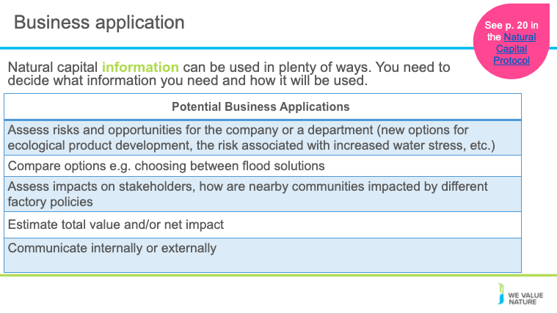
Presenter to explain business applications of natural capital assessments, using the notes below:
A natural capital assessment provides information. Whilst this can be valuable in its own right, there are also numerous ways to use this information.
The NCP focuses on using natural capital assessment for decision-making, measurement and valuation, but it can also be used for disclosure and communication, or to help formulate strategy.
The best way for your company to use natural capital information is highly individual – think back to the challenges and risks you identified earlier in the training and consider how more information could help you meet these challenges.

Presenter to highlight some examples of business applications, e.g.
- Assessing risks and opportunities: e.g. assess risks and opportunities of capital expenditure when deciding which flood solution to choose
- Assessing impacts on stakeholders: e.g. assess how a company's dependency on a local water supply affects local communities
- Estimating the total value and/or net impact of the company: e.g. estimating the total impact of a manufacturing company across the entire value chain (upstream, direct operations, downstream)

Slide 34
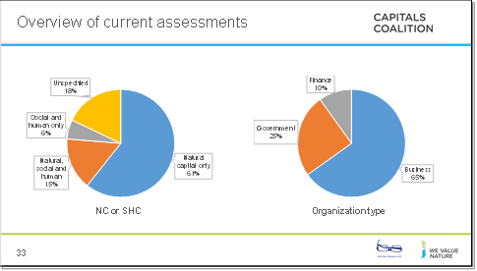
Data from the Capitals Coalition Case Study Database.
Presenter to give an overview of the pie charts presented on the slide. Presenter to explain that the majority of assessments carried out include only natural capital, and that very few assessments measure social and human capital as yet without also measuring natural capital. Presenter to explain that the majority of companies carrying out assessments are businesses, with governments carrying out ¼ of all assessments and finance carrying out the least.

Slide 35
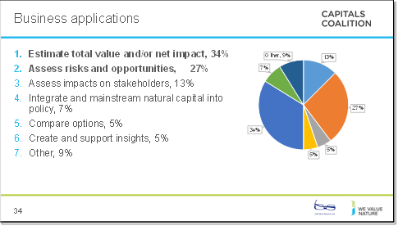
Data from the Capitals Coalition Case Study Database.
Presenter to give an overview of the pie chart presented on the slide. Presenter to explain that the main purpose for carrying out assessments are to estimate total value/or net impact of/on natural, or social and human, capital. The next greatest application is to assess risks and opportunities for the companies carrying out the assessment, and the third biggest reason is to assess company impacts on stakeholders.

Slide 36
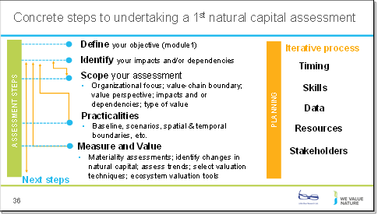
Presenter to explain the steps to undertaking a 1st natural capital assessment using the diagram on the slide. Presenter to explain that defining the objective can be quite difficult but this is a necessary step to have completed before beginning to scope an assessment

Slide 37
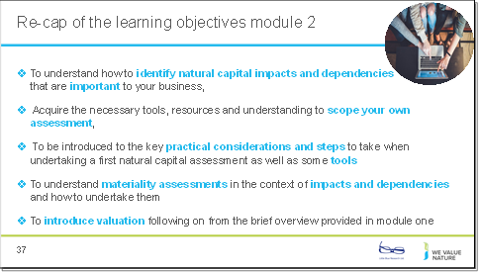
Presenter to quickly re-cap the learning objectives of this training session, referring to the points on the slide

Identifying your natural capital impacts & dependencies
Slide 38
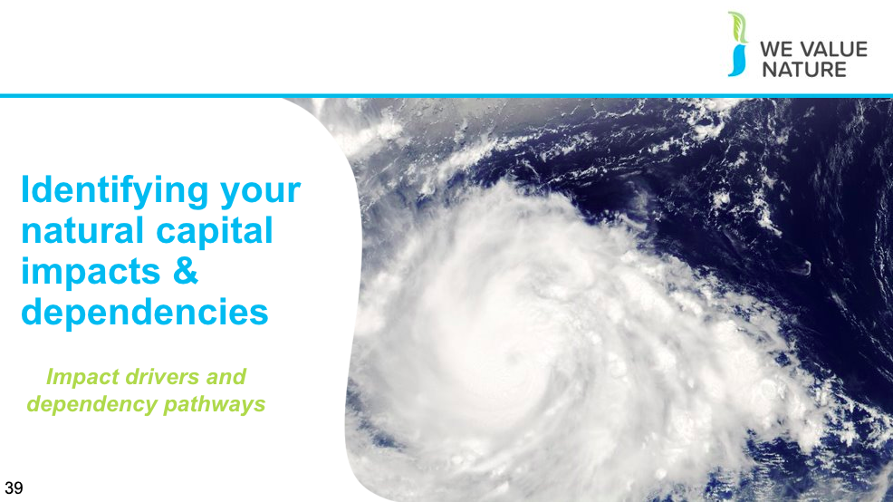
Presenter to introduce the section on understanding business activities and the impact/dependencies that they have on different stakeholders/areas of natural capital

Slide 39
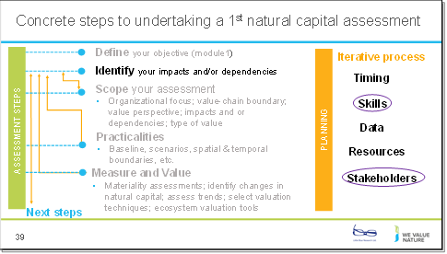
Presenter to provide initial view of impacts and dependencies. This can be set out in more detail during the project and a materiality assessment can be undertaken
Slide 40
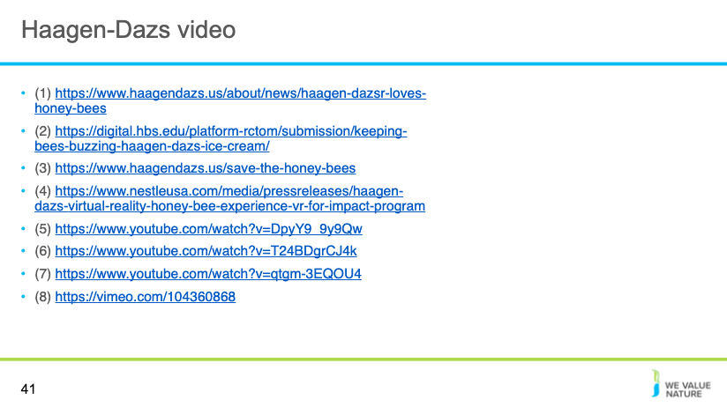

Slide 41

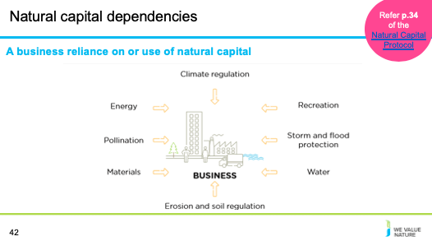

Presenter to provide detail on natural capital dependencies using the notes below and referring to p. 34 of the Natural Capital Protocol:
The protocol defines natural capital dependency as: A business reliance on or use of natural capital. This can occur in your direct operations or somewhere else in your value chain.
Presenter to link natural capital dependencies with the risks and opportunities material covered in M1, using the notes below. Presenter to elaborate on the business impact diagram, using some examples:
- Thinking back to some of the content in M1, we can see how natural capital dependencies can pose different risks and opportunities for businesses. This is useful in establishing the value of natural capital dependencies in relation to other inputs and services that you rely on.
- Energy e.g. energy as a critical production input in a factory
- A reliance on energy may pose financial risks due to volatilities in the energy market which could impose higher costs on the business
- This could also open up financial opportunities if “green funds” become available for more renewable energy sources
- Pollination e.g. regulating service critical in agriculture
- This may pose an operational risk for agricultural sectors if pollination services start to vary
- Materials e.g. reliance on wood
- This may pose a societal risk if local communities start to experience reduced access to woodland or related ecosystem services as a result of business activities
- This may pose a societal opportunity if local communities start to benefit from forestry management
- Erosion and soil regulation e.g. essential for hydropower operations and beverage companies
- This may post legal and regulatory risk if businesses are faced with fines, penalties, compensation or legal cost from regulation efforts
- Water e.g. reliance on water to make cement
- This may pose reputational and marketing risk if loyalty of key suppliers of business service provides in the water industry falls
- Storm and flood protection e.g. local flood barriers
- Reliance on flood barriers could pose increasing risk as climate change makes flooding more likely in certain regions
- Investing in natural flood measures could provide wider benefits to local communities and thus benefit the business through reputation
- Recreation e.g. for tourist attraction
- If businesses rely on recreation such as tourist attractions to raise employee morale, they may be at risk of attracting and attaining their employees due to the volatility of the tourism industry – this could lead to higher recruitment and retention costs
- Climate regulation e.g. natural filtration of water
- This may provide an operational opportunity if businesses invest in green infrastructure like water filtration services, thus reducing overall costs

Slide 42

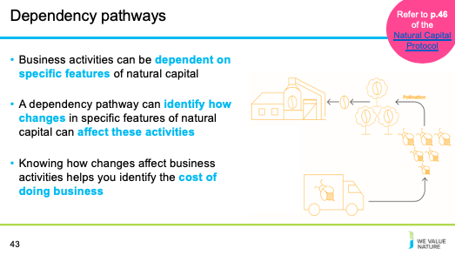
Presenter to link this to the dependency video (if used)
Presenter to explain dependency pathways, using the notes on the slide. Presenter to then walk through the coffee production/pollination example using the notes below and referring to p. 46 of the Natural Capital Protocol:
- Business activities at a coffee production plant have a dependency on the pollination of coffee plants.
- Changes in natural capital cause the bee population to decline due to:
- The business itself, e.g. overuse of pesticides
- Natural changes e.g. extreme weather events
- Human-induced changes, including due to the activity of other businesses, e.g. habitat change
- Changes in natural capital affect business dependency, so pollination services are important
Presenter to walk through the t-shirt manufacture example below, using the notes below and referring to p. 24 of the Natural Capital Protocol:
- At the agricultural level, water is needed to irrigate cotton plants, creating a dependency on water.
- Changes in the natural capital, in this case water availability, can change due to both external factors (e.g. climate change, other agriculture dependent on the same water source, other upstream water usage) and internal factors (e.g. over-abstraction of water for irrigation, water extraction to clean machinery).
- Because of these changes in natural capital, the company has to chose whether to accept a decreased cotton yield, adapt to a more resilient form of agriculture, or pay more for an alternative water supply.
Presenter to link this content to risk, reading an example from module 1:
- Reputation risk – increased public & consumer awareness of environmental and social damages + consumers are increasingly demanding assurance that the products they buy are produced in way that protect our environment (link to pollution)
- Legal risk – giant Texas oil company, Anadarko Petroleum, has agreed to pay $5.1 billion for a vast environmental clean-up - aimed at restoring thousands of sites polluted by toxins and compensating thousands of people with personal injury claims.(link to pollution) https://www.nytimes.com/2014/04/04/business/energy-environment/anadarko-petroleum-to-pay-5-1-billion-to-settle-pollution-case.html
- Financial risk – Underlying all of these risks & opportunities are financial ones! As we have seen, these risks imply important financial costs. Canadian gold mining company, Infinito Gold, lost over 50% of its share value as a result of the withdrawal of a mining concession in Costa Rica due to concerns about the potential impacts on agriculture, endangered species and forests. This led to a reference in the audit accounts to material uncertainties regarding the company’s ability to continue as a going concern (Link to land management and pollution). Source: KPMG, Flora and Fauna International, Acca, Is natural capital a material issue? (2012)
- Biodiversity loss risk: Biodiversity loss comes at the nexus of many other business risks. E.g. through decreasing food security (which itself has economic ramifications), or increasing the likelihood of coastal flooding. Biodiversity loss can be felt through physical risks (increased cost of resources, disruption of operations due to natural disasters unmitigated by appropriate ecosystems), associated regulatory and legal risk, market risk from changing consumer preference as consumers become more aware & discerning RE biodiversity, and supply chain risks. Examples: “Deforestation in the Agno River basin in the Philippines has led to such extensive river and reservoir siltation that the 100-megawatt Binga hydroelectric facility can only operate intermittently”, Studies have shown that the total economic impact of Hurricane Katrina (approximately US$150 billion), was significantly higher than would have been the case if coastal wetlands in the region had been preserved, In 2008, the Norwegian Pension Fund withdrew its £500 million stake in the mining giant Rio Tinto and excluded the company from its funds. The decision to withdraw was based on the activities of Rio Tinto’s mining operations in Indonesia. https://www.pwc.co.uk/assets/pdf/wef-biodiversity-and-business-risk.pdf
But good news is that, where there is risk, there is opportunity to:
- Secure natural resources
- Save costs
- Manage future risks
- Engage stakeholders

Presenter to link this content to opportunities, using an example from module 1 and the risk and opportunities slide in earlier sessions:
- Operational opportunity – EDF rainwater harvesting to manage water scarcity risks leading to reduction in water consumption, economical & energy savings https://www.wbcsd.org/Programs/Food-Land-Water/Water/Circular-water-management/Resources/Case-studies/Rainwater-harvesting-for-water-reduction
- Reputation opportunity – IKEA to use only renewable and recycled materials by 2030 https://www.reuters.com/article/us-ikea-sustainability/ikea-to-use-only-renewable-and-recycled-materials-by-2030-idUSKCN1J31CD
- Legal opportunity – Union Carbide Corporation, subsidiary of The Dow Chemical Company: Seadrift, TX Wetlands for Wastewater Treatment Project description: 110-acre engineered wetland in lieu of an industrial wastewater treatment plant In 1995, the Seadrift water treatment facility was seeking a solution to consistently meet regulatory requirements for water discharge. An innovative GI solution consisting of a constructed wetland was installed and has been successfully operating upon startup and for the last 15 years.https://www.naturalinfrastructureforbusiness.org/wp-content/uploads/2015/11/DowUCC_NI4BizCaseStudy_ConstructedWetlands.pdf
- Financial opportunity – But when these risks are taken into account, we saw how it can also lead to reduced financial costs or improve access to finance. Companies like those you can see here have managed to secure substantial billion-dollar loan facilities where the interest rate of repayments is linked to ESG performance.

Slide 43
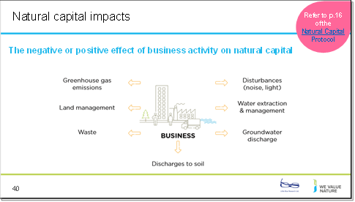
Presenter to provide detail on natural capital impacts using the notes below and referring to p. 16 of the Natural Capital Protocol:
The Protocol defines a natural capital impact as: The negative or positive effect of business activity on natural capital. They can arise directly from business operations or indirectly from the use of products and services. As a result of your impact on natural capital you can generate impacts on your business as well as impacts on society.
Presenter to link natural capital impacts with the risks and opportunities material covered in M1, using the notes below. Presenter to elaborate on the business impact diagram, using some examples:
- Thinking back to some of the content in M1, we can see how natural capital impacts can pose different risks and opportunities for businesses.
- GHG emissions e.g. transportation
- This may pose societal risks for businesses due to the health risks arising from the effect of air pollution on respiratory disease
- On the other hand, this could pose a reputational and marketing opportunity due to new revenue streams offered in areas like carbon offsetting
- Land management e.g. forest management
- This may pose an operational risk by increasing natural hazard costs through degradation of natural ecosystems
- This may also pose an operational opportunity if businesses invest in sustainable and green land management, hence reducing costs by protecting against natural hazards
- Waste e.g. post-consumer waste
- This may pose legal and regulatory risks if new laws or license fees are established, charging more for waste disposal
- This may also pose an operational opportunity for businesses if they minimise or add value to waste and recapture valuable materials otherwise discarded
- Discharges to soil e.g. fertilizers
- This may pose a financial risk if the business’ sales fall due to negative publicity about the business’ impacts on natural capital
- Groundwater discharge e.g. wastewater
- This may pose operational risks if social conflict over polluted water adds to security costs
- This may also pose societal opportunities if businesses use managed water catchments to improve water quality for local communities
- Water extraction and management e.g. factory equipment cleaning
- This may pose a financial opportunity if businesses alter the way in which they go about water extraction, thus attaining” green funds” or investor interest in sustainability
- Disturbances e.g. heavy machinery operation
- This may pose societal issues again as wider society is impacted negatively from heightened noise and light
Sources: NCP (2016, and WVN module 1 training)

Slide 44
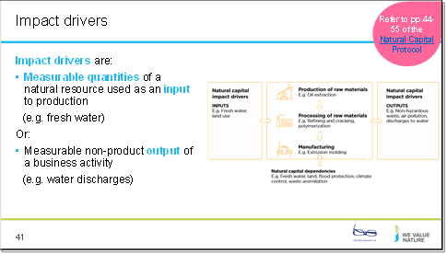

Presenter to walk through the slide, explaining the general steps of an impact pathway, using the notes below and referring to p. 44-55 of the Natural Capital Protocol:
- Business activities produce an impact driver (e.g. non-GHG air pollution)
- Impact drivers lead to changes in natural capital (e.g. reduced air quality)
- Changes in natural capital result in impacts (e.g. health problems)

Presenter to list some example impact drivers for either plastic cup manufacture or cotton t-shirt manufacture, using the notes below:
(1) Plastic cup manufacture example impact drivers:
Inputs: freshwater consumption
Outputs: emissions from GHGs and other air pollutants (in oil extraction and processing); water pollutants; plastic waste
(2) T-shirt manufacture example impact drivers (based on p. 26 of the Natural Capital Protocol)
Inputs: water use; terrestrial ecosystem use; freshwater ecosystem use
Outputs: GHG emissions; non-GHG air pollutants; water pollutants; soil pollutants

Slide 45
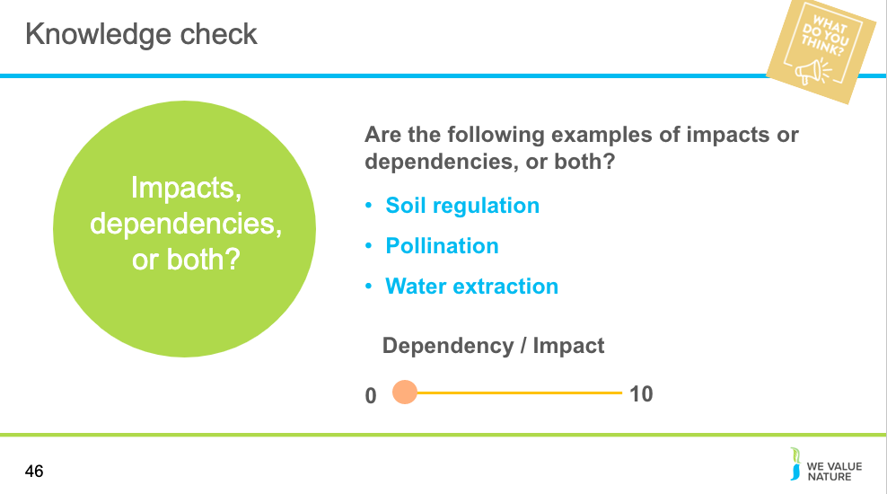
NOTE: knowledge check is optional depending on the time.
Presenter to read the question out on the slide. Once poll is complete, presenter should use the notes below to explain that there are different answers:
- Impacts and dependencies are inter-related. Your assessment may cover your impacts, dependencies or both. This, in part, depends on business application and your objective. A complete assessment considers both impacts and dependencies to gain a full understanding of your company’s risk and opportunity related to natural capital.

- Soil regulation – fundamental ecological process related to maintaining soil health (e.g. nutrient cycling, soil formation)
- Businesses can be dependent on soil regulation. For example, in the agricultural industry, businesses may be dependent on nutrient cycling in the soil to grow crops.
- At the same time, heavy use of soil by a business can degrade the quality of the soil. For example, if an agricultural company uses chemical fertilisers or pesticides on the soil which harm soil quality
- Pollination –
- Businesses can be dependent on pollination. For example, in the agricultural industry, crop yields are dependent on pollination as a regulating service
- At the same time, businesses can impact pollinating services. Bee populations which carry out pollination may decline with land-use changes, habitat loss, climate change and increased use of pesticides on nearby farms.
- Water extraction –
- Businesses can be dependent on water resources as critical production inputs in their business
- At the same time, water use by a company will often mean less water or lower quality water available for other stakeholders
- This shows how dependencies on natural capital can result in natural capital impacts – they are interrelated

To enable Polling: Sign into the Zoom web portal. In the navigation menu, click Account Management then Account Settings (if you are an account administrator) or Settings (if you are an account member). Navigate to the Polling option on the Meeting tab and verify that the setting is enabled. If the setting is disabled, click the toggle to enable it. If a verification dialog displays, choose Turn On to verify the change. Note: If the option is greyed out, it has been locked at either the Group or Account level, and you will need to contact your Zoom administrator.
Creating a poll: Go to the Meetings page and click on your scheduled meeting. If you do not have a scheduled meeting, schedule a meeting now. From the meeting management page, scroll to the bottom to find the Poll option. Click Add to begin creating the poll. Enter a title and your first question. (Optional) Check the box to make the poll anonymous, which will keep the participant's polling information anonymous in the meeting and in the reports. Select whether you want the question to be single choice (participants can only choose one answer) or multiple-choice question (participants can choose multiple answers). Type in the answers to your question and click Save at the bottom. If you would like to add a new question, click Add a Question to create a new question for that particular poll.
You can launch a poll by clicking on the live polling icon in the meeting controls and selecting the poll you want to launch. The participants in the meeting will now be prompted to answer the polling questions. The host will be able to see the results live. Once you would like to stop the poll, click End Poll. If you would like to share the results to the participants in the meeting, click Share Results. The results can be downloaded once the meeting has ended.
In person session – https://www.mentimeter.com/
Mentimeter is an interactive presentation software. The host can create a presentation once signing up to Mentimenter. Questions and activities can be added to each slide of the presentation. Participants can answer the questions and interact with the presentation by typing a 6-digit code found at the top of the presentation into Menti.com. The host can either create a new share on Zoom to display the Mentimeter slides or download the Mentimeter plug-in for PowerPoint.

Slide 46
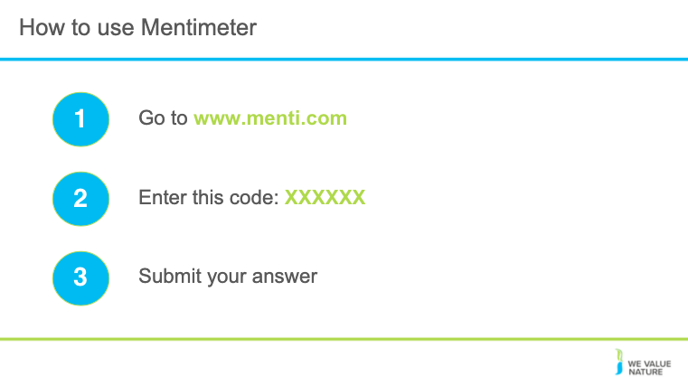

To use Menti meter please go to www.menti on your computer

Slide 47
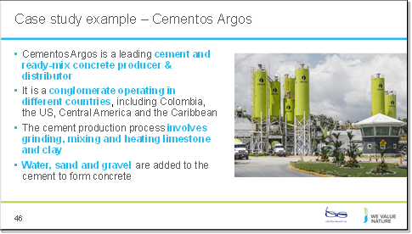
Presenter to flag that this is a cut down exercise from a very advanced assessment. Presenter to explain the case study using the notes on the slide and referring to some of the added context below and using the next slide:
- Grupo Argos (the conglomerate that owns Cementos Argos) is a leading cement and ready-mix concrete producer and distributor, operating in Colombia, the US, Central America and the Caribbean
- Argos wanted to develop a way to assess integrated performance management across the group, in order to help make better informed decisions, enable more accurate risk management, and promote transparency and engagement with investors & shareholders.
- Argos chose to use a Value-added statement (VAS) approach, considering environmental, social and human factors, while still considering financial accounts.
- The company carried-out a year-long benchmarking of methodologies and experiences after reading other companies’ assessments.
- To determine which issues were material, a large internal scoping exercise was carried out by experts across the company.
- Cementos Argos built their VAS using KPMG’s True Value methodology.
- The methodology place monetary values on social, economic and environmental impacts (externalities).
Presenter to explain that the monetary evaluation carried out by the company was a very advanced one (in terms of approach and time taken)

See for more detail:
https://wevaluenature.eu/sites/default/files/2020-03/Grupo_Argos_natural_capital_story_0.pdf
https://mnisaccp01.blob.core.windows.net/sostenibilidad/Doc/2018/eng/Integrated-report-2018.pdf
https://home.kpmg/content/dam/kpmg/ae/pdf/introduction-kpmg-truevalue.pdf

Slide 48
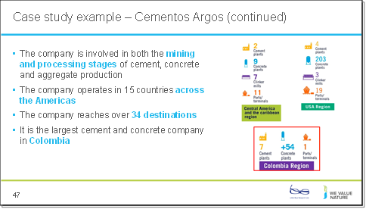

Presenter to carry on with explaining the case study context using the notes on the previous slide
Presenter to explain that the monetary evaluation carried out by the company was a very advanced one (in terms of approach and time taken)
See for more detail:
https://wevaluenature.eu/sites/default/files/2020-03/Grupo_Argos_natural_capital_story_0.pdf
https://mnisaccp01.blob.core.windows.net/sostenibilidad/Doc/2018/eng/Integrated-report-2018.pdf
https://home.kpmg/content/dam/kpmg/ae/pdf/introduction-kpmg-truevalue.pdf

Slide 49
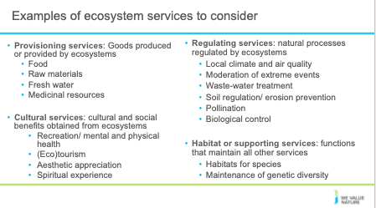
Presenter to list out the ecosystem services that could be considered when identifying the impacts and dependencies in the case of Cementos Argos. Highlight that this is not an exhaustive list and that these services have been sub-grouped (a more detailed list is featured below).
This set of ecosystems services will help frame the exercise and help demonstrate why the cut down list in slide 49 has been chosen:

- Provisioning services: Goods produced or provided by ecosystems
  - Food
  - Crops
  - Livestock
  - Capture fisheries
  - Aquaculture
  - Wild foods
  - Fiber
  - Timber
  - Cotton, hemp, silk
  - Biomass fuel
  - Freshwater,
  - Genetic resources, ornamental
  - Biochemicals, natural medicines & pharmaceuticals

- Regulating services: natural processes regulated by ecosystems
  - Air quality regulation
  - Climate regulation
  - Global (CO2 sequestration)
  - Regional and local
  - Water purification and waste treatment
  - Water flow regulation
  - Natural hazard regulation
  - Erosion regulation
  - Disease regulation
  - Pest regulation
  - Pollination

- Cultural services: cultural and social benefits obtained from ecosystems
  - Recreation
  - Ecotourism
  - Spiritual and religious values
  - Educational
  - Ethical and “existence” values

- Habitat or supporting services: functions that maintain all other services
  - Nutrient cycling
  - Primary production
  - Photosynthesis
  - Water cycling

Source: http://www.teebweb.org/resources/ecosystem-services/

Slide 50

Presenter to read the points on the slide, explaining how the breakout rooms will work, for the virtual session.
Presenter to clarify that in this example they are looking for negative impacts
If time is short the exercise can be limited to either impacts or dependencies rather than both
Note: Limit this exercise to considering the company’s Colombian operations. However, any option can be chosen by the presenter and the relevant results updated to accommodate this change. Additional information relating to the local country context may also be provided by the presenter as needed.

Slide 51
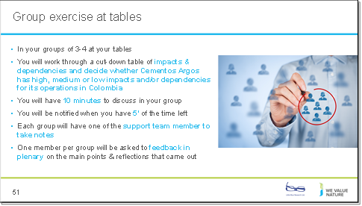
Presenter to read the points on the slide for the in-person session
Note: Limit this exercise to considering the company’s Colombian operations. However, any option can be chosen by the presenter and the relevant results updated to accommodate this change. Additional information relating to the local country context may also be provided by the presenter as needed.
Presenter to clarify that in this example they are looking for negative impacts

Slide 52
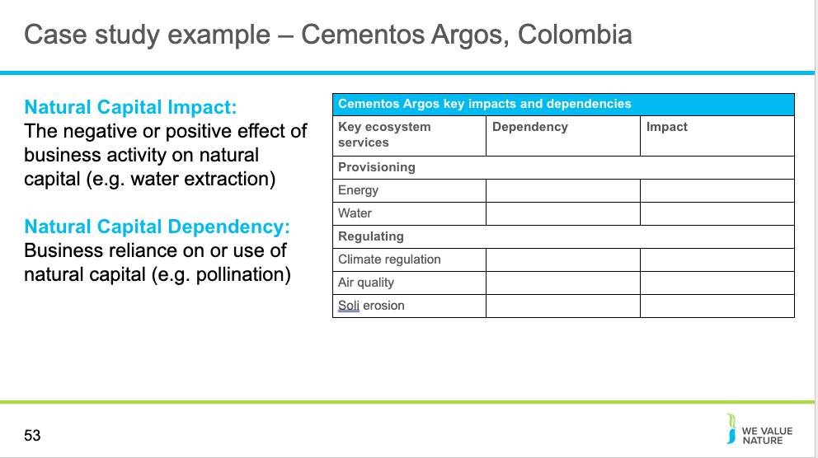
Presenter to give an introduction to the Cementos Argos’ materiality assessment, using the notes below:
Cementos Argos have based all subsequent materiality analyses on the outputs of the 2017 analysis. The 2017 materiality analysis took into account:
- Strategic priorities of the Board of Directors
- The opinions of stakeholders
- Trends, news and dynamics in the sector
- Principles established in the Sustainability Strategy
- Risks
- Opportunities
- Commitments to national and international initiatives
- Internal and external consultation
The company then created a materiality matrix, comparing issues by the relevance for the business and relevance for stakeholders.

Presenter to ask participants to discuss in breakout sessions/at their tables, how relevant each of the indicators are as impacts and dependencies. Presenter to explain that the list of impacts and dependencies on the slide are not exhaustive but rather a list of example impact and dependencies that has been cut down from those ecosystem services described in earlier slides. Presenter to read out the definitions of impact and dependencies:
- Natural capital impacts are defined as the negative or positive effect of business activity on natural capital. For example, businesses may extract a lot of water, depleting natural reserves
- Natural capital dependencies are defined as a business reliance on or use of natural capital. For example, businesses may be dependent on pollination as a regulating service in agriculture

Sources:
https://wevaluenature.eu/sites/default/files/2020-03/Grupo_Argos_natural_capital_story_0.pdf
https://mnisaccp01.blob.core.windows.net/sostenibilidad/Doc/2018/eng/Integrated-report-2018.pdf

Slide 53
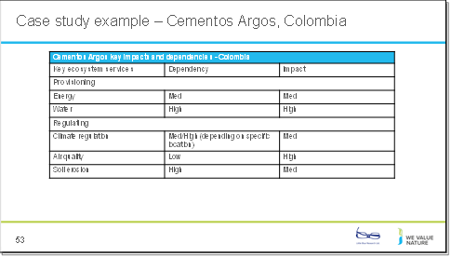
Presenter to walk through the key impacts and dependencies identified by the presenter for Cementos Argos in Colombia, using the table on the slide as well as the notes below, note the results of this slide can be updated to fit different contexts, the following points are taken from Cenentos Argos company literature and help show why various ecosystem service impacts and dependencies were ranked in a particular way. Please note the authors of the training do not have access to complete information for the company and these points represent some initial thoughts based on publicly available documentation:

- Energy- the company used 45.7 million GJ/year of energy in 2018 (dependency). The company is also dependent on fuel for machinery and transportation.
- In Colombia, various measures have been taken to ensure a relatively low impact on energy. In 2019, the company completed its Thermally Activated Clays project at its 1.4Mt/yr at one of its plants in Colombia. This allows for the production and distribution of “green cement”. CO2 emissions have decreased by 38%
- Dependency on energy in Colombia is also lower than other factories – only uses about 30% of the energy consumption of ordinary Portland cement production. Cementos Argos offer low energy intensity solutions, allowing customers to reduce their environmental impact. (p80-81 of the 2018 Integrated Report). For example, Argos have started using an alternative fuels management system. This helped them to triple their capacity to co-process materials in the Colombia Region. In 2018, the company used more than 75000 t of waste (e.g. used tyres) as alternative fuel, equivalent to the waste generated by a city of 200,000 inhabitants. With this system in place in Colombia, the company has increased co-processing capacity by 200%.

- Water- the company used 6.8 million m³/year of water in 2018 (dependency and impact)
- Cementos Argos relies on water as a key production input in making cement etc. and thus dependency is high
- There is a lack of clean and available water supplies in Colombia. Cementos Argos’ high uptake of water thus means that their impact is fairly high

- Geology- 154.1 million t/year of material is used by the company (dependency and impact of mining). The company mines: Clay, Iron, Sand, Limestone, Gypsum, other high-silica minerals.

- Climate regulation- impact of GHGs from high temperature processing
- Colombia has a lot of mountainous regions that are quite unstable and prone to landslides, flooding and tremors. Due to this, dependency on climate regulation can be quite high in certain parts of Colombia, depending on the specific location
- Cementos Argos has made a lot of environmentally friendly steps to put less pressure on climate regulation:
- In 2018, progress was made in the capture of CO₂ with microalgae at the Cartagena Plant. This project was developed together with the Chilean company Clean Energy, the Universidad de Antioquia, Universidad Eafit and the support of RutaN.
- In 2019, the company completed its Thermally Activated Clays project at its 1.4Mt/year at one of its plants in Colombia. This allows for the production and distribution of “green cement”. CO₂ emissions have decreased by 38% and it only uses 30% of the energy consumption of ordinary Portland cement production.

- Air quality- impact of NO_{x} and SO_{x}, PM and Mercury generated in the kilns of cement plants
- Cementos Argos have prepared some plans for the prevention and control of dispersed emissions for the concrete plants of the Colombia Region although air pollution levels are still fairly high. Factories are also positioned fairly close to urban areas so impact is generally quite high (e.g. Cartagena factory)

- Soil erosion - dependency for mining. The company is very reliant on mass stabilization for its mining operations. The company mines: Clay, Iron, Sand, Limestone, Gypsum, other high-silica minerals.
- According to a World Bank analysis of disaster risk management in Colombia,7 86 percent of the country’s population is exposed to medium and high seismic hazards, 31 percent to medium and high landslide hazards, and 28 percent to potential severe flooding. Thus, dependency on mass stabilisation is quite high.

Sources:
https://wevaluenature.eu/sites/default/files/2020-03/Grupo_Argos_natural_capital_story_0.pdf
https://mnisaccp01.blob.core.windows.net/sostenibilidad/Doc/2018/eng/Integrated-report-2018.pdf
https://www.aggbusiness.com/ab9/news/cementos-argos-starts-green-cement-production-line-Colombia;
https://www.globalcement.com/news/item/10501-cementos-argos-enjoys-sales-and-ebitda-boom-in-2019
https://www.worldcement.com/the-americas/10052019/cementos-argos-increases-waste-co-processing-capacity-in-colombia/
https://mnisaccp01.blob.core.windows.net/sostenibilidad/Doc/2018/eng/Other%20emissions%20.pdf)
https://www.wateraid.org/us/where-we-work/Colombia
https://www.gfdrr.org/en/Colombia

Slide 54
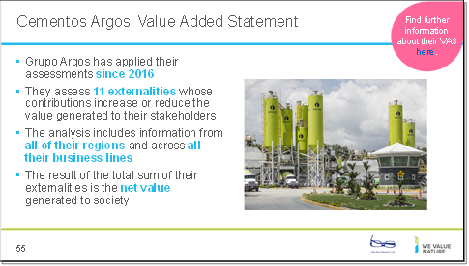
Presenter to flag that an advanced level of assessment was conducted by the company.
Presenter to talk through what initial reviews of impacts and dependencies led to at Cementos Agros.
Presenter to explain the value-added statement using the notes on the slide and referring to some of the added context below:
- Grupo Argos (the conglomerate that owns Cementos Argos) wanted to develop a way to assess integrated performance management across the group, in order to help make better informed decisions, enable more accurate risk management, and promote transparency and engagement with investors & shareholders.
- Argos chose to use a Value-added statement (VAS) approach, considering environmental, social and human factors, while still considering financial accounts.
- The company carried-out a year-long benchmarking of methodologies and experiences after reading other companies’ assessments.
- To determine which issues were material, a large internal scoping exercise was carried out by experts across the company.
- Cementos Argos built their VAS using KPMG’s True Value methodology.

See for more detail:
https://wevaluenature.eu/sites/default/files/2020-03/Grupo_Argos_natural_capital_story_0.pdf
https://mnisaccp01.blob.core.windows.net/sostenibilidad/Doc/2018/eng/Integrated-report-2018.pdf
https://home.kpmg/content/dam/kpmg/ae/pdf/introduction-kpmg-truevalue.pdf

Slide 55
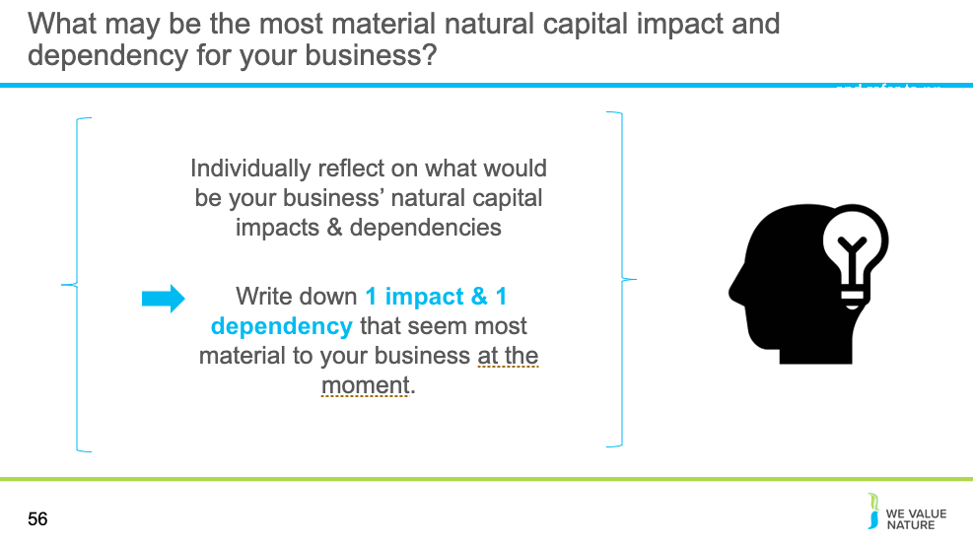
NOTE: reflection is optional
Presenter to read the question out on the slide

Virtual
Presenter should read through the slide, allow the participants some time for reflection and ask each delegate to share their thoughts in the chat
In person
Presenter should read through the slide, each table will be asked to reflect on these points as a group and feedback

Slide 56
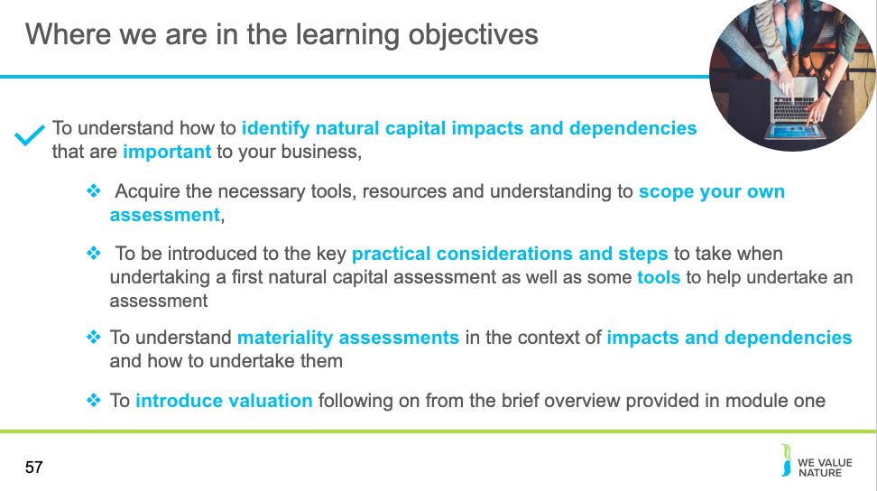
Presenter to highlight that learning objective 1 has now been covered and that the training will proceed to the next learning objective

Disclaimer: The information contained in this report is based on a review of Natural Capital training material in May 2020. The information contained herein is of a general nature and is not intended to address the circumstances of any particular individual or entity. Although we endeavour to provide accurate and timely information, there can be no guarantee that such information is accurate as of the date it is received or that it will continue to be accurate in the future. No one should act on such information without appropriate professional advice after a thorough examination of the particular situation.
The We Value Nature Network hereby expressly disclaim all warranties of originality, accuracy, completeness, merchantability or fitness for a particular purpose with respect to any of this information and in no event shall the parties have any liability for any damages of any kind.
The citing of trade names, reports, websites does not constitute endorsement. The We Value Nature Network and Little Blue Research Ltd. do not accept any liability for damage arising from the use of these speakers notes and make no representation regarding the advisability or suitability of this to specific business or training needs.

(Slides 57-90)
  - Scoping an assessment
  - Materiality

Scoping an assessment
Slide 57

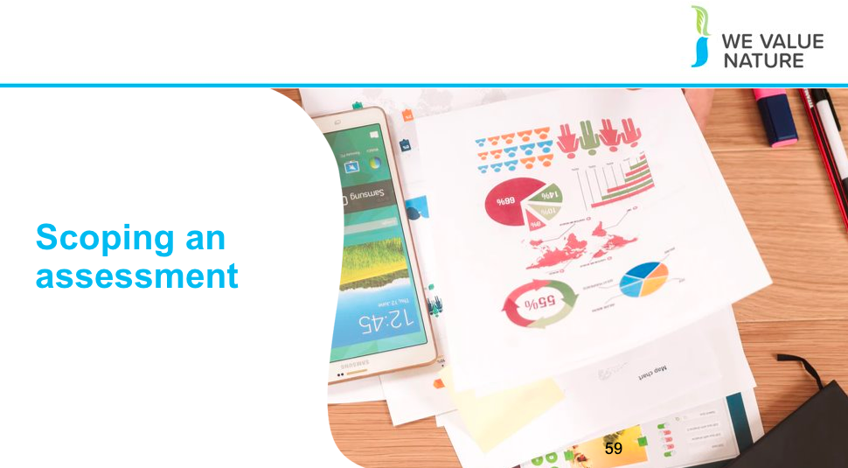

Presenter to introduce the section on ‘scoping an assessment’

Slide 58

Presenter to explain this session will concentrate on concrete steps to undertake a 1st natural capital assessment in relation to scoping and practicalities

Slide 59
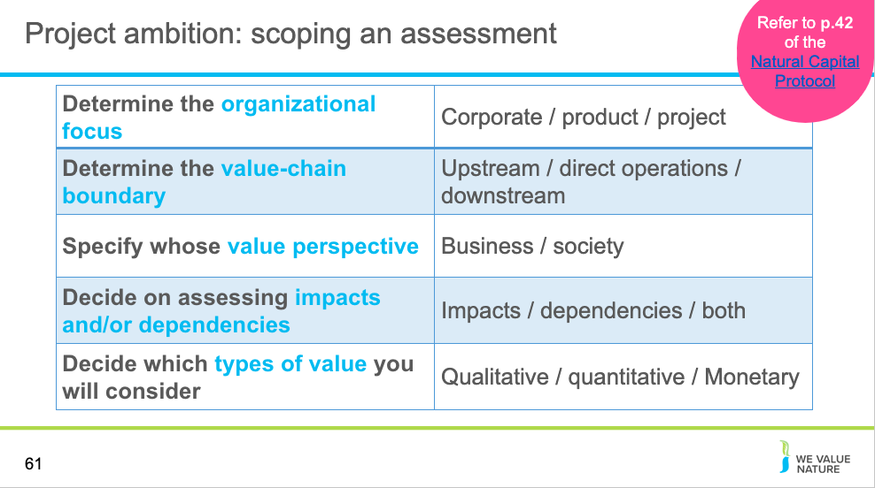

Presenter to walk through the steps to scope an assessment using the table on the slide, the notes below and referring to p.42 of the Natural Capital Protocol. Note: these points represent the ambition for the project and not all of the practicalities – these are covered in the next section in relation to scoping.

The organizational focus is where the assessment will focus, e.g. will the focus be on the corporate level (the whole company), product level (one product or a site), or project level?

Organizational focus: the part or parts of the business to be assessed (e.g., the company as a whole, a business unit, or a product, project, process, site, or incident). For simplicity, these are grouped under three general levels as below:
- Corporate: assessment of a corporation or group, including all subsidiaries, business units, divisions, different geographies or markets, etc.
- Project: assessment of a planned undertaking or initiative for a specific purpose, and including all related sites, activities, processes, and incidents.
- Product: assessment of particular goods and/or services, including the materials and services used in their production.

Presenter to explain that to determine the value-chain boundary, you need to decide where in the value chain the assessment will take place:

For example, a clothing company may decide that the assessment should take place across all upstream operations (e.g. cotton farming and clothes manufacture).

Value-chain boundary: The part or parts of the business value chain to be included in a natural capital assessment. For simplicity, the Protocol identifies three generic parts of the value chain: upstream, direct operations and downstream. An assessment of the full lifecycle of a product would encompass all three parts.
- Upstream (cradle-to-gate): covers the activities of suppliers, including purchased energy.
- Direct operations (gate-to-gate): covers activities over which the business has direct operational control, including majority owned subsidiaries.
- Downstream (gate-to-grave): covers activities linked to the purchase, use, re-use, recovery, recycling, and final disposal of the business’ products and services.

Presenter to explain that the value perspective identifies the potential values that the assessor wishes to be measured as part of the assessment i.e. the value to business, the value to society, or both:

Value perspectives: the perspective or point of view from which value is assessed; this determines which costs or benefits are included in an assessment.
- Business value: The costs and benefits to the business, also referred to as internal, private, financial, or shareholder value.
- Societal values: The costs and benefits to wider society, also referred to as external, public, or stakeholder value (or externalities).

The types of value to be considered include qualitative, quantitative and monetary (see slide in introduction section).

In addition to these considerations there are further questions that a potential assessor should ask including: the time and budget available, and the decision for which the assessment will help to inform – refer to the scoping section that comes next.
If there is time, the presenter can ask participants to complete a Mentimeter poll for one, or each of the scoping areas identified in terms of what would make sense for their own context. For example, what organization focus would be relevant for your company/own situation?. Use the Open-Ended question type, instructions for using Mentimeter are provided in slide 18.

Slide 60
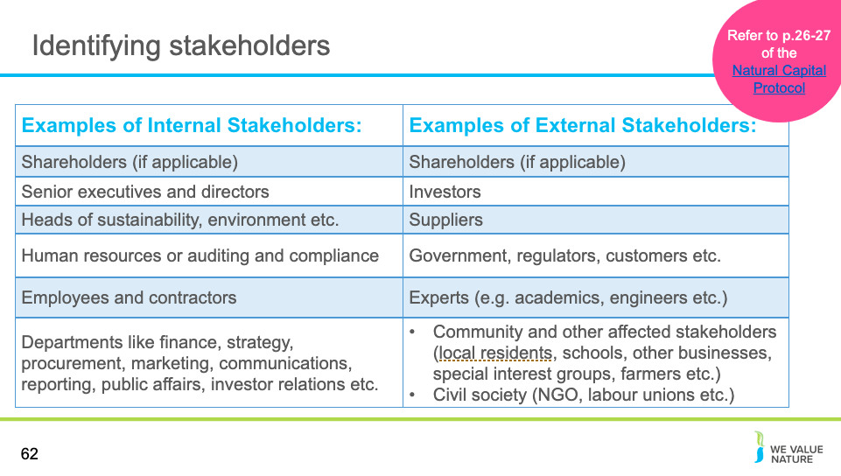
Referring to p. 26-27 of the Natural Capital Protocol, the presenter should explain steps to identify the stakeholder and explain why it is important to identify the stakeholder, using the notes below:
- A stakeholder is defined as any individual, organization, sector or community with an interest or stake in the outcome of a decision or process (see p. 124 of the Natural Capital Protocol)
- It is important to involve the right stakeholders to ensure that your assessment is reliable, relevant and useful in the long term – stakeholders may need to authorize or fund the assessment at the outset
- Often, stakeholders may be the same as the target audience – nonetheless, there are also other stakeholders who may be affected by the results, including people who can provide information, influence or help verify, validate and interpret the assessment
- Internal stakeholders are those directly and or financially involved in the operations – they may provide better insight
- External stakeholders are entities not within the business itself but who care about or are affected by its performance – they may provide greater robustness and credibility as well as necessary insight into the impact of your business on natural capital When mapping stakeholders, it is important to consider the relative importance of stakeholders and their relative influence as well as their legitimacy, willingness and ability to engage or primary/secondary status

Presenter should provide some examples of internal and external stakeholders using the table on the slide.

Sources:
https://courses.lumenlearning.com/boundless accounting/chapter/overview-of-key-elements-of-the-business/#:~:text=External%20stakeholders%20are%20entities%20not,regulators%2C%20investors%2C%20suppliers

Slide 61
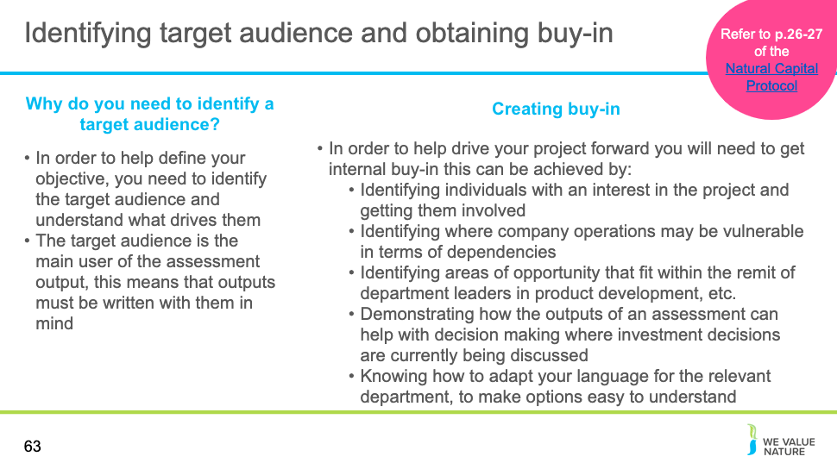

Referring to p. 26-27 of the Natural Capital Protocol, the presenter should explain steps to identify the target audience and why the target audience is important to identify, using the notes below:
- In order to define your objective, you need to identify the target audience and understand what drives them
- The target audience is the main user of the assessment output (i.e. those people that will read and use the output to make decisions)
- The target audience is likely to be an internal stakeholder or decision-maker, but they may be an external audience such as a shareholder if the objective is to provide output for a company report
Presenter should provide some examples of internal and external target audiences refer back to the identifying stakeholders in slide 60.
Presenter should provide further examples of creating buy-in in addition to those shown on the slide.

Slide 62

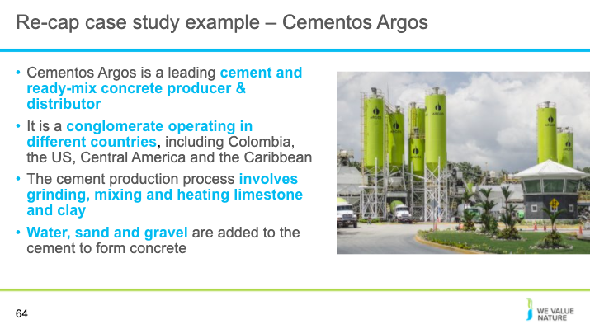

Presenter to re-cap the Cementos Argos example here for the next exercise
- Grupo Argos (the conglomerate that owns Cementos Argos) is a leading cement and ready-mix concrete producer and distributor, operating in Colombia, the US, Central America and the Caribbean
- Argos wanted to develop a way to assess integrated performance management across the group, in order to help make better informed decisions, enable more accurate risk management, and promote transparency and engagement with investors & shareholders.
- Argos chose to use a Value-added statement (VAS) approach, considering environmental, social and human factors, while still considering financial accounts.
- The company carried-out a year-long benchmarking of methodologies and experiences after reading other companies’ assessments.
- To determine which issues were material, a large internal scoping exercise was carried out by experts across the company.
- Cementos Argos built their VAS using KPMG’s True Value methodology.
- The methodology place monetary values on social, economic and environmental impacts (externalities).

Sources:
https://wevaluenature.eu/sites/default/files/2020-03/Grupo_Argos_natural_capital_story_0.pdf
https://mnisaccp01.blob.core.windows.net/sostenibilidad/Doc/2018/eng/Integrated-report-2018.pdf
https://home.kpmg/content/dam/kpmg/ae/pdf/introduction-kpmg-truevalue.pdf

Slide 63
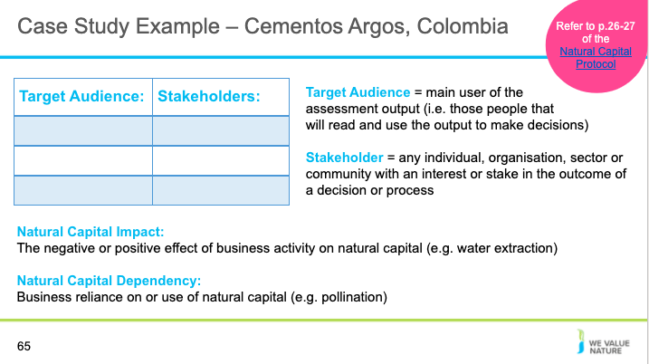
Presenter will now explain the target audience and stakeholder exercise for the delegates.
Participants are asked to identify who they think the target audience for the Cementos Argos value added statement is and which stakeholders could have been involved in the process
There is also a second option for an exercise on scoping the assessment (see slides 65-66)
Depending on whether the presentation is being given virtually or in person, the group will be split into tables or breakout rooms (see slides 50 and 51 for details on how to do this). They will be asked to fill out this table for Cementos Argos in Colombia. Presenter to remind them what target audience and stakeholders are, referring to p. 26-27 of the Natural Capital Protocol.

Re-cap:
- The target audience is the main user of the assessment output (i.e. those people that will read and use the output to make decisions)
- The target audience is likely to be an internal stakeholder or decision-maker, but they may be an external audience such as a shareholder if the objective is to provide output for a company report
- A stakeholder is defined as any individual, organization, sector or community with an interest or stake in the outcome of a decision or process (see p. 124 of the Natural Capital Protocol)
- It is important to involve the right stakeholders to ensure that your assessment is reliable, relevant and useful in the long term – stakeholders may need to authorize or fund the assessment at the outset
- Often, stakeholders may be the same as the target audience – nonetheless, there are also other stakeholders who may be affected by the results, including people who can provide information, influence or help verify, validate and interpret the assessment
- You can have internal and external stakeholders

Presenter to then read the context below to help the delegates with the scoping exercise:
- The objective of the VAS for Cementos Argos is to calculate the net value generated to society from their externalities to provide the company with a comprehensive view on how to retain, add or reduce value.
- The VAS provides useful information on how to make decisions that are more responsible and better informed, manage risks more accurately and enhance transparency for stakeholders
- Examples of ways in which the VAS have been applied include:
- Pilots for Water Scarcity Risk Scenarios
- Pilot for capital allocation decisions (for example comparing the financial and environmental costs of potential investments in machinery
- Embedded ESG criteria in the due diligence processes
- Carried out level and regional specific analyses
- Cementos Argos built their VAS using the KPMG True Value methodology.
- In this VAS, they consider the materiality of natural capital in relation to their business and other stakeholders

Slide 64
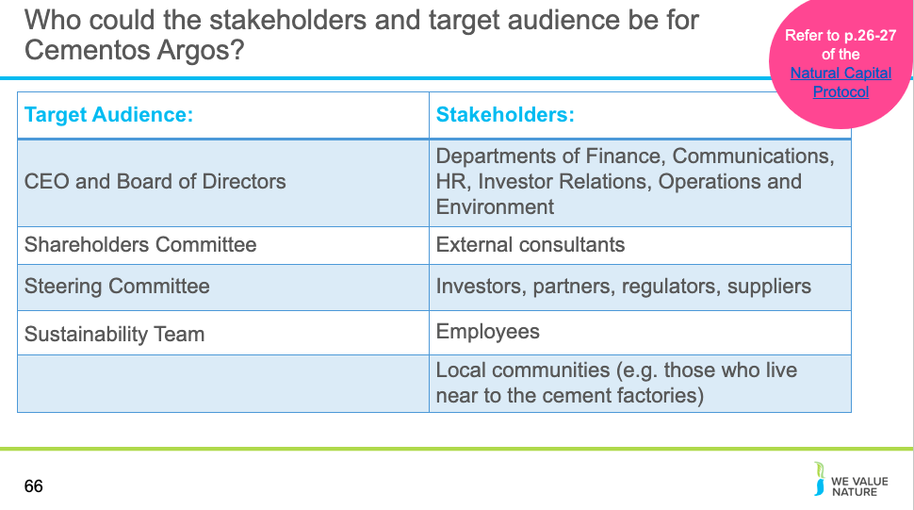
Referring to the table on the slide, the presenter should explain how to identify the stakeholders and target audience specifically for the Cementos Argos case study, giving examples – this can either be presented or used as the results for a group exercise. Refer to p. 26-27 of the Natural Capital Protocol.

- As stated previously, the target audience is the main user of the assessment output:
- The CEO of the group at the time began to read the assessments of other companies and decided that they should investigate the process – this led to a year-long benchmarking of methodologies and experiences. From the CEO asking the sustainability team to investigate natural capital it was then approximately six months until members of the team sat down with company representatives that had already started working on impact valuation and representatives from the Big Four.
- Stakeholders, on the other hand, are any individuals, organizations, sectors or communities with an interest or stake in the outcome of a decision or process. Due to the organizational focus and value-chain boundary of this assessment, the list of stakeholders may be quite long. This list is not exhaustive and suggests who was involved based on the public documents available:
- Departments that were involved included finance, communications, human resources, investor relations, operations, and environment.
- External consultants were brought in, and external assurance was sought to verify the process.

Slide 65
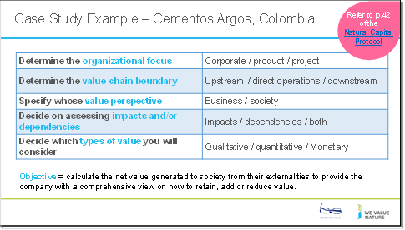
Presenter will now explain the scoping assessment exercise for the delegates. There is also a second option for an exercise on determining the target audience and key stakeholders for Cementos Argos (see slide 63-64)
Depending on whether the presentation is being given virtually or in person, the group will be split into tables or breakout rooms (see slides 50 and 51 for details on how to do this). They will be asked to fill out this table for Cementos Argos in Colombia, which was shown previously. Presenter to remind them what the categories in the table mean, using the notes below:
- The organizational focus is where in the company the assessment will focus, e.g. will the focus be on the corporate level, product level, or project level?
- Value-chain boundary: The part or parts of the business value chain to be included in a natural capital assessment. For simplicity, the Protocol identifies three generic parts of the value chain: upstream, direct operations and downstream. An assessment of the full lifecycle of a product would encompass all three parts.
- The types of value to be considered include: qualitative, quantitative and monetary.
- Value perspectives: the perspective or point of view from which value is assessed; this determines which costs or benefits are included in an assessment.
- Natural capital impacts are defined as the negative or positive effect of business activity on natural capital. For example, businesses may extract a lot of water, depleting natural reserves and natural capital dependencies are defined as a business reliance on or use of natural capital. For example, businesses may be dependent on pollination as a regulating service in agriculture

Presenter to then read the context below to help the delegates with the scoping exercise:
- The objective of the VAS for Cementos Argos is to calculate the net value generated to society from their externalities to provide the company with a comprehensive view on how to retain, add or reduce value.
- The VAS provides useful information on how to make decisions that are more responsible and better informed, manage risks more accurately and enhance transparency for stakeholders
- Examples of ways in which the VAS have been applied include:
- Pilots for Water Scarcity Risk Scenarios
- Pilot for capital allocation decisions (for example comparing the financial and environmental costs of potential investments in machinery
- Embedded ESG criteria in the due diligence processes
- Carried out level and regional specific analyses
- Cementos Argos built their VAS using the KPMG True Value methodology.
- In this VAS, they consider the materiality of natural capital in relation to their business and other stakeholders

Slide 66
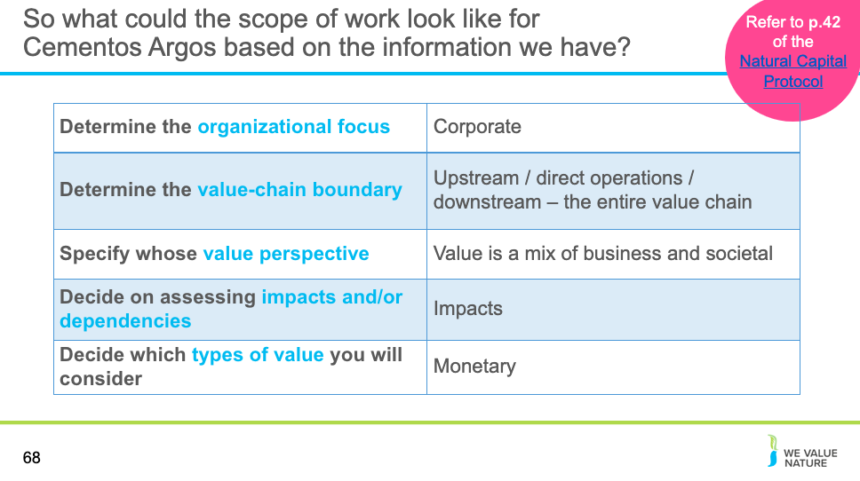
Referring to p. 42 of the Natural Capital Protocol and using the table on the slide, presenter should explain the steps to scope an assessment in reference to the Cementos Argos case study that was considered earlier in the deck – this can either be presented or used as the results for a group exercise
Based on the public information available for Cementos Argos the answers to the scoping questions include:
The organizational focus
- Corporate i.e. assessment of a corporation or group, including all subsidiaries, business units, divisions, different geographies or markets, etc.
- This was selected as the Cementos Argos value added statement is an overall assessment of their corporation, calculating the net value generated to society from their externalities
- In terms of the value-chain boundary: the documentation available for Cementos Argos states that The current analysis includes information from all of their regions (Colombia, United States, and the Caribbean and Central America) and all the business lines (cement, concrete and aggregates) with a focus on direct operations, the supply chain and the overall circular economy through a focus on waste disposal. As such the assessment is assumed to include the entire value chain
Value perspectives: the perspective or point of view from which value is assessed; this determines which costs or benefits are included in an assessment.
- The approach Grupo Argos used related to the production of a value-added statement (VAS) that considers environmental, social and human factors alongside the standard financial accounts. In their materiality assessment they consider the materiality of various factors in relation to their business and other stakeholders (including society), given this information we have assumed that both societies and the business value perspectives are considered.
Impacts and dependencies:
- Natural capital impact as: The negative or positive effect of business activity on natural capital
- Natural capital dependency as: A business reliance on or use of natural capital (NCP page 34)

- Cementos Argos built their VAS using the KPMG True Value methodology. The methodology placed monetary values on social, economic and environmental impacts (externalities), such as talent development, wages and benefits, and water consumption. Based on this information the assessment is assumed to include impacts only.

The types of value to be considered include: qualitative, quantitative and monetary.
- Based on the outputs of the VAS Grupos Argos applies a monetary valuation. Cementos Argos was the first part of the group to develop a value-added statement, in 2016. The time required for the whole assessment process including total impact valuation was six months, assuming between one and three full time employees.

Sources:
https://wevaluenature.eu/sites/default/files/2020-03/Grupo_Argos_natural_capital_story_0.pdf

Slide 67
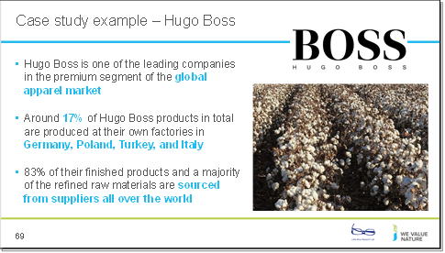
Presenter to explain the Hugo Boss case study using the notes on the slide
Sources:
https://group.hugoboss.com/en/responsibility/we-vision-strategy/natural-capital-evaluation
https://group.hugoboss.com/fileadmin/media/pdf/sustainability/2018-05-31_3rd_White_Paper_EIV.pdf

Slide 68
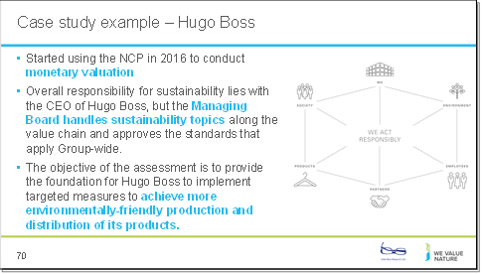
Presenter to explain the Hugo Boss case study using the notes on the slide
Sources:
https://group.hugoboss.com/en/responsibility/we-vision-strategy/natural-capital-evaluation
https://group.hugoboss.com/fileadmin/media/pdf/sustainability/2018-05-31_3rd_White_Paper_EIV.pdf

Slide 69
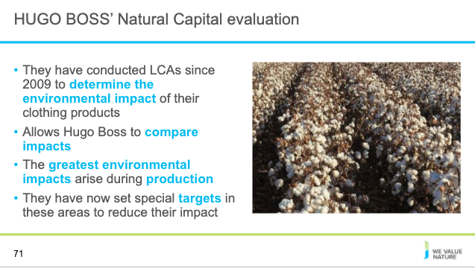
Presenter to explain the Hugo Boss case study using the notes on the slide
- They have conducted LCAs since 2009 to determine the environmental impact of their clothing products
- The assessment allows Hugo Boss to compare impacts and identify which steps in the value chain have the greatest environmental impact
- The greatest weight among the environmental impacts of the value chain arise during the production steps
- They have set special targets in these areas and become involved in relevant initiatives
- They categorized work steps by their corresponding ecological effects to create hot spots where more precise analysis and suitable measures can be employed

Sources:
https://group.hugoboss.com/en/responsibility/we-vision-strategy/natural-capital-evaluation
https://group.hugoboss.com/fileadmin/media/pdf/sustainability/2018-05-31_3rd_White_Paper_EIV.pdf

Slide 70
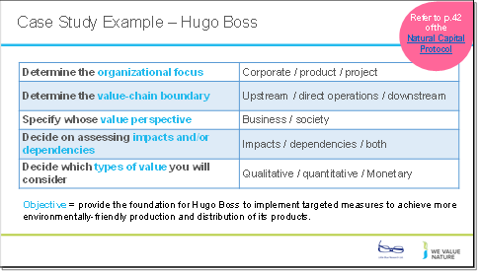
Presenter will now explain the scoping assessment exercise for the delegates. There is also a second option for an exercise on determining the target audience and key stakeholders for Hugo Boss (see slides 72 and 73). The exercise can be modified to focus on just one question using polling if conducting a shorter training course
Depending on whether the presentation is being given virtually or in person, the group will be split into tables or breakout rooms (see slides 50 and 51 for details on how to do this). They will be asked to fill out this table for Hugo Boss, which was shown previously. Presenter to remind them what the categories in the table mean, using the notes below:
- The organizational focus is where in the company the assessment will focus, e.g. will the focus be on the corporate level, product level, or project level?
- Value-chain boundary: The part or parts of the business value chain to be included in a natural capital assessment. For simplicity, the Protocol identifies three generic parts of the value chain: upstream, direct operations and downstream. An assessment of the full lifecycle of a product would encompass all three parts.
- The types of value to be considered include: qualitative, quantitative and monetary.
- Value perspectives: the perspective or point of view from which value is assessed; this determines which costs or benefits are included in an assessment.
- Natural capital impacts are defined as the negative or positive effect of business activity on natural capital. For example, businesses may extract a lot of water, depleting natural reserves and natural capital dependencies are defined as a business reliance on or use of natural capital. For example, businesses may be dependent on pollination as a regulating service in agriculture

Presenter to then read the context below to help the delegates with the scoping exercise:
- The objective of the Hugo Boss LCA is to provide the foundation for Hugo Boss to implement targeted measures to achieve more environmentally friendly production and distribution of its products.
- They have been conducting LCAs since 2009 to help determine the environmental impact of their clothing products

Slide 71
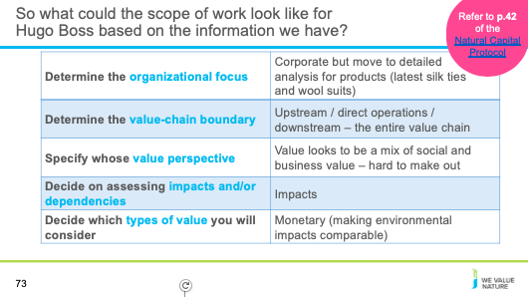
Referring to p. 42 of the Natural Capital Protocol and using the table on the slide, presenter should explain the steps to scope an assessment in reference to the Hugo Boss case study -– this can either be presented or a black table presented initially and this table used as the results for a group exercise
The organizational focus is where in the company the assessment will focus, e.g. will the focus be on the corporate level, product level, or project level?
Organizational focus: the part or parts of the business to be assessed (e.g., the company as a whole, a business unit, or a product, project, process, site, or incident). For simplicity, these are grouped under three general levels as below:
- Corporate: assessment of a corporation or group, including all subsidiaries, business units, divisions, different geographies or markets, etc.
- Project: assessment of a planned undertaking or initiative for a specific purpose, and including all related sites, activities, processes, and incidents.
- Product: assessment of particular goods and/or services, including the materials and services used in their production.

To determine the value-chain boundary, you need to decide where in the value chain the assessment will take place. For a clothing company, the assessment may take place across all upstream operations (e.g. cotton farming and clothes manufacture).
Value-chain boundary: The part or parts of the business value chain to be included in a natural capital assessment. For simplicity, the Protocol identifies three generic parts of the value chain: upstream, direct operations and downstream. An assessment of the full lifecycle of a product would encompass all three parts.
- Upstream (cradle-to-gate): covers the activities of suppliers, including purchased energy.
- Direct operations (gate-to-gate): covers activities over which the business has direct operational control, including majority owned subsidiaries.
- Downstream (gate-to-grave): covers activities linked to the purchase, use, re-use, recovery, recycling, and final disposal of the business’ products and services.

Explain that the value perspective determines that value being measured i.e. the value to business, the value to society, or both.
- The types of value to be considered include: qualitative, quantitative and monetary.

Value perspectives: the perspective or point of view from which value is assessed; this determines which costs or benefits are included in an assessment.
- Business value: The costs and benefits to the business, also referred to as internal, private, financial, or shareholder value.
- Societal values: The costs and benefits to wider society, also referred to as external, public, or stakeholder value (or externalities).

Note: the results shown in the table are assumptions based on the publicly available data and documentation available on the work that Hugo Boss has completed in relation to Natural Capital.

Sources:
https://group.hugoboss.com/en/responsibility/we-vision-strategy/natural-capital-evaluation
https://group.hugoboss.com/fileadmin/media/pdf/sustainability/2018-05-31_3rd_White_Paper_EIV.pdf

Slide 72
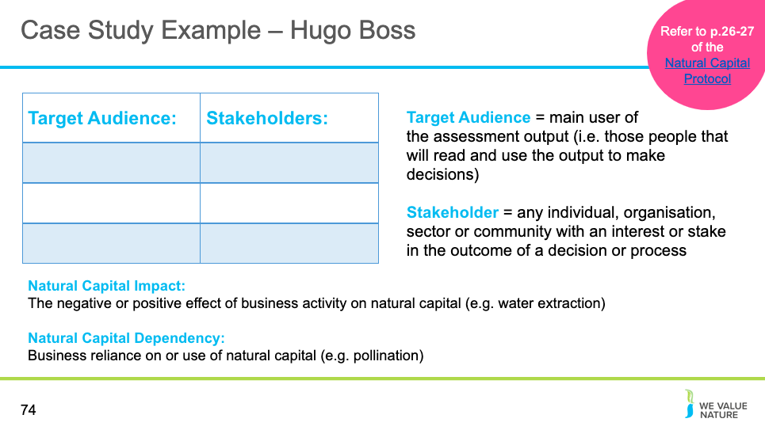
Presenter will now explain the target audience and stakeholder exercise for the participants. There is also a second option for an exercise on scoping the assessment (see slides 70-71).
Participants are asked to identify who they think the target audience for the Hugo Boss example is and which stakeholders could have been involved in the process
Depending on whether the presentation is being given virtually or in person, the group will be split into tables or breakout rooms (see slides 50 and 51 for details on how to do this). They will be asked to fill out this table for Hugo Boss.
Presenter to remind them what target audience and stakeholders are, referring to p. 26-27 of the Natural Capital Protocol. Presenter to also remind delegates the definitions for impacts and dependencies, as this will help them to answer the target audience and stakeholder questions:

Re-cap:
- The target audience is the main user of the assessment output (i.e. those people that will read and use the output to make decisions)
- The target audience is likely to be an internal stakeholder or decision-maker, but they may be an external audience such as a shareholder if the objective is to provide output for a company report
- A stakeholder is defined as any individual, organization, sector or community with an interest or stake in the outcome of a decision or process (see p. 124 of the Natural Capital Protocol)
- It is important to involve the right stakeholders to ensure that your assessment is reliable, relevant and useful in the long term – stakeholders may need to authorize or fund the assessment at the outset
- Often, stakeholders may be the same as the target audience – nonetheless, there are also other stakeholders who may be affected by the results, including people who can provide information, influence or help verify, validate and interpret the assessment
- You can have internal and external stakeholders

Presenter to then read the context below to help the delegates with the scoping exercise:
- The objective of the Hugo Boss LCA is to provide the foundation for Hugo Boss to implement targeted measures to achieve more environmentally friendly production and distribution of its products.
- They have been conducting LCAs since 2009 to help determine the environmental impact of their clothing products
- Overall responsibility for sustainability lies with the CEO of Hugo Boss, but the Managing Board handles sustainability topics along the value chain and approves the standards that apply Group-wide.

Slide 73
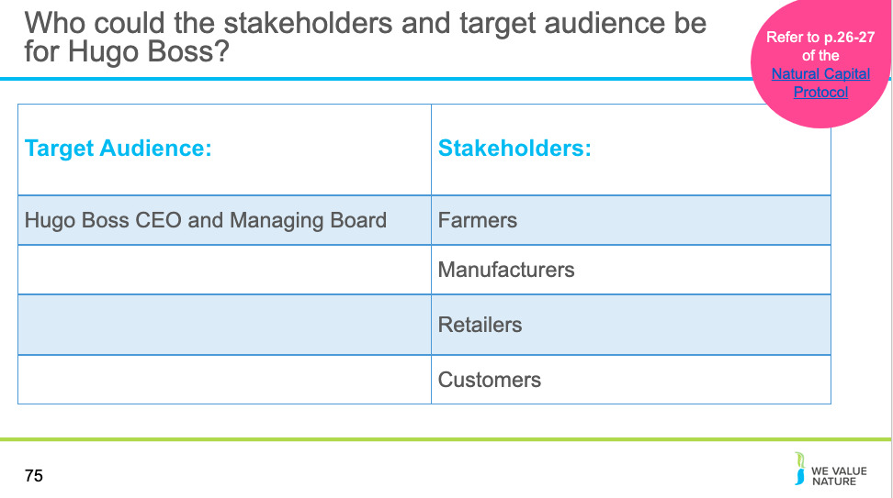
Referring to the table on the slide, the presenter should explain how to identify the stakeholders and target audience specifically for the Hugo Boss case study, giving examples – this can either be presented or used as the results for a group exercise. Refer to p. 26-27 of the Natural Capital Protocol.
- As mentioned in the case study overview, the objective of the Hugo Boss LCA is to provide the foundation for Hugo Boss to implement targeted measures to achieve more environmentally friendly production and distribution of its products. It is useful to understand the objective of the LCA when working out who the target audience and stakeholders are:
- The target audience is the main user of the assessment output
- The Hugo Boss website states that “Overall responsibility for sustainability lies with the Chief Executive Officer of HUGO BOSS. At its meetings, the Managing Board handles sustainability topics along the value chain and approves the standards that apply Group-wide.” Thus, the CEO and Managing Board will be the target audience directly overseeing the production and distribution of environmentally friendly products coming out of this LCA
- Stakeholders, on the other hand, are any individuals, organizations, sectors or communities with an interest or stake in the outcome of a decision or process some examples are listed based on the publicly available information for Hugo Boss
- Farmers (e.g. cotton farmers/ sheep farmers) will be impacted by the production of environmentally friendly products as they are key in the harvesting of raw materials to use in these products
- Manufacturers are also impacted, as they are central in the production of environmentally friendly products
- Retailers are key due to their role in the distribution of these products
- Customers are key in the purchasing and uptake of these products – without customers creating demand there would be no market and thus no incentive in creating these items

Slide 74
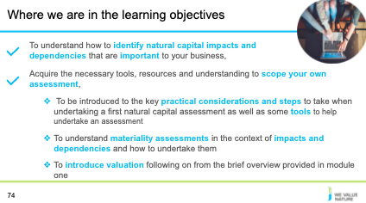
Presenter to highlight that learning objective 2 has now been covered and that the training will proceed to the next learning objective

Slide 75
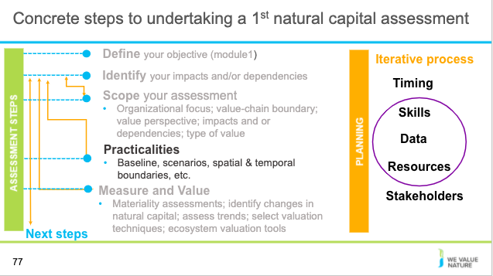

Presenter to explain that the next section will concrete on the practicalities of an assessment

Practical considerations
Slide 76
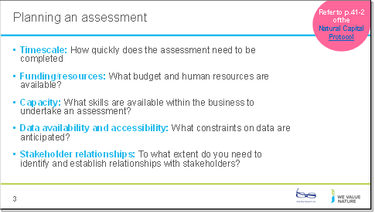

See p. 41-42 of the Natural Capital Protocol for more details.

Presenter to walk through the things to consider when planning an assessment using the notes on the slide. Run through examples for each as shown below:
- Timescale – An assessment may be needed to input into a decision in 6 months’ time
- Funding/resources – The budget may be limited to $50 USD and 20% of an environmental manager’s time
- Capacity – The relevant skills may come from the company’s sustainability team, with some assistance from an environmental economist
- Data availability and accessibility – The company may only have data available from the past year
- Stakeholder relationships – A full stakeholder mapping may need to be carried out, which identifies the need for further stakeholder engagement

Slide 77

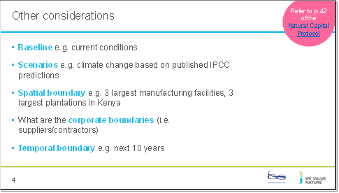

See p. 41-42 of the Natural Capital Protocol for more details

Presenter to go through the other considerations, using the notes on the slide and the notes below:
- The baseline is the conditions under which the valuation is taking place. For a clothing company, for example, the baseline may be set as its typical agricultural impacts in their largest country of operation during a base year. Note that not all assessments require a single baseline, e.g. when comparing two options against each other.
- A scenario is a storyline describing a possible future. Scenarios explore aspects of, and choices about, the future that are uncertain, such as alternative project options, business as usual, and alternative visions. Example scenarios for a clothing company may include the baseline agricultural impacts as one scenario and have the impacts of a new agriculturally improved system as the second scenario.
- The spatial boundary is the geography over which the assessment will take place. This can range from a specific site in the value chain to looking at all products produced by the company. For a clothing company, this may include all farmland owned by the company.
- An example corporate boundary for a clothing company may be plantations directly owned by the company (i.e. excluding 3rd party producers).
- The temporal boundary looks at the time horizons that the assessment will use. This can be a snapshot or a specific period of time. For the clothing company example, this may be 3 years after a new agriculturally improved system has been put in place.

Note: presenter should refer back to slide 59 in which project ambition is considered

Slide 78
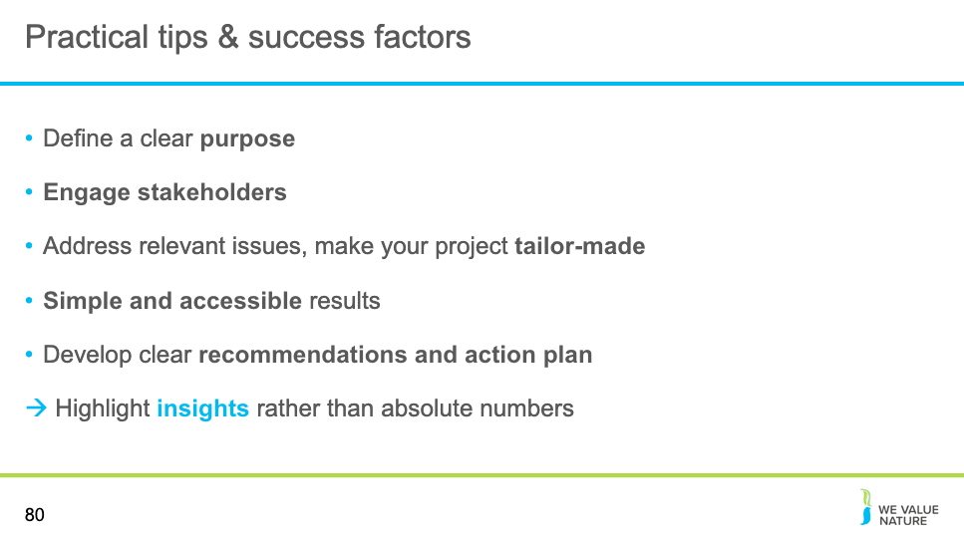

Presenter to elaborate on practical tips and success factors by explaining the points on the slide.

Slide 79
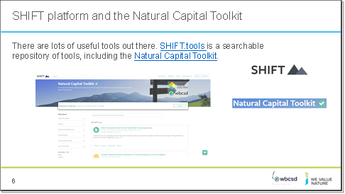

Presenter to explain that there are many useful tools available; many of which are freely accessible and readily available for companies to use and start assessing their natural capital impacts and dependencies. Presenter to talk through at least one example of these with some information as to the use of the data and what it has helped the company to achieve. Note: the presenter can update this slide to include their own examples or other tools:

The examples listed here are not exhaustive:
- SCA/eftec: natural capital balance sheet showing value to business, value to society, total value, and how much of this is reported in financial accounts. Total assets in financial accounts reported as 3250mn euros, whilst total natural capital assets value at 12,369mn euros.
- Used as internal risk management tool, in internal & external communications and in government/regulatory relations. Production required an element of learning as SCA was a first mover in the space.
- Solvay: extra-financial statements which show economic, environmental and social indicators in similar form to a standard financial statement, with different units of measurement (i.e. not all monetary).
- LafargeHolcim (LH): Integrated profit & loss statement, estimation of total value LafargeHolcim provides for society. Considers socio-economic and environmental factors alongside financial. The statement is the result of cross-functional collaboration. Used in LT strategy to help LafargeHolcim building value for shareholders, people and planet. To help shape the mindset of decision makers in LafargeHolcim and enhance decision making process by looking at things from the bottom-up.
- BASF: Value to society approach, considers impact categories along the entire supply chain and provides an absolute value of contribution in monetary terms. Can compare results between years since 2013. This approach in particular allows comparison between financial and non-financial impacts and maps impacts along different stages of the value chain, as well as providing a better understanding of interdependencies between economic, social and environmental issues.
- Phillips: used an EP&L providing an environmental footprint for the whole value chain in monetary terms, using LCA methodology. However only looks at hidden environmental costs to society, not benefits.
- Kering: EP&L (next slide)
- Natura EP&L: in 2013, results have been used for carbon neutrality programme.
- KPMG methodology: True Value methodology
Sources:
https://naturalcapitalcoalition.org/connecting-finance-and-natural-capital-case-study-for-eftec-natural-capital-statements/
https://annualreports.solvay.com/2019/en/extra-financial-statements.html
https://www.lafargeholcim.com/sites/lafargeholcim.com/files/atoms/files/04062018_lafargeholcim-sustainability-report-integrated-profit-loss-2017.pdf
https://www.basf.com/global/en/who-we-are/sustainability/we-drive-sustainable-solutions/quantifying-sustainability/we-create-value.html
https://www.innovationservices.philips.com/news/environmental-profit-loss-epl-account/
https://www.kering.com/en/sustainability/environmental-profit-loss/
https://naturalcapitalcoalition.org/wp-content/uploads/2017/09/Case-Study-Natura-1.pdf
https://home.kpmg/xx/en/home/services/advisory/risk-consulting/internal-audit-risk/sustainability-services/kpmg-true-value-services.html

After explaining this slide, presenter should ask: what approaches would be of interest to them? What do they think their senior management team prefer?

Slide 80
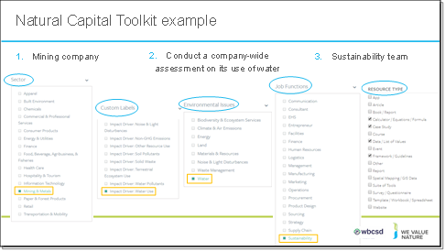

Presenter to explain how the SHIFT platform works using the example of the Natural Capital Toolkit. Presenter to explain that the choice of the tool used will depend on various factors. See notes below for examples of things to consider when looking up a tool on the SHIFT platform:
- What is the objective / what are you trying to achieve? / What decision are you trying to inform? – Is it to inform business strategy? Business management? Or operating decision?
- What is the scope? Are you looking at product, corporate level?
- What perspective are you looking at? Business? Societal? Both?
- How much resources do you have available to conduct the assessment?
- How much information / data do you already have?
- Will you need external help?

Slide 81
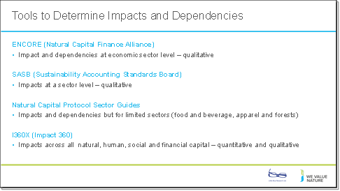

Presenter to provide some information on tools that are useful in determining impacts and dependencies as another example. Presenter to the slide and the notes below:
Some examples of relevant tools for identifying impacts and dependencies include (this list is not exhaustive, presenter can add their own examples):

- Encore:
- Tool to help users understand and visualize impact of environmental change on the economy
- Focuses on goods and services that nature provides to enable economic production
- Guides users in understanding how businesses across sectors depend on nature and how these dependencies might represent business risk if environmental degradation disrupts them

- SASB:
- Connects businesses and investors on the financial impacts of sustainability
- SASB has industry specific standards which provide insight on which ESG factors are likely to create or destroy value
- Helps to identify priority issues and improve the results of companies

- Natural Capital Protocol Sector Guides
- Support the protocol by providing additional guidance and sector specific insights
- Sector guides do not provide additional methodologies and are not stand-alone documents but should be used to guide organizations from specific sectors through an application of the NCP
- Identifies impacts and dependencies relevant to businesses operating in the sector
- Offers practical guidance for sector specific protocol application
- Practical examples to demonstrate sector specific business applications of protocol

- I360X Tool:
- Online “software as a service” platform that assesses natural capital, human capital, social capital and financial capital to understand impact
- Uses sophisticated algorithms and global databases to measure these externalities
- The result is the comprehensive integrated profit and loss report that integrates value added or lost across all four capitals
- I360X helps corporations make sustainable decisions, positively impacting nature, society and humans as well as the bottom line
- I360X helps to benchmark your impact against peers in your industry and region
- Impact measurement is presented in the form of economic value, quantifiable volumes and qualitative ranks

Details on each tool with further links are available on the SHIFT platform:
- Encore: https://encore.naturalcapital.finance/en
- SASB: https://shift.tools/contributors/313
- Natural Capital Protocol Food and Beverage Sector Guide: https://shift.tools/iframe/1794?ssl=true
- I360X: https://www.gistimpact.com/

Slide 82
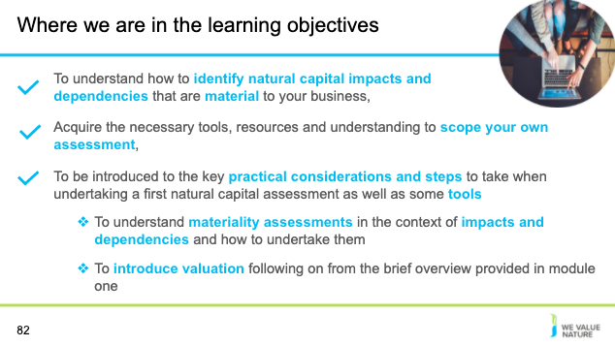

Presenter to highlight that learning objective 3 has now been covered and that the training will proceed to the next learning objective

Materiality
Slide 83

Presenter to introduce section on materiality

Slide 84
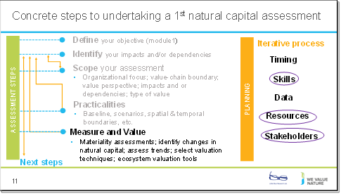
Presenter to explain that this is part of the introduction to the measure and value section of the protocol.

Slide 85
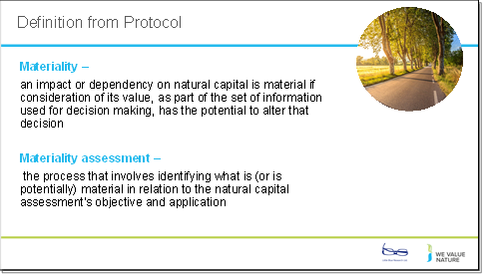

Presenter to read out the definitions of materiality and materiality assessment on the slide. Presenter to then walk through the four stages of conducting a materiality assessment, using the notes below:
- Identifying potentially material impacts and/or dependencies
- Identifying criteria for the materiality assessment
- Gathering relevant information
- Completing the materiality assessment

- To carry out a materiality assessment, the assessor must identify a small group of potentially material impacts and/or dependencies.
- Information will need to be gathered and criteria set to measure the materiality of the chosen impacts and dependencies.
- Note that the information gathering stage of the materiality assessment will involve identifying the potential sources of data.

Slide 86
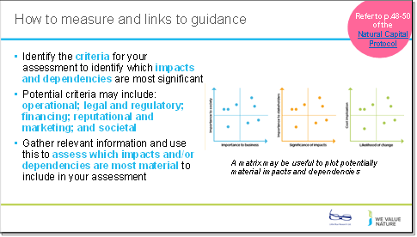

Based on pages 48-50 of the NCP
Presenter to explain how to identify criteria for identifying material issues using the notes below.
Presenter can ask the audience how many have undertaken a materiality assessment as part of their current role.

- Throughout the measurement phase, the assessment’s objective and purpose should be considered
- Identify criteria based on who the impacts are most significant for, and whether you are considering the value to business, society or both
- Examples of materiality criteria include (this list is not exhaustive):
- Operational: the extent to which the natural capital impact or dependency may significantly affect business operations, project implementation, or the value of existing or new product(s).
- Legal and regulatory: the extent to which the natural capital impact or dependency may trigger a legal process or liability (e.g., emission fees or extraction quotas, environmental impact mitigation requirements).
- Financing: the extent to which the natural capital impact or dependency may influence “cost of capital” or your access to capital, investor interest, or insurance conditions.
- Reputational and marketing: the extent to which the natural capital impact or dependency may affect the product portfolio, company image, or relationship with customers and other stakeholders (e.g., changing customer preferences).
- Societal: the extent to which the natural capital impact or dependency may generate significant impacts to society

- Note that the type of information that may be collected to determine the materiality of an impact or dependency may include:
- Type of impact and/or dependency
- Scale of impact and/or dependency
- Consequence of impact and/or dependency (on business, society, or both)
- Time scale (short, medium, and long-term)

- Explain that collecting this information may include stakeholder consultation; seeking expert opinion; compiling available information; conducting a brief assessment of value (e.g. what is the financial value of the asset involved).
- To carry out the assessment, establishing a panel of relevant assessors with a broad range of skills is recommended. It is also recommended that relevant thresholds are set for different criteria, with anything exceeding them considered material. It is possible that some impacts or dependencies are uncertain at and may require further information gathering or consultation to resolve.

Presenter can refer to the Cementos Argos materiality matrix as an example (to match the case studies used) or to replace this with reference to another example, available on page 6 of their integrated report:
https://mnisaccp01.blob.core.windows.net/sostenibilidad/Doc/2018/eng/Integrated-report-2018.pdf

Slide 87
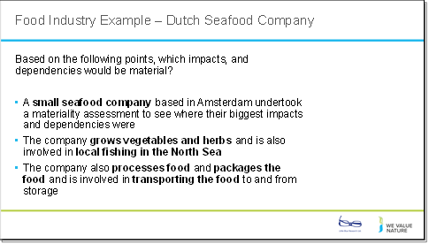
Presenter to walk through the points listed on the slide in relation to the case study.

In this case study, Nature^Squared demonstrates their Natural Capital Accounting framework for Small and Medium-sized Enterprises (SMEs): Accounting For A Better Planet. The technique was used to demonstrate that:
- SMEs can use a materiality assessment along with larger companies.
- The Accounting For A Better Planet framework provides SMEs with a simple and integrated overview of their relation to natural capital, thereby enabling companies to create a positive impact where it is mostly needed. It not only allows companies to have an understanding of their impacts and dependencies on natural capital, it also identifies key areas for change
- The framework has 7 key themes: biodiversity; land-use change; climate; air quality; soil quality; water use; and water quality.

An example of the application of the framework is given below:
- A small-sized seafood company based in Amsterdam that:
- source their fish locally from the North Sea.
- considers sustainability as part of their DNA
- their main objective was to create real positive impact through their business operations and to communicate their sustainable journey with their customers.
- that the scope of the analysis would be rather broad, e.g. measuring both impacts and dependencies and incorporating all supply chain stages

The presenter will then start breakout room sessions for participants to discuss the potentially material impacts and/or dependencies and how to rank these.
See slides 50 and 51 for instructions

Source: file:///Users/sabinagordon/Downloads/case%20study%20-%20accounting%20for%20a%20better%20planet%20(1).pdf

Slide 88
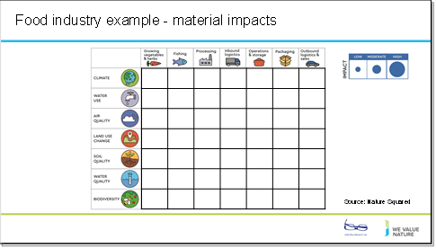

Presenter will explain the framework on the slide, using the notes below. Presenter will split the delegates into breakout rooms/table exercises (see slide 50 and 51 for instructions). Presenter will ask the respondents to consider how they will rank impacts for the fishing company using the key on the screen (criteria high medium and low). The delegates will be asked to feedback after a few minutes, giving their top 3 impacts for the company and giving the reasons for this choice.

See Nature Squared’s ACCOUNTING FOR A BETTER PLANET – AN ACTION-ORIENTED NATURAL CAPITAL ACCOUNTING FRAMEWORK FOR SMES, Case study: Netherlands for more detail.

Source: file:///Users/sabinagordon/Downloads/case%20study%20-%20accounting%20for%20a%20better%20planet%20(1).pdf

Slide 89
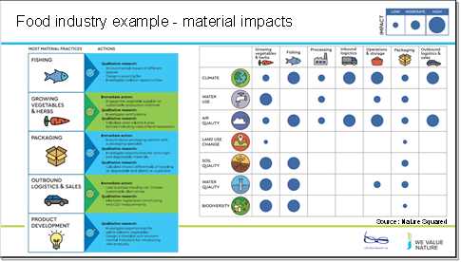

Presenter will run through the impacts and dependencies selected as material by the food industry SME in this example. Presenter to go through the most material impacts shown on the slide (climate, air quality, water quality etc.) and compare them to the impacts suggested by participants. Presenter to ask what criteria were used for high medium and low during the exercise.

- The framework has been implemented and extensive feedback was collected by Nature^Squared.
- Nature^Squared conducted a series of workshops to help the firm through the materiality process.
- This is a great example of how you can conduct a qualitative assessment of your natural capital impacts and dependencies which can already translate into concrete actions to take in response to this. Here are just the impacts, but the same exercise was repeated for dependencies too.
- To complete it, they discussed relative importance with different stakeholders and simply provided relative orders of magnitude, based on resources
- From this, they were able to identify most material elements of their practices and then prioritise which actions to take.
- This exercise can be repeated in consultation with your own employees and stakeholders.
- You don’t necessarily need to measure and value your impacts, this type of assessment can already be very informative without a lot of time, expertise or a big budget. Again, it depends on what your objective is.
- Based on this analysis and an additional stakeholder analysis, the activities of fishing, growing vegetables, and packaging were identified as most material. Outbound logistics and sales were also prioritized as alternative practices were considered as easy to implement and material for the client

For each of the prioritized business activities, several strategies have been developed to realize sustainable changes. The strategies range from measurements and qualitative research to tangible action plans when alternative practices were readily available.
The following list of activities shows how the client used the results of the materiality assessment to decide on how to further assess their impacts and dependencies on nature
E.g.
- Fishing:
- Qualitative research… environmental impact of different species, design a sourcing list and investigate coalition opportunities
- Vegetables and Herbs:
- immediate action… engage the vegetable supplier on sustainable production methods…
- Qualitative research…. investigate certifications … calculate used volume and area farmed including costs of land restoration
- Packaging:
- Immediate action … inquire about packing options with a specialist
- Qualitative… investigation of non-virgin and degradable materials… calculate impact differentials of recycling vs degradable and plastic vs cupboard
Lastly, the firm decided to integrate a natural capital approach into product development to ensure a sustainable design of new products.
See Nature Squared’s ACCOUNTING FOR A BETTER PLANET – AN ACTION-ORIENTED NATURAL CAPITAL ACCOUNTING FRAMEWORK FOR SMES, Case study: Netherlands for more detail.
Note: further information can be added to the impact categories for example, including initial assessments of data availability and data ownership for all high impacts identified
Source: file:///Users/sabinagordon/Downloads/case%20study%20-%20accounting%20for%20a%20better%20planet%20(1).pdf

Slide 90
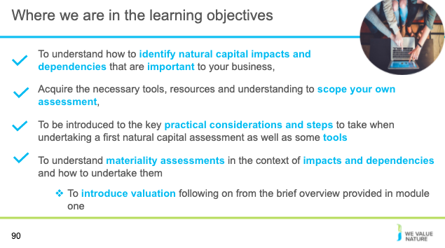

Presenter to highlight that learning objective 4 has now been covered and that the training will proceed to the next learning objective

Disclaimer: The information contained in this report is based on a review of Natural Capital training material in May 2020. The information contained herein is of a general nature and is not intended to address the circumstances of any particular individual or entity. Although we endeavour to provide accurate and timely information, there can be no guarantee that such information is accurate as of the date it is received or that it will continue to be accurate in the future. No one should act on such information without appropriate professional advice after a thorough examination of the particular situation.
The We Value Nature Network hereby expressly disclaim all warranties of originality, accuracy, completeness, merchantability or fitness for a particular purpose with respect to any of this information and in no event shall the parties have any liability for any damages of any kind.
The citing of trade names, reports, websites does not constitute endorsement. The We Value Nature Network and Little Blue Research Ltd. do not accept any liability for damage arising from the use of these speakers notes and make no representation regarding the advisability or suitability of this to specific business or training needs.

(Slides 91-104)
  - Introduction to monetary valuation for scoping a natural capital assessment
  - Wrap-ups & next steps

Introduction to monetary valuation for scoping a natural capital assessment
Slide 91
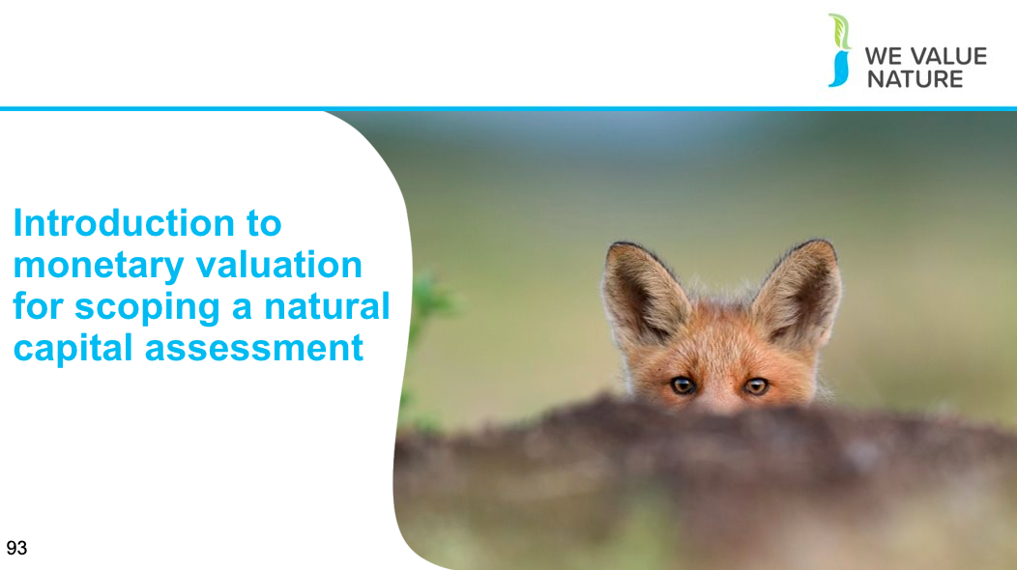

Presenter to introduce section on ‘introduction to monetary valuation for scoping a natural capital assessment’

Slide 92

Presenter to explain that this is part of the introduction to the measure and value section of the protocol – focusing on understanding valuation in the context of scoping a natural capital assessment

Slide 93
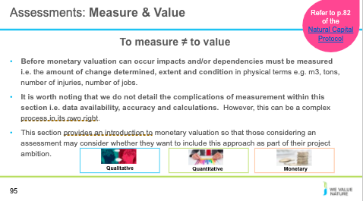
Presenter to present the difference between measuring and valuing and referring back to the introduction section of the training
Presenter to state there are complexities associated with measurement that should be considered when scoping a project and that this session provides a short overview that is limited to monetary valuation to help the scoping of an assessment
NOTE: the following point on natural capital accounting (NCA) is optional – if mentioned, it should be made clear that we are not focusing on NCA specifically in this training
NCA allows for the integration of all different pieces of evidence without requiring valuation. There are links between this and the system of environmental economic accounting that takes place at a jurisdiction level
Link to more information on SEEA: https://seea.un.org/content/homepage

Slide 94

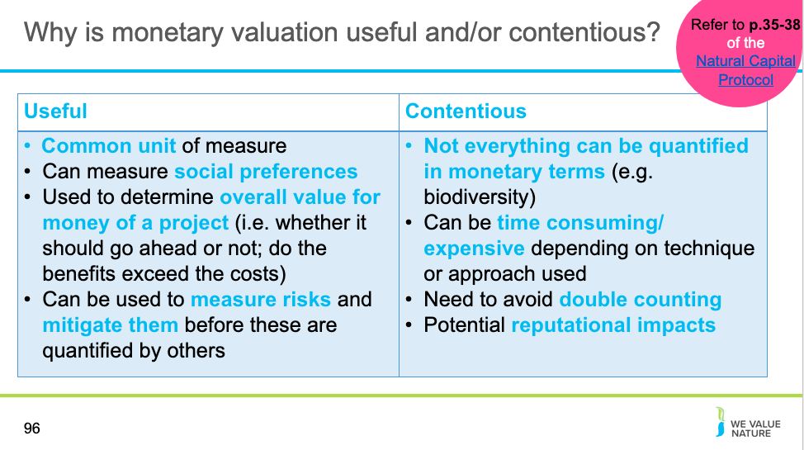

Presenter to explain why monetary valuation is useful and/or contentious using the notes below:
- Monetary valuation works by translating quantitative estimates of costs and/or benefits into a single common currency
- Monetary valuation can be useful because... (Source: NCP p.38)
  - Can provide information on the marginal value of incremental changes in impacts or dependencies, either at a point in time or over a given period
  - Monetary valuation can also be used to assess trends in value as a function of changes in supply and demand conditions. Both market and non-market approaches to monetary valuation aim to measure social preferences—using observed prices in the market in the former case, and “revealed” or “stated” preference methods for impacts or dependencies that do not have explicit market prices
  - Monetary valuation is good for ease of comparison with financial values because it puts values in a common unit of measure. When monetary values are estimated correctly and consistently, they are broadly comparable and offer meaningful information to assess trade-offs
- Monetary valuation can be contentious/hard because... (Source: NCP p.35-38)
  - Sometimes stakeholders find it difficult to accept or interpret the monetary valuation of certain benefits. Societal costs and benefits for example, rarely translate directly into financial costs and benefits to businesses, even when they are expressed in monetary terms. This means that monetary estimates are often only partial estimates of the overall value (Source: NCP p. 35)
    - This is because these societal costs and benefits can rarely be imposed by companies precisely. For example, the financial costs imposed by environmental legislation are often lower than the societal costs of the impacts avoided. Equally, the financial costs of reputational damages associated with impacts on natural capital may be greater than the societal costs of the impacts themselves.
    - Ultimately, not everything can be quantified in monetary terms – considering the value of ecosystem services in terms of the impact of human well-being, for instance, may be more helpful in framing corporate ecosystem valuation
  - It can be time consuming and expensive, especially if primary research is required to generate data although some lower-cost monetary valuation methods are available like value transfer (Source: NCP p.38)

Other things to note are the need to avoid double counting with monetary valuations… e.g. when intermediate costs and or benefits rather than only final costs and or benefits are assessed (although classification systems like CICES and NESCS which were built to address this concern)
Source: Referring to p.35-38 of NCP
CICES (https://cices.eu/)
NESCS (https://www.epa.gov/sites/production/files/2015-12/documents/110915_nescs_final_report_-_compliant_1.pdf)

Slide 95

Presenter to explain the concept of total economic value, using the notes below:

- Economic value is a measure of how much something (e.g. an ecosystem service) improves the wellbeing of an individual or of society as a whole
- The concept of total economic value has now become one of the most widely used frameworks for identifying, categorizing and valuing ecosystem benefits
- Many of the services provided by ecosystems are not captured in existing markets, so are considered only in an assessment of total economic value
- Instead of focusing only on direct commercial values, TEV also considers subsistence and non-market values, ecological functions and non-use benefits
- Direct use: raw materials and physical products that are used directly for production, consumption and sale (e.g. energy, shelter, food)
- Indirect use: ecological functions that maintain and protect natural and human systems through services (e.g. maintenance of water quality and flow, flood control, storm protection, micro-climate stabilisation)
- Optional values: premium placed on maintaining resources and landscapes for future possible direct and indirect use
- Non-use: value of ecosystem regardless of current or future use, for cultural, spiritual, aesthetic, heritage and biodiversity reasons
- Ultimately, TEV presents a more complete picture of the economic importance of ecosystems – this demonstrates the scale and range of economic costs associated with degradation, beyond the loss of direct use values

Source: Module 3 BET training

Slide 96

Presenter to read the question and the definitions on the slide providing time for the participants to reflect and answer. Once reflection is complete, presenter should explain that the type of value that businesses extract from ecosystem goods and services is dependent on many factors for example:

- The type of business you have, your value-chain etc. For example, an agricultural production company, may rely on ecosystem goods and services very directly whereas a tourism agency, may rely on ecosystem goods and services for indirect value

Presenter to add their own examples and add other factors which may influence values.

Virtual
Presenter should ask each delegate to share their thoughts in the chat

In person
Each table will be asked to reflect on these points as a group and feedback

Slide 97
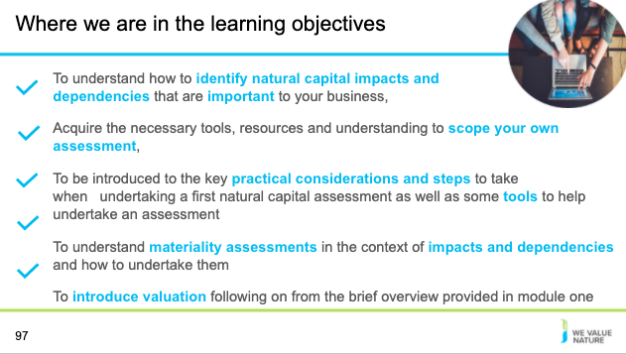

Presenter to highlight that learning objective 5 has now been covered

Case study section (optional industry speaker)
Presenter to handover to case study presenter to give presentation on natural capital accounting in a business context if an industry speaker is helping with the training. Presentation will last for 10 minutes and then 5 minutes will be allocated for a Q&A session following the presentation.

Wrap-up & next steps
Slide 98
Slide 99
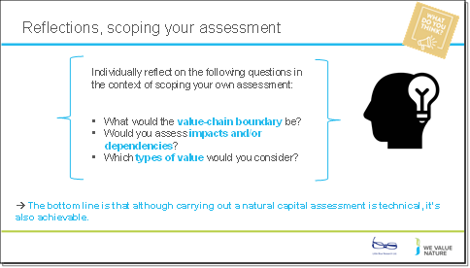

Presenter to read the questions on the slide and ask the delegates to individually reflect on these for a couple of minutes.

Virtual
Using a Zoom poll, the presenter will get participants to answer the 3 questions, as though they were scoping their own assessments.
In person
Using a Mentimeter poll, the presenter will get participants to answer the 3 questions, as though they were scoping their own assessments.

See slide 18 for Mentimeter instructions

Slide 100

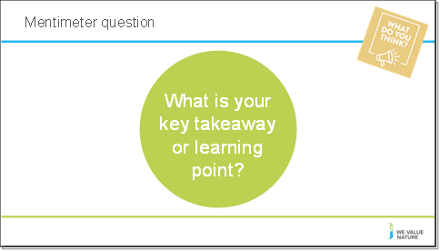

Presenter to read the questions on the slide an use an online poll to gather results.

Virtual
Using a Zoom poll, the presenter will get participants to answer the 3 questions, as though they were scoping their own assessments.

In person
Using a Mentimeter poll, the presenter will get participants to answer the 3 questions, as though they were scoping their own assessments.

See slide 18 for Mentimeter instructions

Slide 101

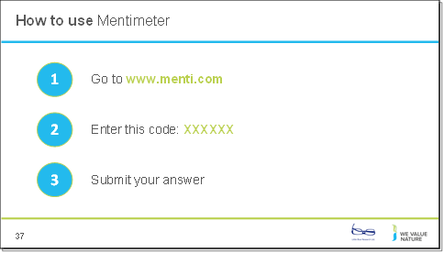
To use Menti meter please go to www.menti on your computer

Slide 102

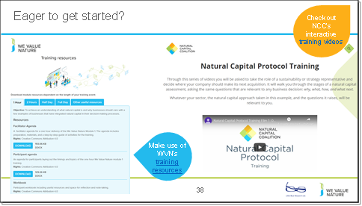
Presenter to explain the NCP training videos, using the notes below:
The Capitals Coalition has recently launched a set of training videos that will guide you in an interactive way through a light natural capital assessment to explore just how much can be achieved with limited resources. Interested to learn more? Check out these videos here: https://naturalcapitalcoalition.org/protocol-training/

Slide 103

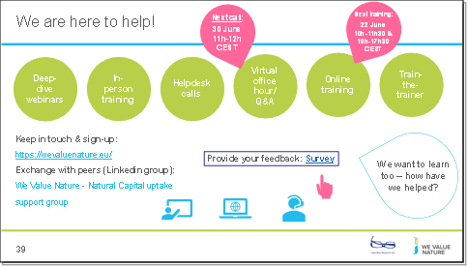

Presenter to point the delegates towards other resources that they can explore. Use the notes below as well as the notes on the slide:
- WHAT ELSE would you need? What support would you need?
- Sign-up for in-person day training, t-t-t
- If want support, need to fill out survey (Google form survey)
- Refining training further, keen to know how have used this training and catch-up via call (if don’t want to, let us know)

Slide 104
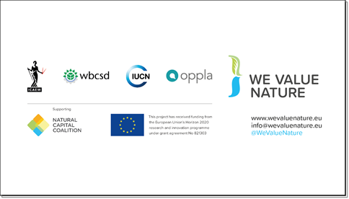
Presenter to conclude the presentation

Disclaimer: The information contained in this report is based on a review of Natural Capital training material in May 2020. The information contained herein is of a general nature and is not intended to address the circumstances of any particular individual or entity. Although we endeavour to provide accurate and timely information, there can be no guarantee that such information is accurate as of the date it is received or that it will continue to be accurate in the future. No one should act on such information without appropriate professional advice after a thorough examination of the particular situation.
The We Value Nature Network hereby expressly disclaim all warranties of originality, accuracy, completeness, merchantability or fitness for a particular purpose with respect to any of this information and in no event shall the parties have any liability for any damages of any kind.
The citing of trade names, reports, websites does not constitute endorsement. The We Value Nature Network and Little Blue Research Ltd. do not accept any liability for damage arising from the use of these speakers notes and make no representation regarding the advisability or suitability of this to specific business or training needs.

