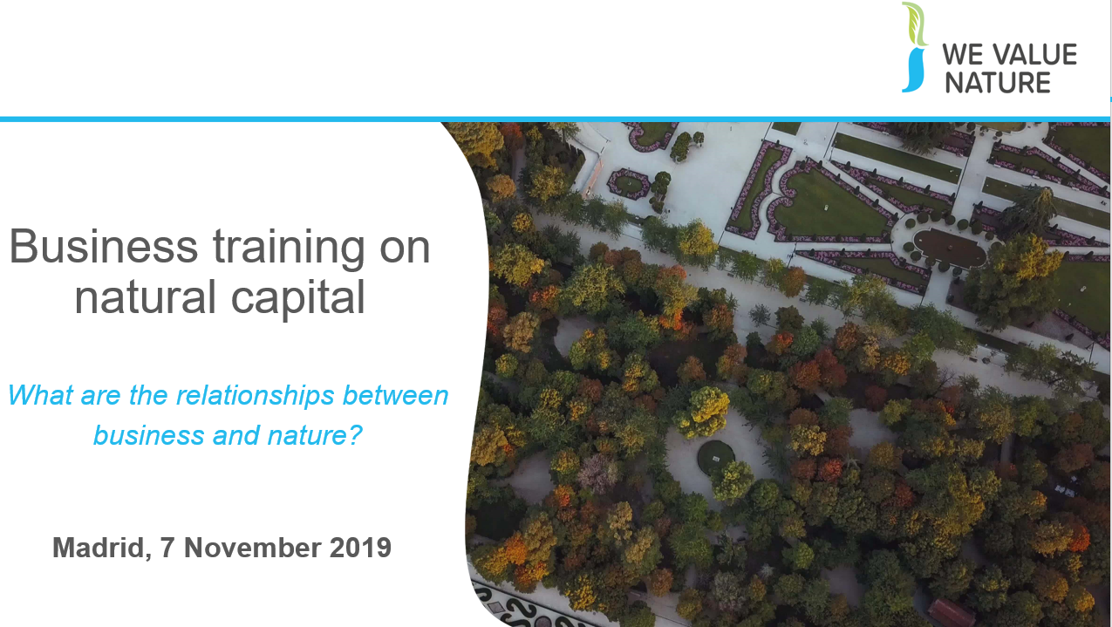
Speaking notes: business training on natural capital

Welcome all participants.

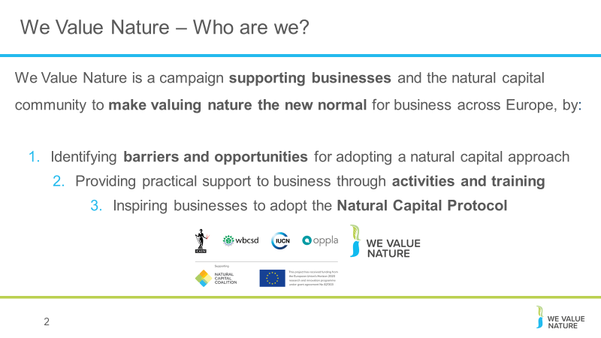
Introductions

Before kicking-off the training, introduce that this training is being given as part of the We Value Nature Campaign and explain what it is, its purpose, objectives and partners involved.

The We Value Nature Campaign is a €2 million EU-funded campaign supporting businesses and the natural capital community across Europe with the aim of making valuing nature the new normal for business. As we will have a chance to explore during today’s training, by valuing nature, businesses can make smarter decisions that benefit themselves, society and the planet as a whole.

The campaign is coordinated by the Institute of Chartered Accountants in England and Wales (ICAEW), World Business Council for Sustainable Development (WBCSD), The International Union for Conservation of Nature (IUCN) and Oppla. And it is supporting the Natural Capital Coalition, which has recently merged with the Social & Human Capital Coalition to become now the ‘Capitals Coalition’.

The campaign will aim to increase the uptake of the natural capital approach (including: natural capital assessment, natural capital accounting, nature-based solutions and green infrastructure) by identifying barriers and opportunities, providing practical support to business through activities (such as webinars, helpdesk calls, etc.) and training such as this one, as well as by inspiring businesses to adopt the NCP.

Take this opportunity to also thank the different stakeholders that supported the training (if relevant).
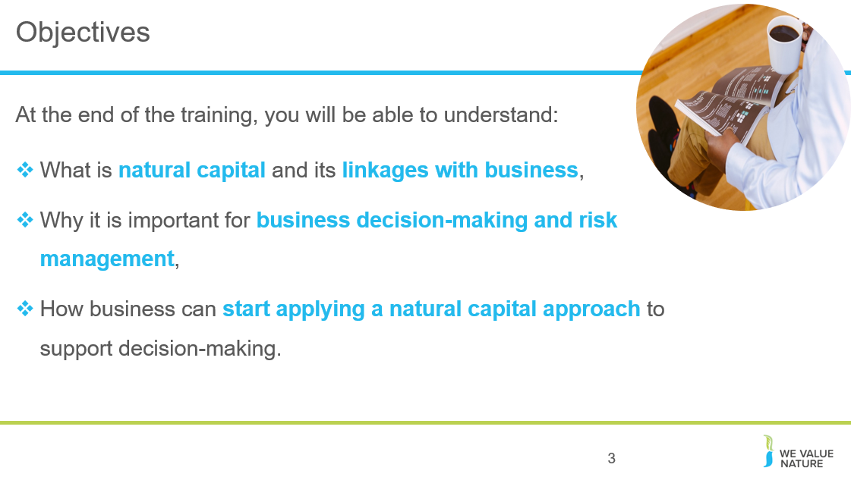
The objectives for today.
Emphasize that this training is particularly targeted at businesses in the early stages of their natural capital journey wanting to understand where to get started / organizations that want to help businesses get started.

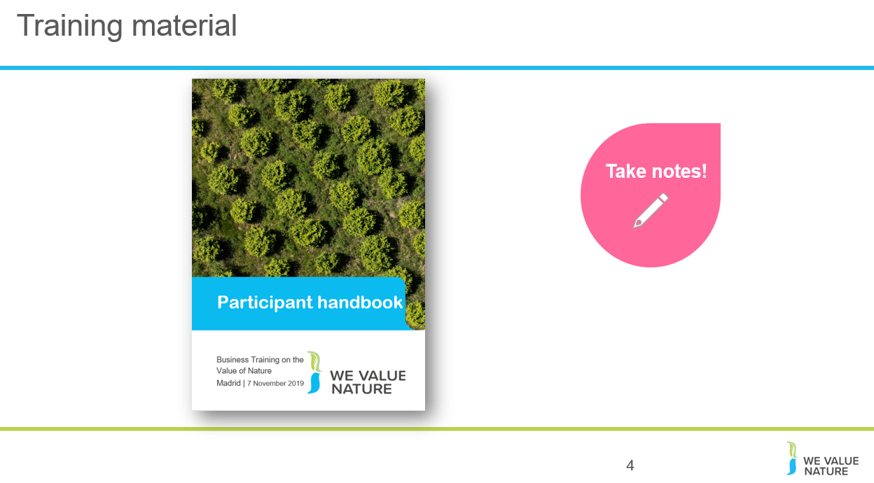
Mention that they should all have a ‘Participant handbook’ and explain that its purpose is to use it throughout the training. We have included in there some of the slides from the training but also additional information.

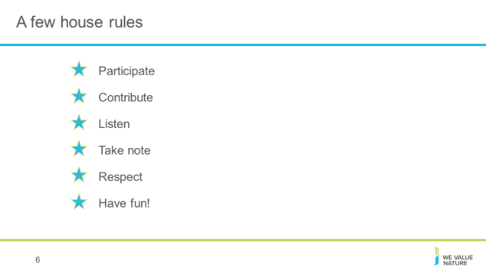
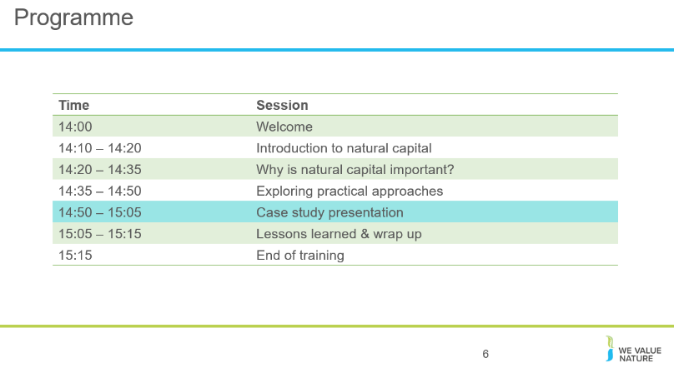
Run through the training ‘house riles’ re common courtesy, what is expected of participants during the training and the program for the session.
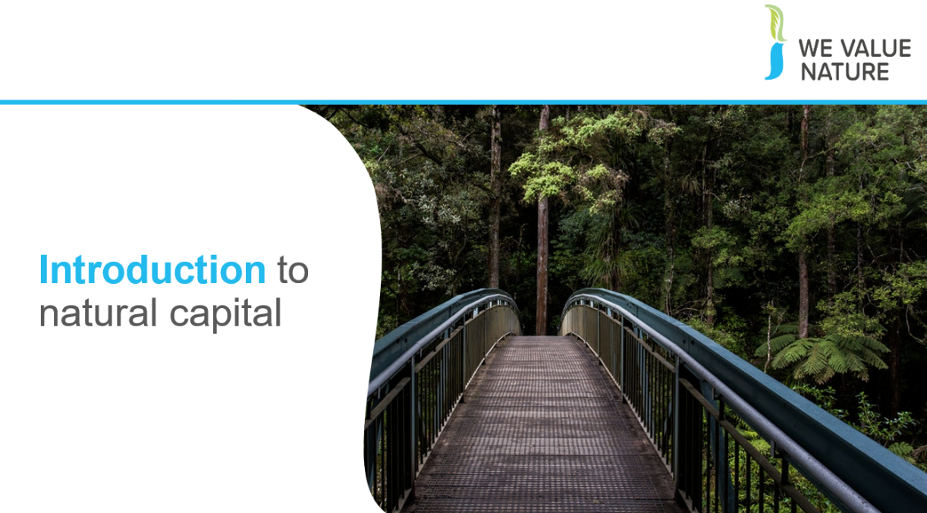
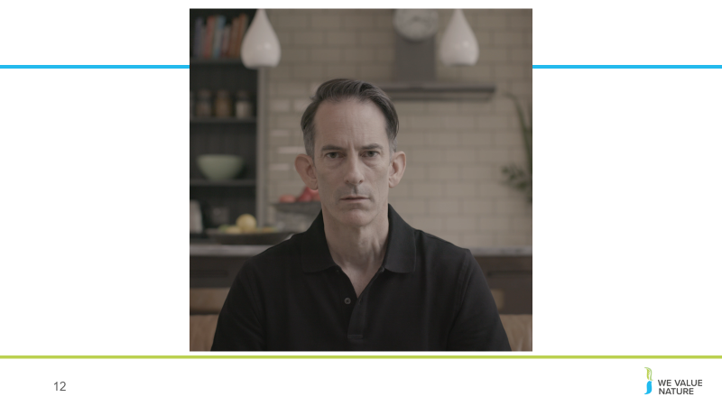

After showing video, open the floor to anyone that wishes to share something
Potential questions that can be asked to participants:
- Has anyone of you seen this video before? (Show of hands)
- What did you think of the video?
- What feelings or perceptions were perhaps triggered when viewing the video?
Direct them to where they can find the video: https://www.youtube.com/watch?v=UXZhlJyuw8A. The video was produces by WBCSD with the help of many of its members and with the aim to raise awareness among businesses on the importance to apply natural capital thinking into business.

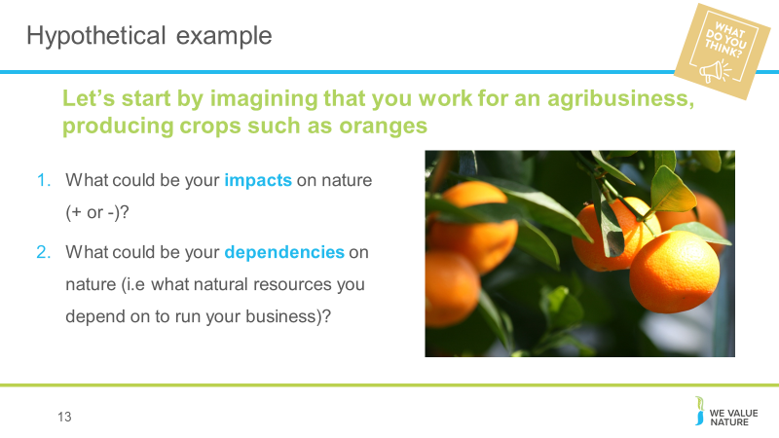
Hypothetical example

Give participants 3’ to reflect on both questions at their respective table and then offer participants to share in plenary some of the ideas that came out – 2’.
Reflect on responses:
- Reference of resources
- Scope of impacts – some examples referenced at product level others at supply chain level – direct operations or through supply chain
- Some may be directly related to the business. Others more indirect: water use through the process and noise/disturbances in extracting and manufacturing process, small particles
- Manufacturing process, customer phase – thinking about full suit
- How may depend on nature: if car manufacturing downstream from a forest for example, it depends on it to protect from flooding which if didn’t have that forest, factory could be at risk of being swamped
Potential answers:
Impacts: water use, soil degradation through overuse, (but also health: preventing too much rainwater runoff etc., absorbing carbon, biodiversity (loss because of monoculture, or helping through providing habitats), use of fertilizer
Dependencies: water, fertile soil, appropriate temperature and climate,
Elements to be considered:
What stages of value chain are we considering, where is farm based, is it organic or mass production?

Defining natural capital

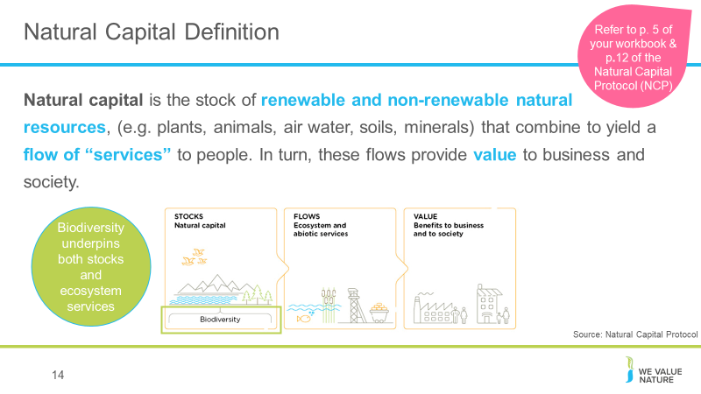

We have started thinking about natural resources an agricultural producer relies and impacts on but what do we mean when we talk about natural capital?

Well in fact, everything you have discussed through the previous example is natural capital is some form or another. Whether it is the assets/resources it represents (such as water and soil you have identified as needed for the farm) or the services it brings (e.g. pollination, etc.).

From climate adaptation to ecosystem services, the environmental jargon is everywhere. What is important, is not to remember all the terminology used, but rather that these are all connected to the value of nature and that people have different entry points and priorities and will use one or another terminology based on that. But fundamentally, we are all speaking about the same things, just in different ways.

This is the definition according to the Natural Capital Protocol. Refer to p. 12 of Natural Capital Protocol.

The stocks refer to the natural resources available to us while the flows refer to the different benefits people receive from ecosystems such as:
- timber,
- fiber,
- pollination,
- water regulation,
- climate regulation,
- recreation,
- etc.
Abiotic services are benefits to people that do not depend on ecological processes but arise from fundamental geological processes e.g. – supply of minerals, metals and oil and gas, as well as geothermal heat, wind, tides, etc.

In the Protocol biodiversity (part of stocks) is considered to be critical to the health and also the stability of natural capital in so much that it provides resilience to shocks like:
- Floods
- Droughts
As well as supports fundamental processes such as:
- carbon and water cycles
- soil formation
ADDITIONAL BACKGROUND:
Ecosystem services – key distinction between:
Supporting services: fundamental ecological processes that support the delivery of our ecosystem services
Regulating services: indirect benefits from nature generated through regulation of ecosystem processes e.g. – mitigation of climate change through carbon sequestration, water filtration by wetlands, erosion control and protection from storms

Why is natural capital important?
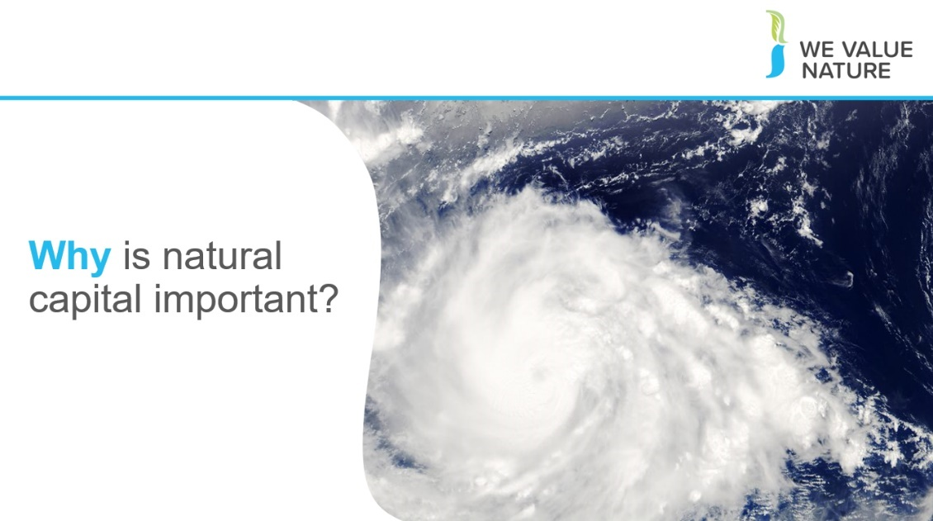

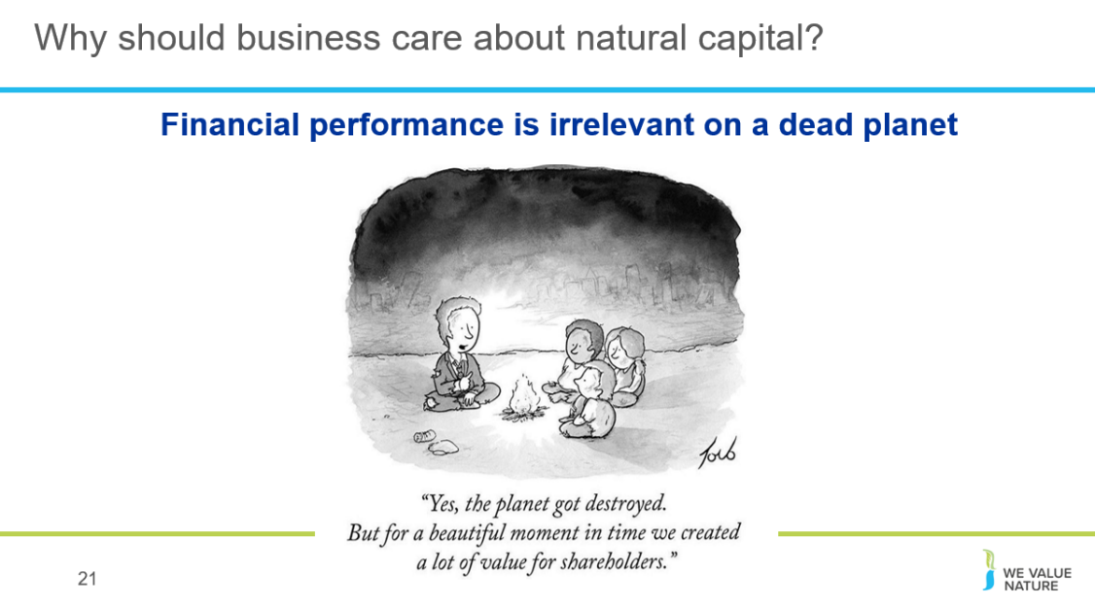

Business as usual is no longer possible.
Our ‘take-make-dispose’ way of consuming is no longer possible.
By destroying our natural world and its resources, we are destroying the critical foundations of our own survival.
We are going to see how business is part of the problem but also part of the solution.

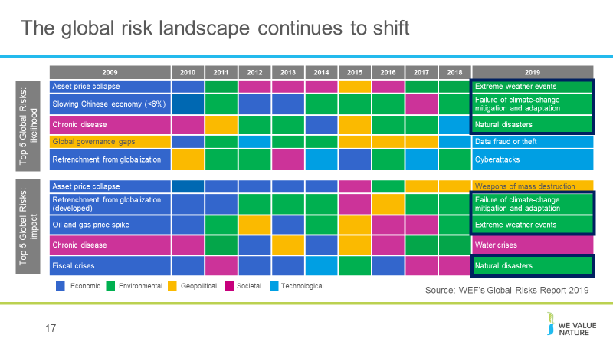
This is from World Economic Forum’s global risks report.

We can see that there’s been a complete shift of risks from 10 years ago. You can see that 10 years ago, none of the top risks by likelihood or impact fell under the umbrella of “environmental”. Come back to today, and 3 of the top 5 risks by both likelihood and impact are environmental.

Companies are increasingly facing natural capital related risks. More than ever, they are having to be able to understand, manage and mitigate their natural capital impacts and dependencies.

WEF’s Global Risks Report 2019 is published against a backdrop of worrying geopolitical and geo-economic tensions.
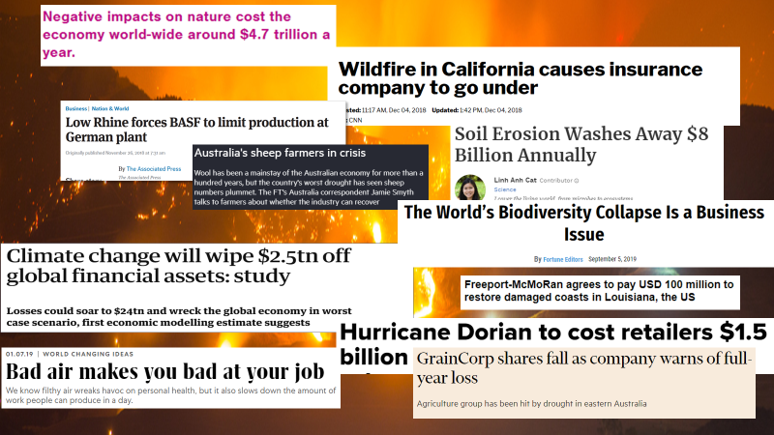

Real life examples:
- California fires: Last summer, California faced the deadliest and most destructive wildfire season ever recorded. The same year, a heat wave baked the entire Northern Hemisphere, killing dozens from Quebec to Japan.
- BASF: In 2018, BASF had to stop production of a component of polyurethanes at its main plant in Germany because low water levels in the Rhine river are impeding its ability to transport raw materials to the site.
- Pitch for nature: ‘negative impacts on nature cost the economy world-wide around $4.7 trillion a year.’
- Climate change will wipe $2.5tn off: according to estimates from economic modelling, clamate change could cut the value of the world’ financial assets by $2.5tn. The research also showed the financial sense in taking action to keep climate change under the 2C danger limit agreed by the world’s nations. In this scenario, the value of financial assets would fall by $315bn less, even when the costs of cutting emissions are included.
- Soil erosion: A new study estimates $8 billion in global economic losses caused by soil erosion reducing crop yields and increasing water usage. On average, 24% of arable land globally is undergoing severe erosion, with a severely detrimental effect on global food production.
- Australia’s sheep farmers in crisis due to severe drought that has caused the sheep population to plummet, leaving some farmers doubtful if the industry can survive at all.
- GrainCorp shares fall: after group warned it was likely to post a loss due to battling severe drought in Australia. GrainCorp’s stocks fell 10% on the news, leveling out at a 7% fall later in the day. It expected disruption to grain production due to drought.
- Hurricane Dorian costs retailers 1.5billion dollars: Foot traffic at apparel stores is expected to fall 25%, while visits to outlet centers will decline 32%. Restaurant traffic is expected to decrease 14%, threatening the typical labor day boost retailers in the region normally see at this time of year. The storm also affected ports on the Carolinas coast when many retailers are expecting to get their shipments for Christmas season around this time, disrupting supply chains.
- Biodiversity loss is a business issue: speaking at the Forbes Global Sustainability Forum, executive secretary of UNCBD said so because destruction is driven by business, whilst the consequences will also have significant impacts on business
- Bad air: researchers at the national university of Singapore studied pollution levels and worker output at two textile factories in China and found that having to work in poor air conditions leads to a decrease in productivity over time
- Freeport-McMoRan: mining company agrees to pay USD 100million to Louisiana communities in response to the damage it has caused to the coast through drilling for oil. Freeport is one of 98 companies that have been sued in 46 lawsuits over the disappearing Louisiana coastline. The agreement is likely to light the way for future litigation and settlements with industry big players such as Shell, Exxon, Chevron etc.

ADDITIONAL BACKGROUND:
Climate-related disasters have cost the world $650 billion over the last three years, and NA is shouldering most of the burden, according to a report from Morgan Stanley. 14 weather and climate disasters cost the nation $91 billion in 2018, Earth's fourth hottest year on record. A warmer planet could mean a big hit to G.D.P. in the coming decades.
IPCC report:
  - Consequences of 1°C of global warming through extreme weather, rising sea levels and diminishing Arctic sea ice
  - If the global temp. heats up by 1.5°C , Central and Eastern North America (Toronto, Ottawa and Montreal) will see highest levels of warming of extreme hot days.
  - Grasslands and wetlands that spread across Alberta, Saskatchewan and Manitoba down into the U.S. are breeding grounds for 50-80 percent of waterfowl in NA. Loss of biodiversity if the planet heats up by 2°C.
  - Heavy taxes or prices on carbon dioxide emissions —as high as $27,000 per ton by 2100 — would be required. Almost politically impossible move in the U.S., world’s largest economy and second-largest greenhouse gas emitter behind China.
  - B y 2050, use of coal as an electricity source would’ve to drop from nearly 40 percent today to 1-7 percent. Renewable energy such as wind and solar, which make up about 20 percent of the electricity mix today, would have to increase

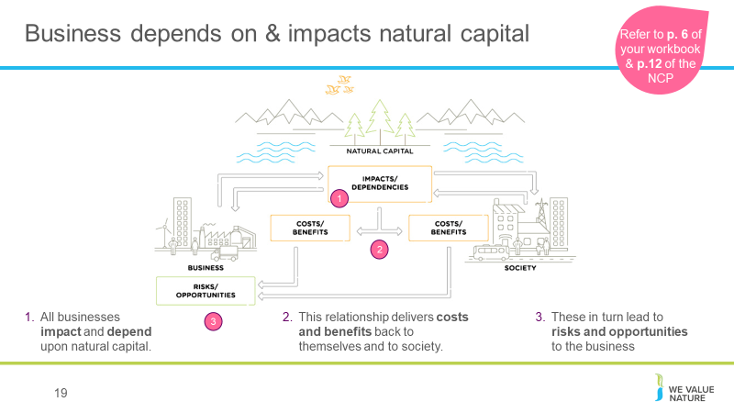
What the examples (from the previous slide) show, is that natural, social and economic issues are fundamentally interconnected and cannot be separated from one another. It also illustrates how natural capital underpins all the other capitals and without it we would not have social and human or financial capital.
1. All businesses impact and depend upon natural capital.
2. This relationship delivers costs and benefits back to themselves and to society.
3. These in turn lead to risks and risks and opportunities to the business
But this isn’t just theory and a nice diagram, these impacts and dependencies have the potential to affect businesses in a real way, and we’re seeing that right now.

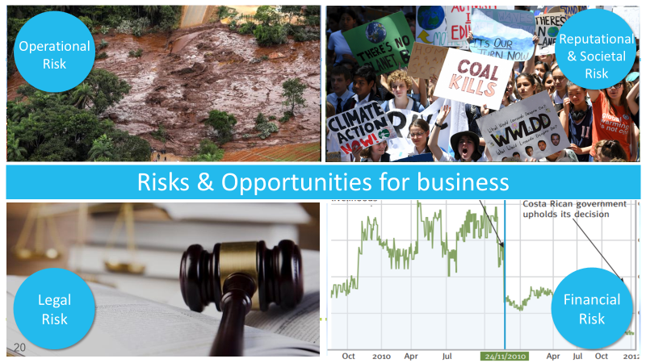

In years gone by, sustainability issues have sometimes taken business by surprise and companies have paid the cost. Companies are increasingly being impacted by the changing risk landscape discussed earlier.

The Protocol highlights key types / categories of risks and opportunities: (– refer to p. 18 of the Protocol).

Operational risk – Vale damn collapse
Reputation risk – increased public & consumer awareness of environmental and social damages + consumers are increasingly demanding assurance that the products they buy are produced in way that protect our environment and respect human rights –link with SOCIETAL risks – health impacts on local communities, social license to operate
Legal risk – giant Texas oil company, Anadarko Petroleum, has agreed to pay $5.1 billion for a vast environmental clean-up - aimed at restoring thousands of sites polluted by toxins and compensating thousands of people with personal injury claims.
Financial risk – Underlying all of these risks & opportunities are financial ones! As we have seen, these risks imply important financial costs. Canadian gold mining company, Infinito Gold, lost over 50% of its share value as a result of the withdrawal of a mining concession in Costa Rica due to concerns about the potential impacts on agriculture, endangered species and forests. This led to a reference in the audit accounts to material uncertainties regarding the company’s ability to continue as a going concern
Source: KPMG, Flora and Fauna International, Acca, Is natural capital a material issue? (2012)
Biodiversity loss risk: Biodiversity loss comes at the nexus of many other business risks. E.g. through decreasing food security (which itself has economic ramifications), or increasing the likelihood of coastal flooding. Biodiversity loss can be felt through physical risks (increased cost of resources, disruption of operations due to natural disasters unmitigated by appropriate ecosystems), associated regulatory and legal risk, market risk from changing consumer preference as consumers become more aware & discerning RE biodiversity, and supply chain risks. Examples:
- “Deforestation in the Agno River basin in the Philippines has led to such extensive river and reservoir siltation that the 100-megawatt Binga hydroelectric facility can only operate intermittently”,
- Studies have shown that the total economic impact of Hurricane Katrina (approximately US$150 billion), was significantly higher than would have been the case if costal wetlands in the region had been preserved,
- In 2008, the Norwegian Pension Fund withdrew its £500 million stake in the mining giant Rio Tinto and excluded the company from its funds. The decision to withdraw was based on the activities of Rio Tinto’s mining operations in Indonesia.

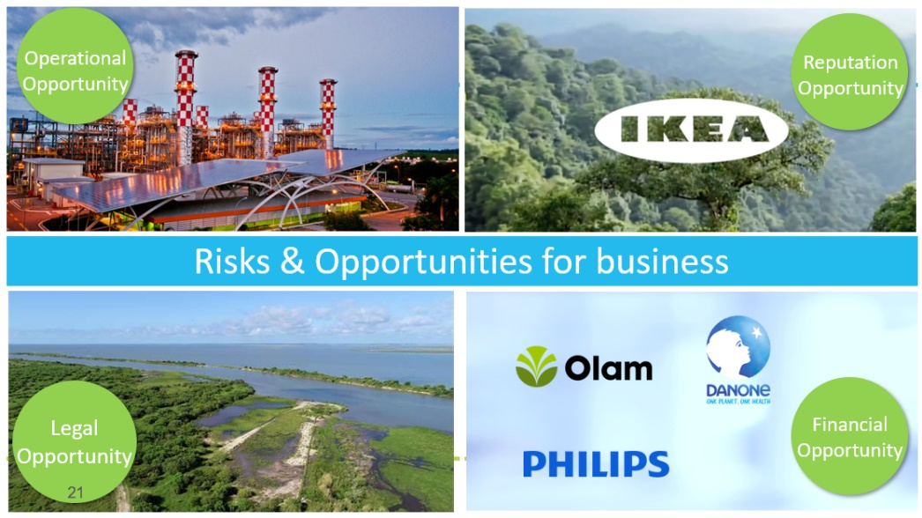

But good news is that, where there is risk, there is opportunity to:
- Secure natural resources
- Save costs
- Manage future risks
- Engage stakeholders
Operational opportunity – EDF rainwater harvesting to manage water scarcity risks leading to reduction in water consumption, economical & energy savings
Reputation opportunity – IKEA to use only renewable and recycled materials by 2030
Legal opportunity – Union Carbide Corporation, subsidiary of The Dow Chemical Company: Seadrift, TX Wetlands for Wastewater Treatment Project description: 110-acre engineered wetland in lieu of an industrial wastewater treatment plant In 1995, the Seadrift water treatment facility was seeking a solution to consistently meet regulatory requirements for water discharge. An innovative GI solution consisting of a constructed wetland was installed and has been successfully operating upon startup and for the last 15 years.
Financial opportunity – But when these risks are taken into account, we saw how it can also lead to reduced financial costs, or improve access to finance. Companies like those you can see here have managed to secure substantial billion dollar loan facilities where the interest rate of repayments is linked to ESG performance (such as Danone). That is to say if the company has strong environmental and social performance they pay back less on the loan.

Highlight that business impacts and dependencies are closely linked. For example, a company may depend on water, while the quality of its water management practices will affect the scale of impacts generated through its use of water.

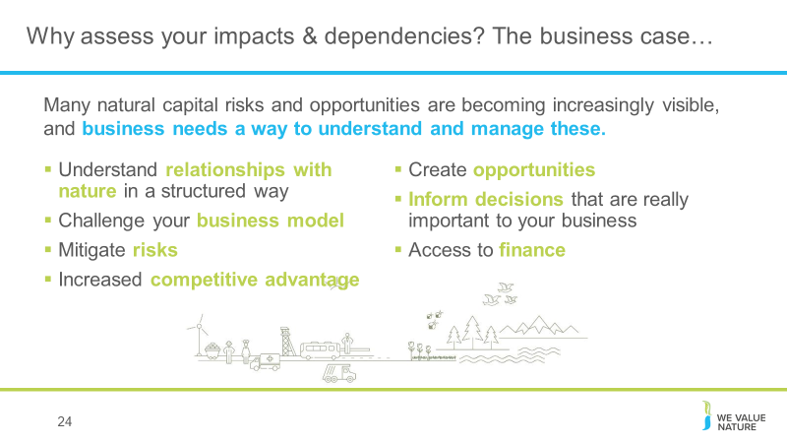
There are evidently a lot of pertinent risks around nature and the environment facing businesses today. Where does natural capital come into this - how can it help you manage these risks?
To assess natural capital is to assess your company’s impacts and dependencies on nature.
It provides information that will help you to understand your relationship with nature. By focusing on impacts and dependencies, natural capital provides structure to this understanding.
Once you have a better understanding of your relationship with nature, you can use this to challenge your business model, mitigate risks and create opportunities. Natural capital can also be a valuable tool for broadening the conversation to include all parts of your business, including the finance team.

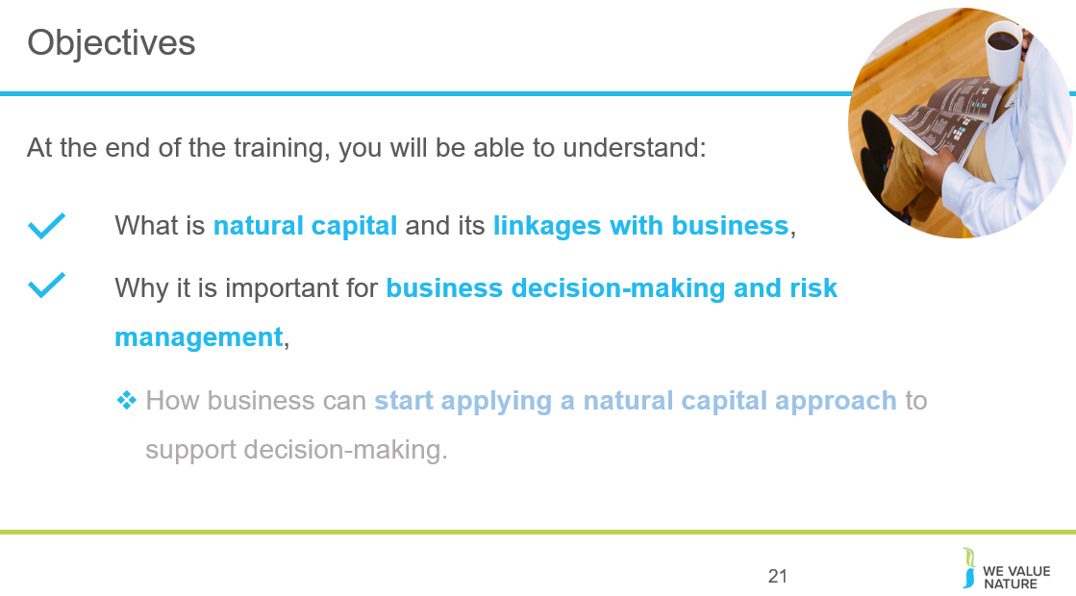

Briefly summarise what participants have learnt so far, and highlight what’s next.

How can business apply natural capital?
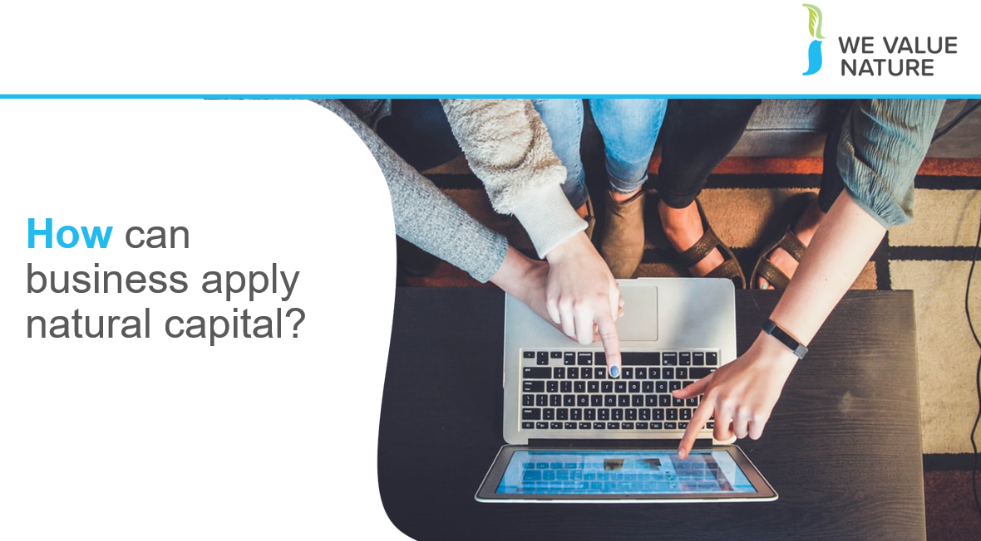

After looking at why natural capital is important and why should business care about it, we are now going to look at how business can start applying and integrating NC, how to get started on NC journey.

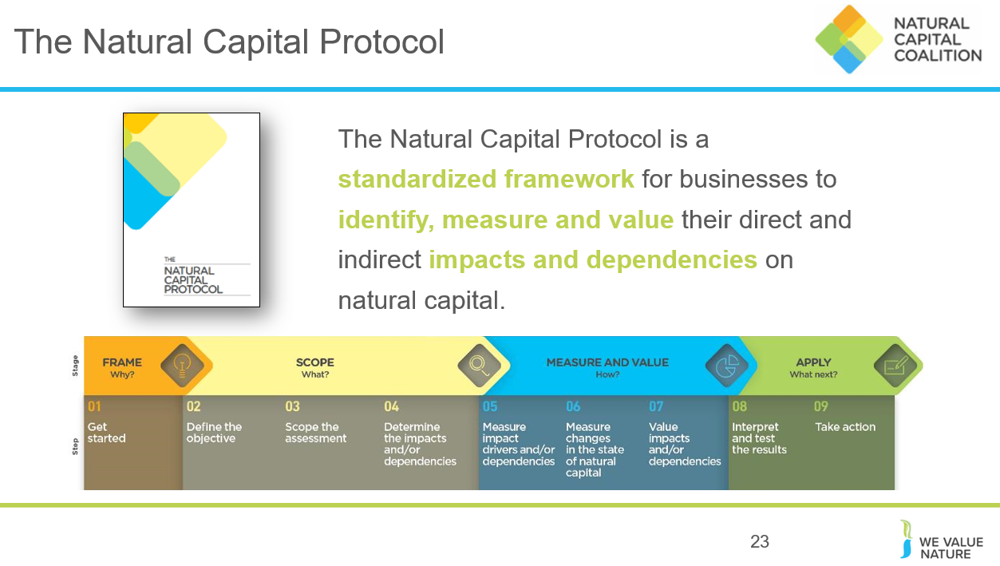

The Natural Capital Protocol has been produced by the Natural Capital Coalition (a network of more than 300 organisations across research, science, academia, accountancy, reporting and many others…) in order to harmonize approaches to natural capital and help businesses get to grips with a crowded and confusing landscape.

The NCP build upon many approaches and seeks to present a standardized, harmonized, global approach to applying natural capital and ultimately, supporting better and more informed decisions.

STRUCTURE of the Protocol:
4 overarching stages of frame (why), scope (what), measure and value (how) and apply (so what) and 09 logical steps. It should be easy to follow and should be suitable for any business across any sector or geography. The stages and steps are iterative so expect that you may need to revisit a previous step.

The NCP is a framework – it lays out the steps, helps to structure your thinking and your research. However, in order to actually assess natural capital in your business, you will need to make use of specific methodologies or tools. The Protocol does not recommend any specific tools, because this is highly dependent on your particular business context and what you want to get out of your assessment. What the protocol does do is help you realise your business context, to frame your assessment and prepare you to select the right tools for your assessment. NCC also provides a toolkit, which we will share the link for after this presentation, which collates a few of these useful resources and tools in one place.

Facilitation note: be sure to frame the NCP as an overarching, globally accepted framework, and also highlight that it does not provide specific tools with which to carry out an assessment – for that you need something like the NCP toolkit.

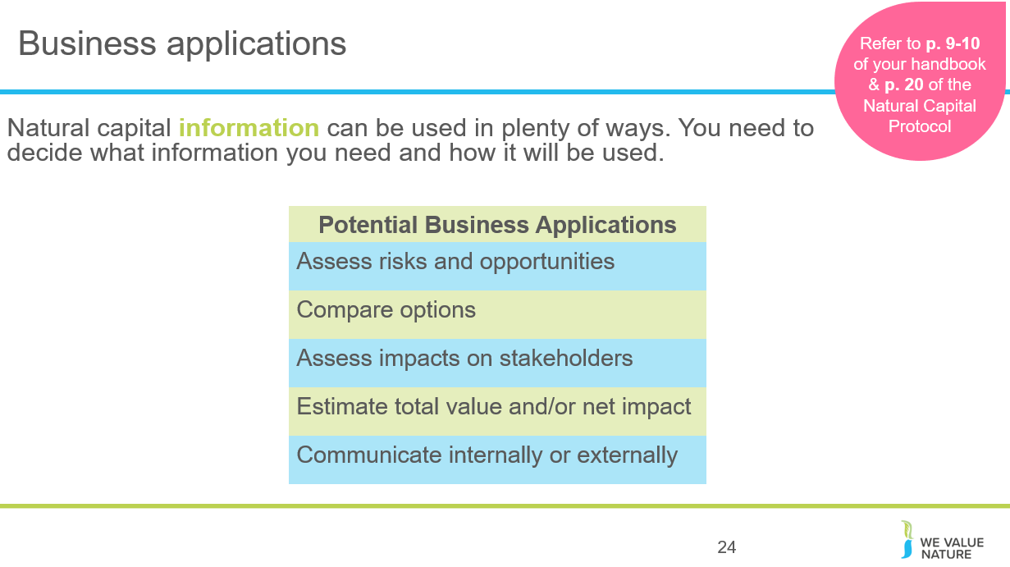
A natural capital assessment provides information. Whilst this can be valuable in its own right, and it’s okay to carry out an assessment just for fact-finding, this means there are also numerous ways to use this information for further purposes.
The NCP focuses on using natural capital for decision-making, measurement and valuation, but it can also be used for disclosure and communication, or to help formulate strategy.
The best way for your company to use natural capital information is highly individual – think back to the challenges and risks you identified earlier in the training and consider how exactly how more information could help you meet these challenges.

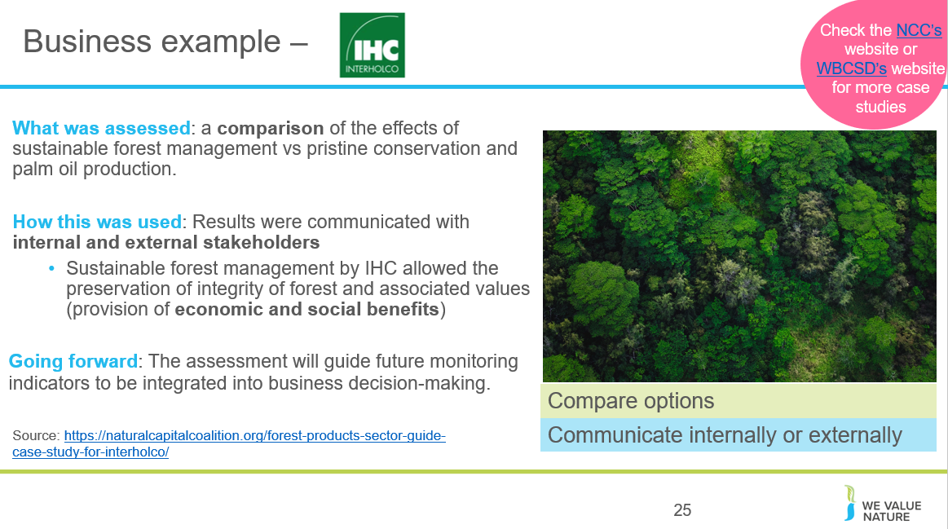
Source. Interholco (IHC) specializes in forest management and wood production and is one of the largest producers of African tropical hardwood
IHC undertook a study comparing the effects on the forest of undertaking sustainable forest management in the Congo basin vs pristine conservation and palm oil production.
They found that SFM provided more economic value and comparable natural value as conservation. Palm oil theoretically provides 700x economic value than conservation and 40x more than SFM, but this is outweighed by significant co2 emissions associated with deforestation for palm oil and irreversible loss of ecosystem (showing benefit of taking NC approach).
Going forward: the assessment will be used to provide insight on impacts and dependencies, and guide future monitoring indicators to be integrated into business decision making. IHC may in future undertake specific NC assessment for new business development scenarios.

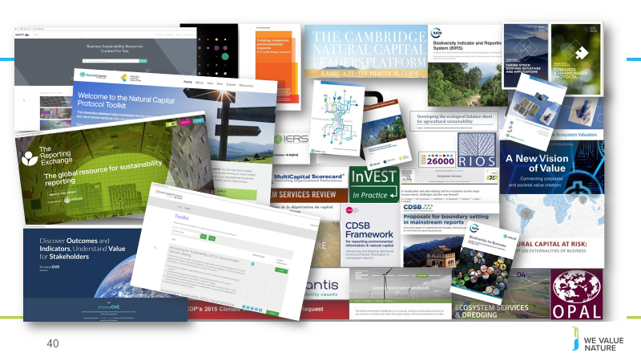
We can see from this slide, the wealth of intellectual content, tools and approaches that already exist in the natural capital field.
This certainly highlights the need for standardization, and a process into which all of these existing resources can input. As we have seen, the Natural Capital Protocol does NOT aim to recreate or invent any new methodologies – instead leverages what we already have.
This also shows that while there are many tools, methodologies and resources out there, this can add to the confusion hence the importance to have a good understanding of what it is you are trying to achieve, what kind of information you are trying to collect or decision you are trying to inform in order to chose the most appropriate tool / resource.

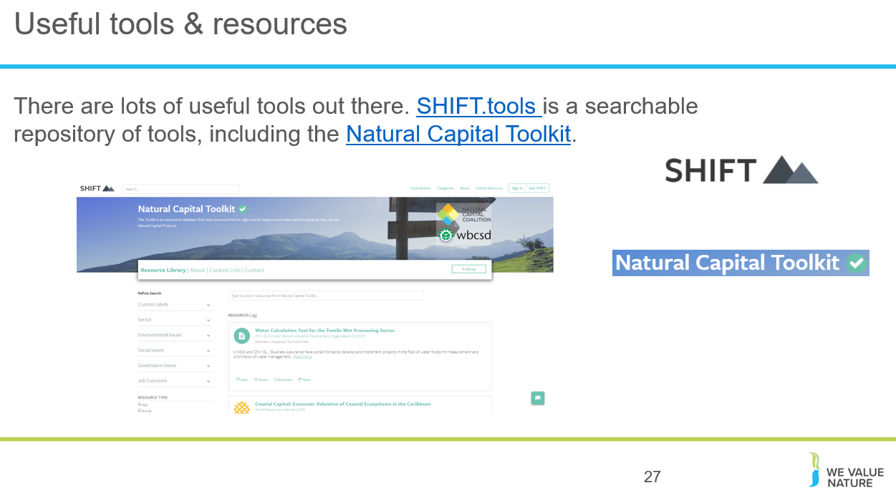
This shows that there are many tools out there, many of which are freely accessible and readily available for companies to use and start assessing their natural capital impacts and dependencies.

Facilitation note: This is a nice exercise to have them realize that there are many tools available and that the one they will choose will depend on many aspects.

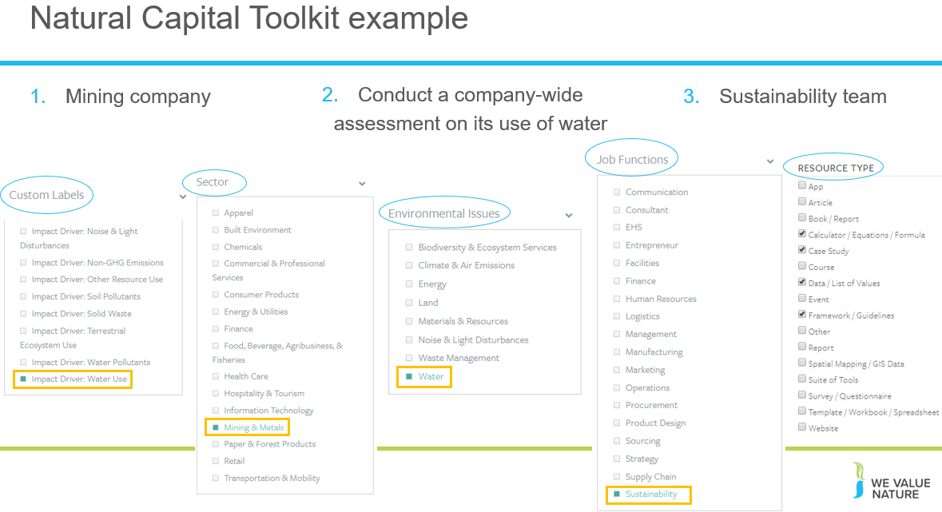

Conclusion is that:
- There are no perfect answers!
- The choice of tool will depend on various factors:
  - What is the objective / what are you trying to achieve? / What decision are you trying to inform? – Is it to inform business strategy? Business management? Or operating decision?
  - What is the scope? Are you looking at product, corporate level?
  - What perspective are you looking at? Business? Societal? Both?
  - How much resources do you have available to conduct the assessment?
  - How much information / data do you already have?
  - Will you need external help?
  - Etc.

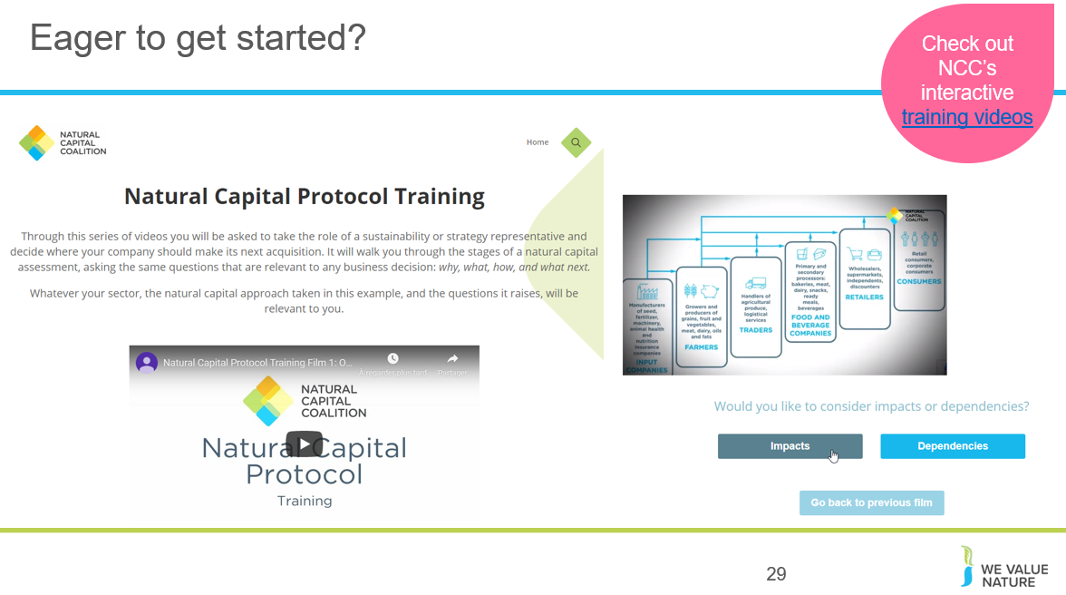

The Natural Capital Coalition has recently launched a set of training videos that will guide you in an interactive way through a light natural capital assessment to explore just how much can be achieved with limited resources. Interested to learn more? You will be able to access these videos in the link on this slide which will be sent to you after the training.

Case study presentation
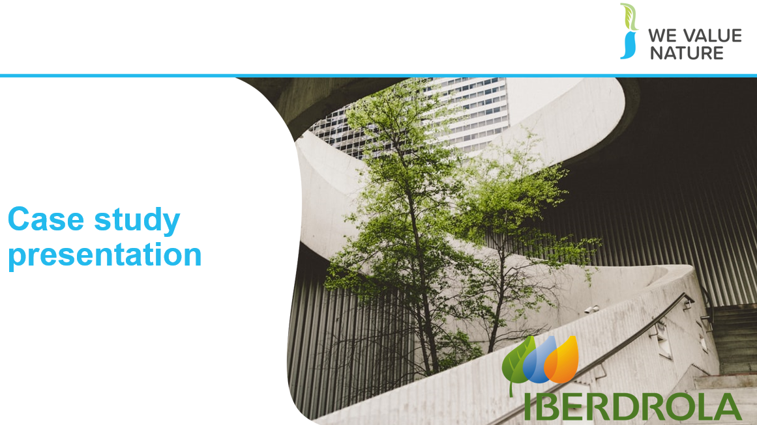

Speaker: Emilio Tejedor, Environment Manager of the Innovation, Sustainability and Quality Department

Iberdrola Energía, S.A.U. offers power plant construction services for electricity, water, and gas sectors. The company was incorporated in 1988 and is based in Madrid, Spain. Iberdrola Energía, S.A.U. operates as a subsidiary of Iberdrola, S.A.
- Case study presentation (15’)
- 10’ presentation
- 5’ Q&A / discussion in plenary
Prior to the training, brief presenter to focus his/her presentation on the below points:
- Problem statement (what made them adopt a NC approach)
- Approaches / tools used
- Barriers / challenges + how overcame these
- + outcomes of the solution put into place & decision(s) informed
- Stakeholders involved
- How would do things differently + next steps

Urge participants to take note of case study in the dedicated space in their handbook.

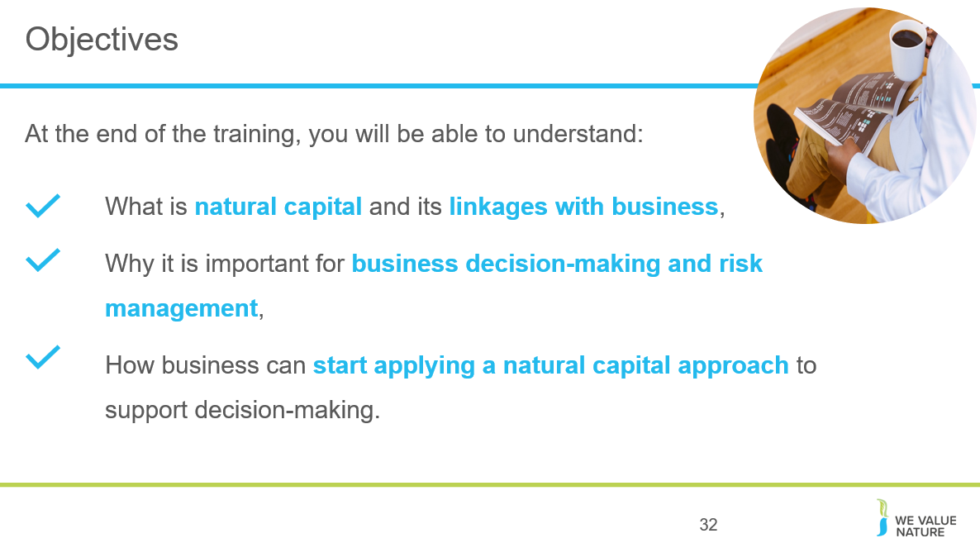
Summarise how last section has contributed to this final learning objective.
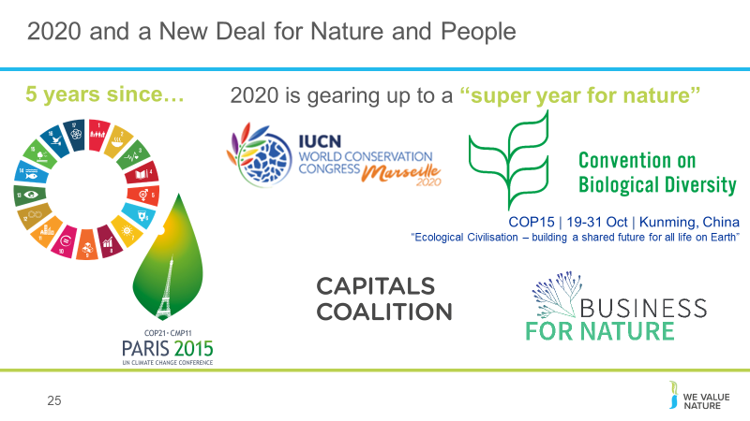

Strong call for a global agenda for action on nature and biodiversity; 2020 “super year” for nature. There are several crucial political decision milestones in 2020, providing key opportunities to address the frightening loss of nature. Protecting wildlife and reversing the decline of nature requires urgent global action.
ATTENTION!! Don’t assume that everyone will know these initiatives so also make sure to explain these and why business should care about them / keep an eye out.
While the IPBES Global assessment report warns that nature is declining globally at rates unprecedented in human history, it also tells us that it is not too late to make a difference, but only if we start now at every level from local to global, and through transformative change, that is, system-wide reorganization across technological, economic and social factors, including paradigms, goals and values.
2020 as a crucial year for securing international agreements for a New Deal for Nature and People, through a commitment by heads of state at the 75th United Nations General Assembly. World leaders are also expected to review the progress made on the UN Sustainable Development Goals, the Paris Agreement and, crucially, negotiate new 10-year targets for the UN Convention on Biological Diversity (CBD).
- Many of companies’ SDGs targets coming to an end in 2020
- Paris Agreement on Climate is due to begin.
- 15th CDB COP meeting in Beijing in 2020 - This is a very important conference, as targets for nature for the decade 2020 to 2030 are to be agreed.
- Unified business voice through Business for Nature coalition: it will champion radical collaboration to unite the vast network of business initiatives for nature in a somewhat similar way to the We Mean Business coalition did/does for climate. It will complement and drive business momentum for the Nature Action Agenda. A diverse, and powerful group of stakeholders including WBCSD, We Mean Business, the Consumer Goods Forum, the World Economic Forum, the Natural Capital Coalition and WWF have come together to initiate this coalition. (WBCSD leading business solutions)

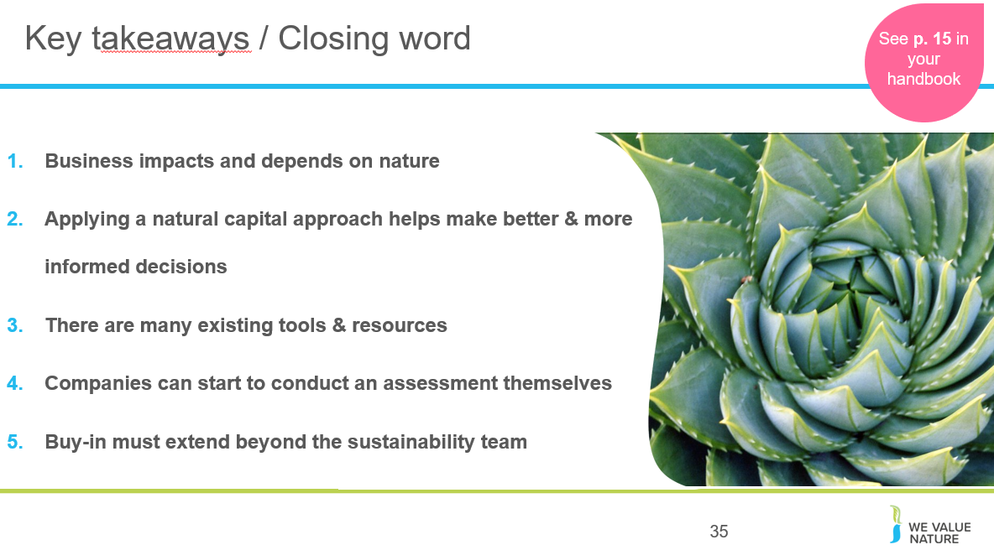
- Business impacts and depends on nature – the NCP provides the framework to identify and assess impacts and dependencies,
- Understanding, measuring and valuing natural capital (i.e. taking into account) will help business make better & more informed decisions,
- There are many existing tools & resources to measure and value impacts and dependencies. The one you chose depends on the information you are aiming to get or the decision you are trying to inform,
- Companies can start to conduct an assessment themselves by getting the project going, scoping the assessment and integrating natural capital considerations into internal processes,
- For natural capital to become strategically important, buy-in must extend beyond the sustainability team.
ADDITIONAL BACKGROUND
How much will an assessment cost?
Some of the Protocol pilot testers - like our members Nestlé and Roche - estimated they spent about USD $50,000 on consulting services for their assessments over a six-month period. Some companies spend less, others spend more.
Dow, Kering and Natura have invested significantly more over a longer term, for in-depth assessments that contribute to their multi-year strategic ambitions
The Protocol can help companies navigate these kinds of situations by making sure the services required align with the assessment's objective.
Skills & data needed:
It's usually much more efficient to build on existing data that's readily available in-house, and the Protocol provides guidance on gathering and using that data too.
For example, many companies have data on their own GHG emissions, water, waste, and some also have results of product Life Cycle Assessments - this existing information can provide a really good starting point for a natural capital assessment. How applicable it is will depend on the objectives and scope of the assessment though, so it's important to find the balance between getting perfect data (e.g. from monitoring in the field) and using proxies that are not as accurate but can be more practical and still lead to better decisions.
Internal buy-in:
In many cases, natural capital assessments can be a bottom-up effort. Trying to drive natural capital assessments from sustainability, environment or health and safety departments is sometimes difficult, but nevertheless, the Protocol provides guidance on integrating the assessment into the business itself.
One way to facilitate engagement internally can be to show that "many companies are already doing natural capital assessments; they're just using different terminology and steps.
To support this engagement, it is important to look beyond those benefits that can be valued through the natural capital assessment itself, and acknowledge how a natural capital approach can motivate organizational change in support of broader business goals." This means that there will be more leadership from the top to better measure, value and then integrate natural capital into business.
The bottom line is that although carrying out a natural capital assessment is technical, it's also achievable. Not every assessment has to be a huge undertaking, so companies should start off with a scope that makes most sense to their situation. The Protocol will help you do this.
Finally, we must make sure the information obtained from the assessment is included in core business decision-making. This will ensure you have the best possible impact on your business, and on the environment.
https://www.wbcsd.org/Programs/Redefining-Value/Business-Decision-Making/Measurement-Valuation/News/What-does-it-take-to-carry-out-a-natural-capital-assessment
Facilitation note: make sure to remind participants that they can do it, it’s not as complex as it may seem, and that WVN are here to help and have the resources!
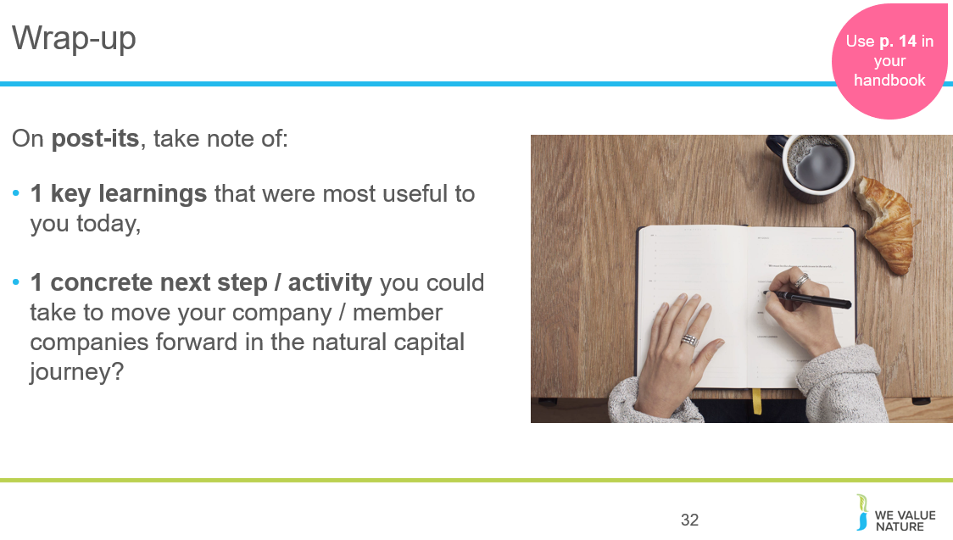

Ask participants to write down on 1 post-it 1 key learnings and on other post-it, next concrete action will take. To save time, ask them to place both post-its on flipcharts as they leave the room.

Remind that there will be time during the coffee break following this session to ask questions, discuss further with us or Emilio.
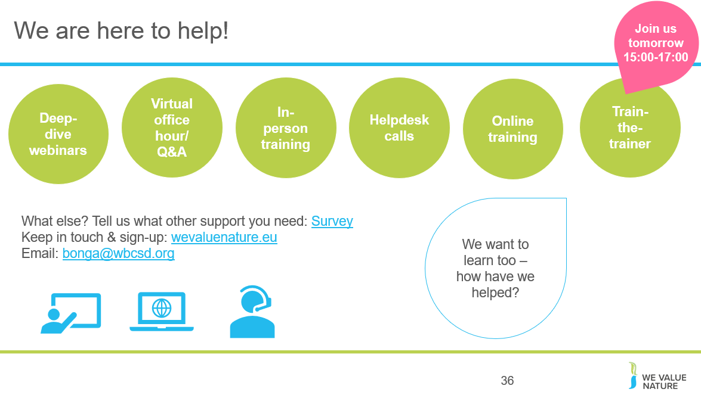
WHAT ELSE would you need? What support would you need?
Sign-up for in-person day training, t-t-t
If want support, need to fill out survey (Google form survey)
Refining training further, keen to know how have used this training and catch-up via call (if don’t want to, let us know)

Please don’t hesitate to contact Katia Bonga (bonga@wbcsd.org) to get latest updated on upcoming engagement opportunities.

