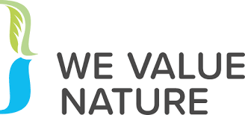

Create a market place for Nature-based Solutions where project ideas meet investors.

Revised draft 12 April 2022

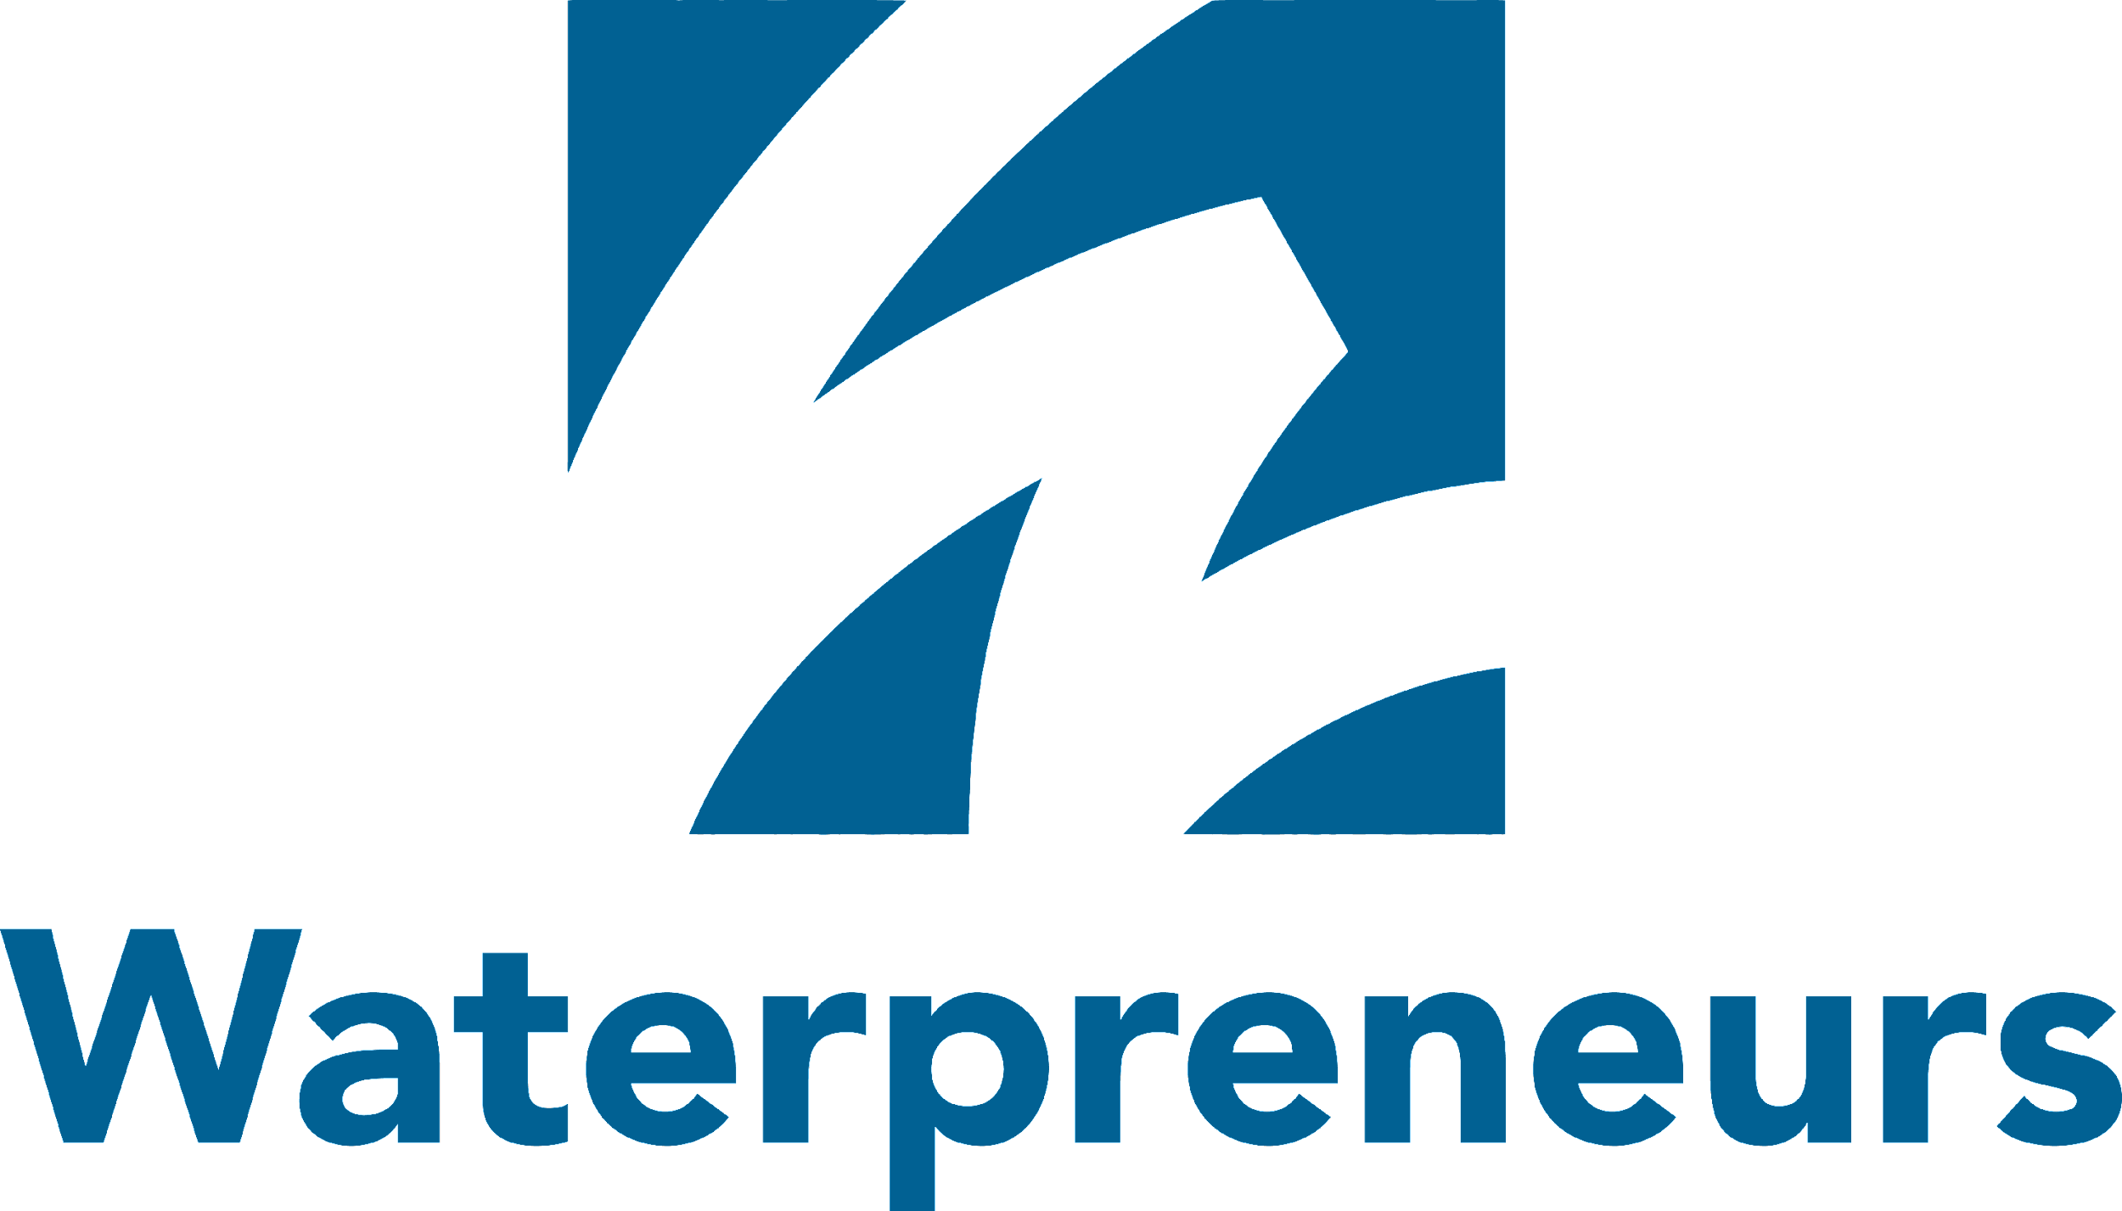
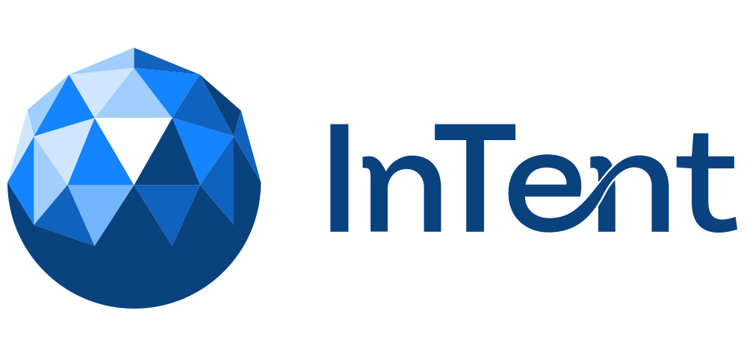
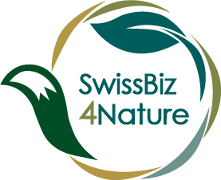

Innovate for Nature (I4N)
An innovative biodiversity focused marketplace dedicated qualified investors and curated projects

Event Outputs and Operational Framework for Future Use

Contents

Preamble and next steps 3
1. Initiative background 3
2. Innovate for Nature (I4N) goals 4
3. Innovate for Nature vision 5
4. Operating scheme 6
5. Achievements to date 8

Preamble and next steps

We Value Nature was solicited to provide some support to allow for the first event on Dec 8, 2021 to take place. This was provided through the operational fund and allowed the first event to take place as the Covid situation allowed for a hybrid event. As this was organized in the last few weeks of the life of the WVN project the engagement was to provide an additional legacy document and some reflections on the main outcomes of this first event as well as some thoughts and reflections on how this could be repeated and exported outside of the Swiss context and linked to other existing European based initiatives. The current existing partners involved are Swiss based consultancies and not for profit organizations with some international outreach but wanted to first test the model and roll it out in Switzerland before exploring further roll out in Europe or beyond.
As of April 2022 the full funding for a further roll out has not been secured yet. All the event/workshop outputs are freely available online and links are provided to the We Value Nature platform. Some additional preparation material for future roll out and pitching documentation to seek additional funding have been prepared and available on demand. No definite plans as how this is taken to the next level are formalized to date and this report includes some of the initial attempts. The current partners are awaiting an answer from a potential donor Migros Pioneer Fund in May/June 2022. IUCN, who will remain involved after the end of the We Value Nature project will ensure that connection is kept to European based initiatives such as Network nature to further explore the interest and opportunity to roll out at a European scale or beyond and explore synergies with existing initiatives.

Initiative background

The Innovate for Nature (I4N) marketplace is a specific platform operating in alliance with the IUCN led “Swiss Business for Nature” initiative aiming at transforming economic actors behaviours toward stopping nature losses and improving the overall state of biodiversity, in Switzerland and beyond. The Swiss Business for Nature coalition has decided to partner with Waterpreneurs (Waterpreneurs) and InTent (Intent : A place for business with purpose | InTent (intent-for-change.org)) so as to benefit from proven investor matchmaking event know-how in view of further developing the visibility and mainstreaming of Nature-based Solutions projects.
Nature-based Solutions (NbS) are defined as “actions to protect, sustainably manage, and restore natural or modified ecosystems, that address societal challenges effectively and adaptively, simultaneously providing human well-being and biodiversity benefits” (IUCN). Research highlights that NbS could provide around 30% of the cost-effective mitigation needed by 2030 to stabilize warming to below 2°C. They can also provide a powerful defence against the impacts and long-term hazards of climate change, which is the biggest threat to biodiversity. Finding ways to work with ecosystems, rather than relying solely on conventional engineered solutions, can help communities adapt to climate change impacts. Using nature to green cities can also result in significant energy savings and health benefits.

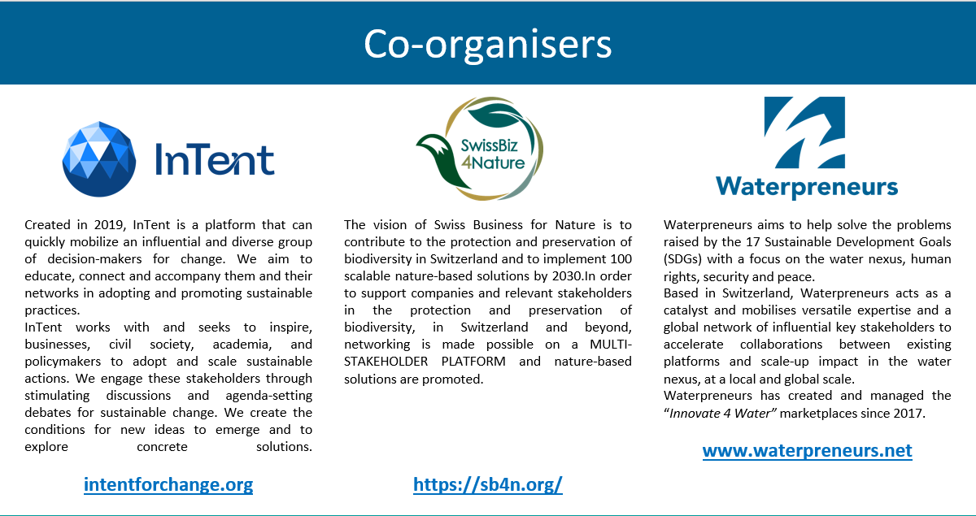

Innovate for Nature (I4N) goals

I4N aims at providing a framework for companies engaged in nature relevant projects to embed the IUCN Global NbS Standard and to qualify for pitching their fundraising needs in front of qualified investors. I4N intends to leverage a series of events, scaling up worldwide possibly, so as to become the marketplace of reference where entrepreneurs meet with investors to expand on the imperative to deliver NbS projects at scale. Importantly all the screening and NbS evaluation methodologies are compulsorily tied to IUCN and its experts.

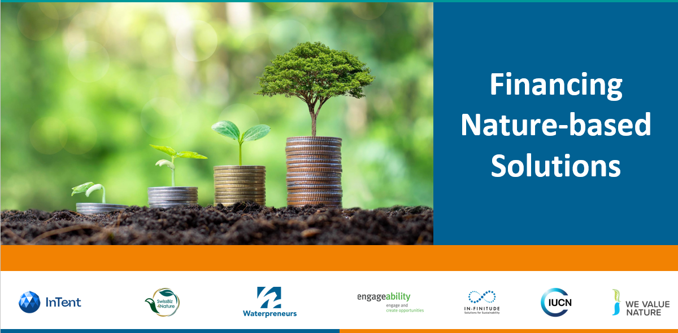

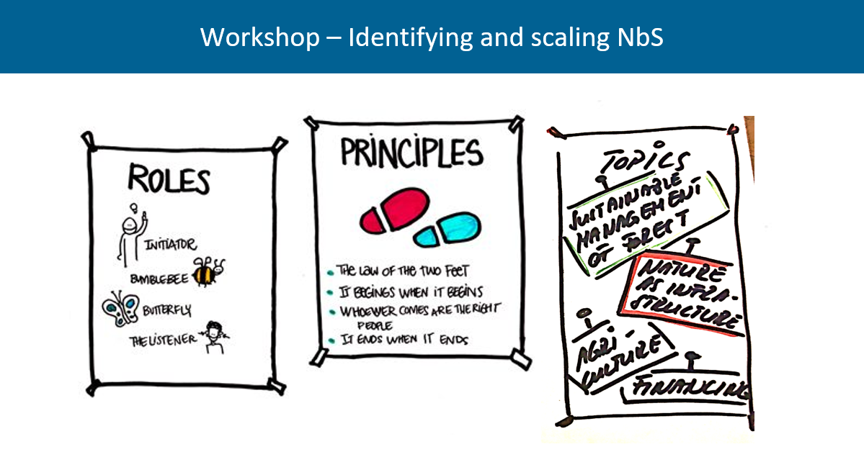

Innovate for Nature vision

Through proven methodologies and the support of authoritative institution in the field of biodiversity, IUCN, Innovate for Nature intends to deliver impactful positive change in the local natural ecosystems whilst encouraging projects and entrepreneurs to adopt new paradigm frameworks in full alignment with the green finance expectations.

The benefits are multiple as per the following virtuous implications:
- Businesses and entrepreneurs see value in adopting the IUCN NbS Global Standard by being given access to a large array of financiers and influential stakeholders, standing altogether in a large network effect.
- Based on the worldwide presence of IUCN, there is an opportunity to create regional hubs and movements that will lead and coordinate Innovate for Nature in the most effective fashion to further apply the marketplace concept to local realities.
- Innovate for Nature is an instrument that will align viable economic parties (companies and investors) to comply with nature positive imperatives.
- Innovate for Nature has the ambition to foster public-private partnerships allowing governments and public actors to closely collaborate with private sector actors and financiers in developing the right frameworks and conditions to roll out nature based solutions at scale.
- Innovate for Nature can establish the right basis to help authorities define a regulatory frame in the future pertaining to embedding nature positive aspects in all business models.
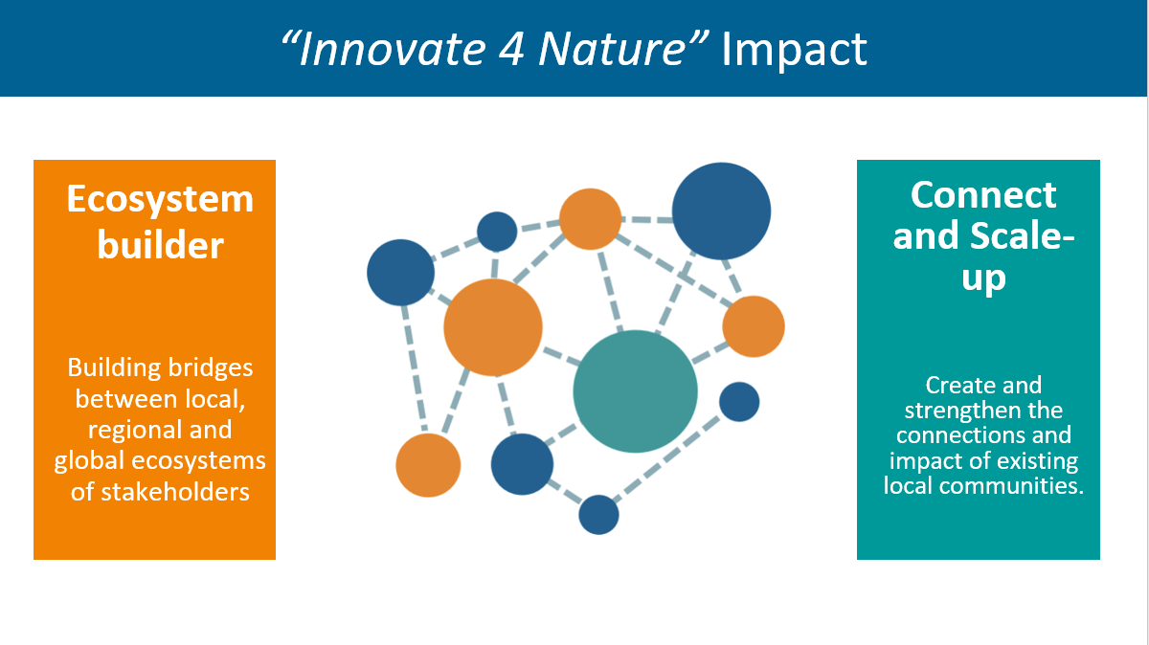

Operating scheme

Innovate 4 Nature main piece consist in a matchmaking event for which a thorough level of preparation is required, and, on the other hand, there is a large spectrum of follow on activities taking place post-event.
This can be summarized chronologically in the following sequence:
- I4N Promotion. The next Innovate for Nature event is advertised at a given location and a call for projects is launched
- Pitch Entry. Each project that is submitted goes through a specific financial evaluation screening (provide by an experienced ESG analyst) together with a NbS check list (to be developed). This is a simplified version from the full IUCN NbS Global Standard self assessment, indicating the presence or absence of key elements that will need to be developed further to be in stronger adherence with the IUCN NbS global standard over time.
- Classification of projects. Each project receives a rating according to a three rank system (excellent, needs improvement or fail).
- Projects rated as excellent automatically qualify for obtaining a pitching slot at the I4N event. Specific “pitch preparation” coaching is provided ahead of the event but will not require a major change or review of the actual project proposal.
- Projects rated as “needs improvement” are eligible to further coaching given by I4N staff, and upon satisfactory effective improvements, then they can also benefit from a pitching slot at the I4N event.
- Projects rated as “fail” are not being granted with any pitching slot for the next I4N event, however they are free to receive support from the I4N experts in order to qualify for another event in the next 12 to 18 months.
- I4N Event Day. Organization of the matchmaking event gathering NbS projects proponents (enterprise actors), prominent private sector companies, government and public sector representatives and investors (financial institutions, investment funds, philanthropists). Ensure participation of recognized leaders for interventions and keynotes giving a vibrant and compelling atmosphere to the event.
- Complete assessment of adherence to the IUCN NbS Global Standard. After the event, once a matchmaking is effective in between a project and a financier, I4N mandates IUCN to run an extensive check of the project vis-à-vis the IUCN NbS Global Standard by following the IUCN NbS Self-Assessment procedure, strictly, that involves a thorough Technical Review by IUCN NbS experts.
- Promotion. For the successful NbS projects that receive funding, the I4N consortium offers wide-spread broadcasting and showcasing in select media and partner platforms.
- Scaling. I4N is interested to grow internationally and is prone to engage with sponsors and relevant parties willing to host such meaningful platform abroad whether it is in Europe, Africa, Americas or Asia. It is an open place of discussion at this point.

The “Innovate for Nature” project funnel procedure
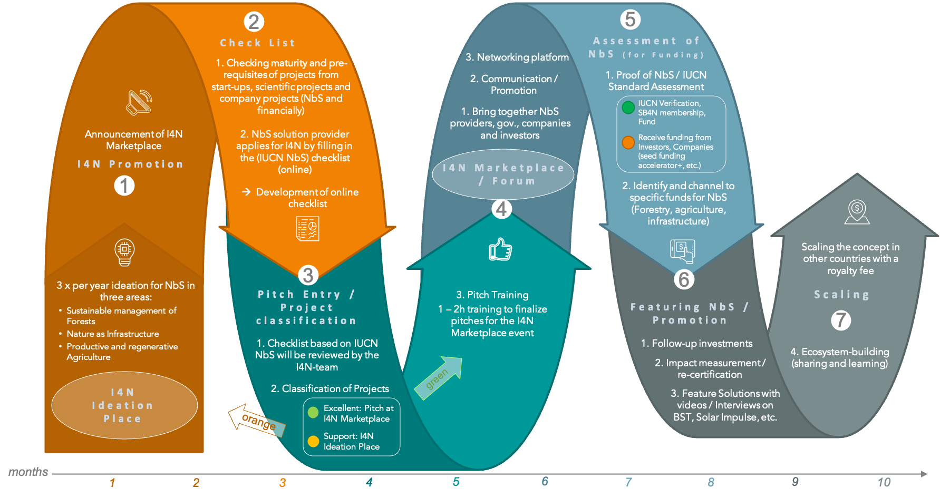

Achievements to date

So far I4N has been deployed once, as per the event organized at the EPFL (Swiss Federal Institute of Technology Lausanne) campus in Switzerland on 8 December 2021, gathering non-state actors, NGOs and relevant coalitions.
Documentation and full recordings of the 8 hour event are available on the following links:
https://www.innovate4water.net/innovate4nature-lausanne
The handbook (one single Pdf file) provides all recordings of the key note speeches. It includes links to the murals used for the afternoon workshops and a one page summary of the pitches (20 in total) provided by the participants in the morning.
Finally a short overall summarizing video to promote this type of event has also been produced by Intent:
See attached link https://www.intent-for-change.org/wrap-up-of-innovate-4-nature-lausanne-2021
Some participants have been interviewed providing their reflections and tell a bit more about their projects as the 5 minutes pitch were too short.
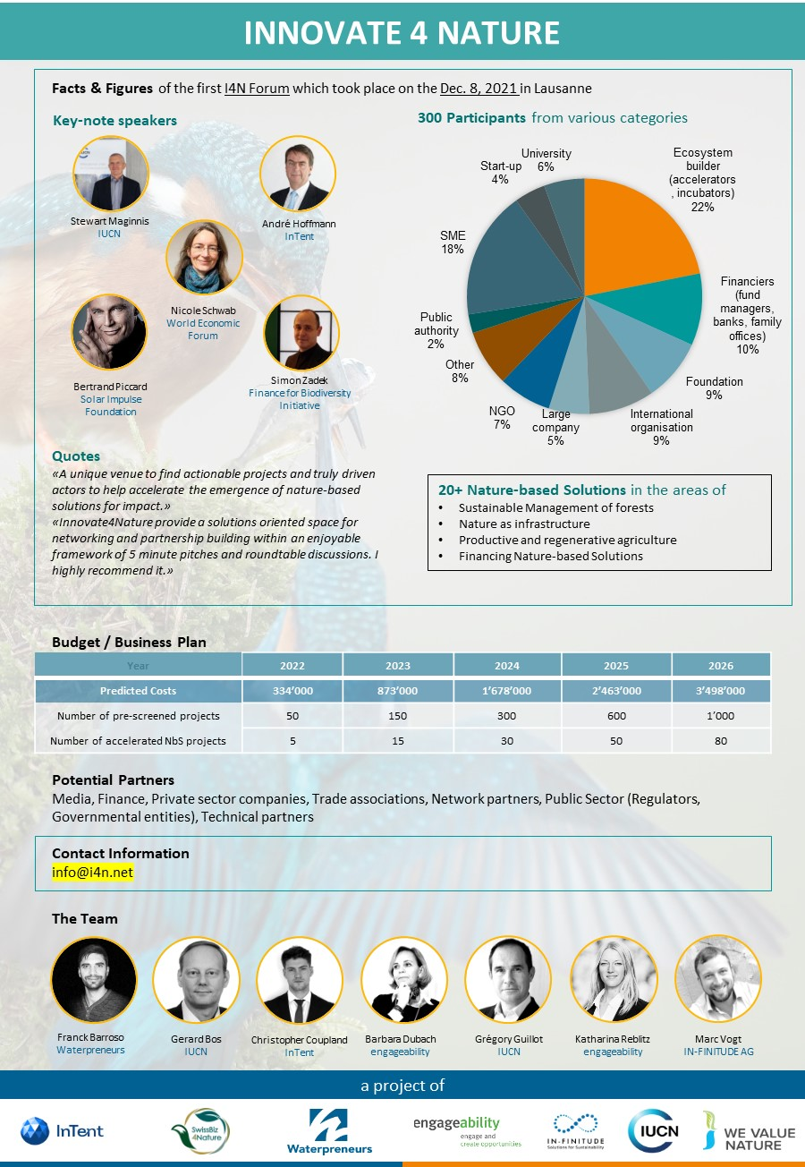

Way Forward

Please find below the documentation prepared to pitch for the additional funding and allow for the next events to take place.
The documentation in annex 1 outlines the ambition of the current partners to roll this in Switzerland first to ensure the model is fully tested and ensuring the ideation, assessment, coaching and incubating roles are well defined and structured. After the necessary tools, such as the check list and financial analysis, are properly developed and tested a roll out outside Switzerland is contemplated.
It was interesting to note that all the pitches and projects presented go well beyond the Swiss boarders but as the value chain or one of the key actors involved was linked to Switzerland it provided fertile ground to link them to potential investors.
We hope soon to be able to report on the next event and on progress by one or more of the project presented at this event.
The I4N team is grateful to the contribution and support from We Value Nature to allow the first event to take place and support the preparation of its further roll out.

